

JOINT INSTITUTE FOR NUCLEAR RESEARCH

Frank Laboratory of Neutron Physics

**FINAL REPORT ON THE**

**START PROGRAMME**

Investigation of copolymers based on indolo[3,2-b]carbazole and polyethylene glycols using SAXS, AFM, DLS methods

**Supervisor:**

PhD Yulia Gorshkova, FLNP

**Student:**

Dina Sharipova, Russia, Kazan Federal University

**Participation period:**

July 17 – August 13, 2022

October 2 – October 15, 2022

Dubna, 2022

**Table of contents**

**Abstract** 3

**Introduction** 4

**Methods** 5

**Small-angle X-ray scattering** 5

**Atomic force microscopy** 6

**Dynamic light scattering** 6

**The object of research** 7

**Results** 8

**SAXS** 8

**AFM** 10

**DLS** 11

**Conclusion** 13

**Gratitude** 14

**References** 15

# **Abstract**

One of the areas of competence of a modern specialist is the ability to determine the characteristics of nanoobjects. Such characteristics include the shape, size of particles, their spatial configuration, uniformity of structure, the relationship of chemical components, etc. Various research methods are used to study them.

During the Start program, some methods of studying materials were mastered, namely Small-angle X-ray Scattering, Atomic Force Microscopy, Dynamic Light Scattering. The test sample under investigation was a copolymer based on indolo[3,2-b]carbazole and polyethylene glycol 3000. The report provides an introductory description of these methods, as well as the obtained experimental results.

# **Introduction**

A specialist in the field of materials science should have knowledge of various approaches to material research. A professional who has the skills to work with certain installations, as well as who is able to correctly process and interpret the results obtained at these installations, becomes indispensable.

The purpose of my work was to master the methods used in the study of nanomaterials, such as small-angle X-ray scattering (SAXS), atomic force microscopy (AFM), dynamic light scattering (DLS). The test sample was a copolymer based on indolo[3,2-b]carbazole and polyethylene glycol 3000.

The following tasks were set:

* Acquisition of skills in working with the Xeuss 3.0 X-ray scattering unit, obtaining and further processing of small-angle scattering curves in the XSACT and SasView 4.2.2 programs.
* Familiarization with the atomic force microscope device, obtaining an AFM image and its subsequent processing of an AFM image.
* Mastering the method of dynamic light scattering using the Photocor Complex spectrometer as a method for determining the hydrodynamic radius of spherical particles.

# **Methods**

## **Small-angle X-ray scattering**

Small-angle X-ray scattering (SAXS) is the result of the interaction of X-ray radiation with the electrons of a nanostructured sample. The principle of the method is that uniformly distributed inhomogeneities of a polydisperse medium with a size of 1-100 nm scatter X-rays at small angles.

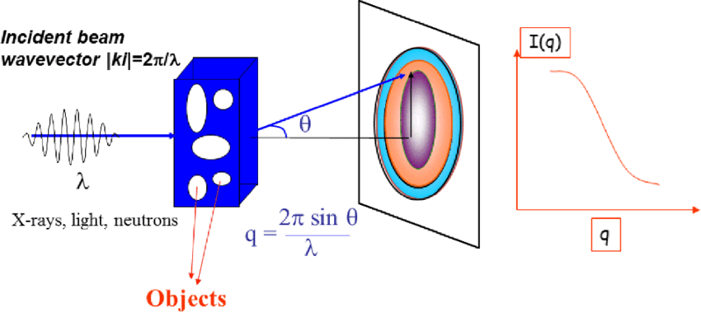

*Fig.1 The principle of the small-angle scattering experiment [1].*

Small-angle scattering makes it possible to study structures ranging in size from units to several hundred nanometers. The interference pattern of scattering is formed by the addition of a set of secondary elastically scattered waves that differ from each other in phase. The phase differences and amplitudes of the terms depend on the spatial distribution of the electron density, that is, on the structure of the object. They determine the shape of the experimental scattering curve, the analysis of which makes it possible to uniquely determine the shape and size of molecules (for protein and nucleic acid molecules), the nature of the mutual stacking of components (in viruses), the packing of polymer chains in polymers, the size distribution of particles and pores in powders and sorbents, etc [2].

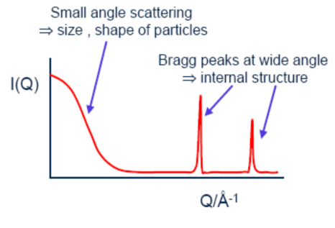

*Fig.2 Scattering curve [3].*

## **Atomic force microscopy**

Atomic force microscopy (AFM) is a type of scanning probe microscopy based on van der Waals interactions of the probe with the sample surface.

The principle of operation of the atomic force microscope is based on the registration of the force interaction between the surface of the test sample and the probe. A nanoscale tip is used as a probe, located at the end of an elastic console called a cantilever. The force acting on the probe from the surface causes the console to bend. The appearance of elevations or depressions under the tip leads to a change in the force acting on the probe, and hence a change in the bending size of the cantilever. Thus, by registering the amount of bending, we can conclude about the relief of the surface. The resolution of this method is approximately 0.1-1 nm horizontally and 0.01 nm vertically[6].

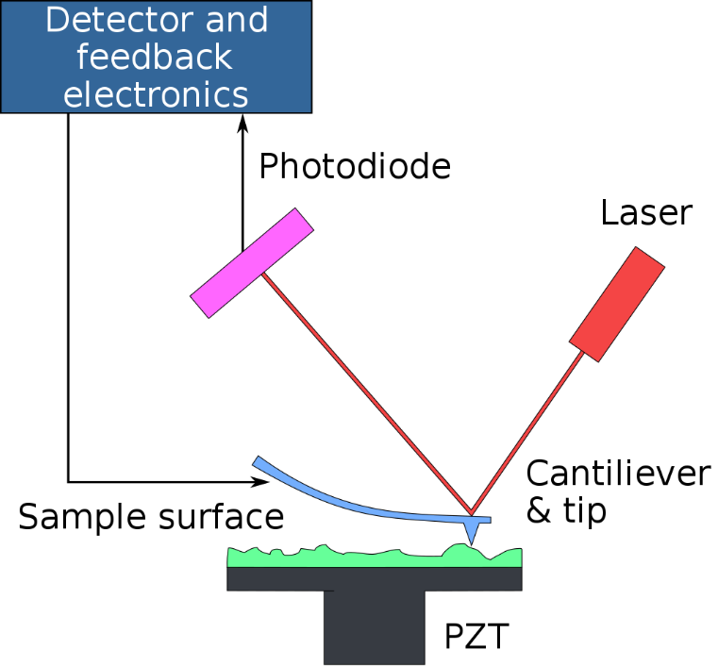

*Fig.3. Scheme of operation of the atomic force microscope [4].*

By the forces acting between the probe and the sample surface, we mean the long-range Van der Waals forces, which at short distances are repulsive forces, and with a further increase in distance they turn into attractive forces.

## **Dynamic light scattering**

The principle of particle size measurement is based on measuring at different times the intensity of scattered light in a volume containing particles in a solvent. Due to the Brownian motion of dispersed particles, which causes microscopic fluctuations in Rtheir local concentration, and due to the resulting local inhomogeneities of the refractive index, the light intensity oscillates relative to its average value when a laser beam passes through such a medium. By the frequency of these oscillations, it is possible to obtain information about the particle diffusion coefficient, which depends on the particle size.

Also, the measurement results depend on the concentration of particles. With a high concentration of particles, a beam of light scattered from one particle can meet another particle before it is registered by the detector, and the information is lost. Therefore, only weak solutions are considered [6].

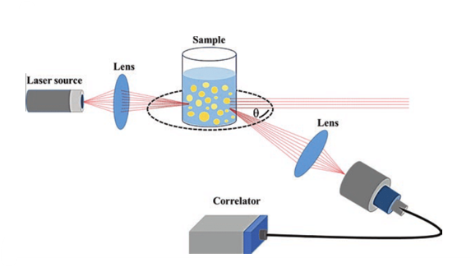

*Fig.4. Representation of dynamic light scattering principle [5].*

# **The object of research**

The object of the research was copolymers based on indolo[3,2-b]carbazole and polyethylene glycols. A polymer matrix obtained by solvent deposition was also investigated by SAXS. It is assumed that these copolymers have good solubility, and also retain luminescent properties, unlike carbazole.

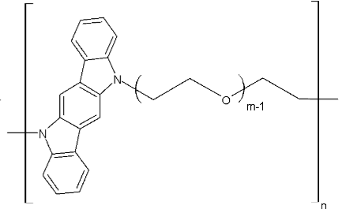

*Fig. 5. Indolo[3,2-b]carbazole-PEG copolymer, where m=68.1 for PEG 3000.*

# **Results**

## **SAXS**

All measurements were carried out at the Xeuss 3.0 X-ray scattering station. The measurements were out in a vacuum at room temperature. The X-ray tube was with a copper anode with a wavelength of 0.154 nm.

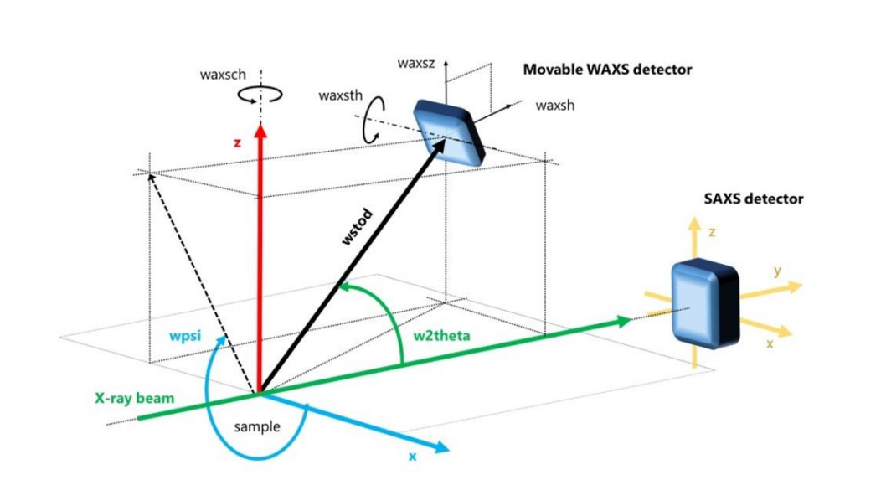

*Fig.6. Set-up for small-anle X-ray scattering (SAXS) and wide-angle X-ray scattering (WAXS) [7].*

The samples were powder of (IС-alt-OE-3000) and powder of A polymer matrix obtained by solvent deposition. The powders were used as test samples. The powders were placed in Sample Holders, secured on both sides with cardboard film. During processing, two layers of kapton were subtracted as a buffer.

Measurements were carried out for distances of 100 mm, 900 mm, 1800 mm, 4500 mm between the SAXS detector and the sample. WAXS modes were also measured for 3 different detector positions.

The initial processing of small-angle scattering curves was in the XSACT program. Data on small-angle scattering of X-rays for individual P (IС-alt-OE-3000) and mixed with polymer matrix A (RA) were obtained in the Sas View 4.2.2 program[8].

**

*Fig. 7. Small-angle scattering and X-ray diffraction for powder P (IС-alt-OE-3000) (1); matrices PA, precipitated from solvent (2)*

In the region of large q values from 0.4 to 4 Å⁻1 corresponding to wide scattering angles, Bragg peaks corresponding to the diffraction pattern of PEG scattering were found for the powder P (IС-alt-OE-3000). The PA matrix is in an amorphous state.

|  |  |
| --- | --- |
|  |  |
| *Fig. 8. 2D presentation of WAXS mode for powder P (IС-alt-OE-3000) (a); matrices PA, precipitated from solvent (b)* | | |

For polymer A (PA) obtained by solvent deposition, the obtained small-angle scattering curve was processed in the range of transmitted pulses from 0.004 to 0.3 Å⁻¹.

For the region of small, transmitted pulses, an approximation of the X-ray power dependence used in the form of a Pareto distribution was used:

$$I\left(q\right)=C*\frac{A}{q_{0}}*{\frac{q_{0}}{q}}^{\left(A+1\right)}+B$$

Then

$R=1/q_{0}$ is the radius of a sphere if A is equal to 3.

*n=A+1* is the Porod Exponent.

The Porod exponent – the magnitude of the degree Exponent - turned out to be 4.16. Based on the data obtained, it can be assumed that there are spherical homogeneous inhomogeneities in the system with a characteristic size exceeding the diameter D > 2/q0 = 2/ 0.004 = 500 Å.

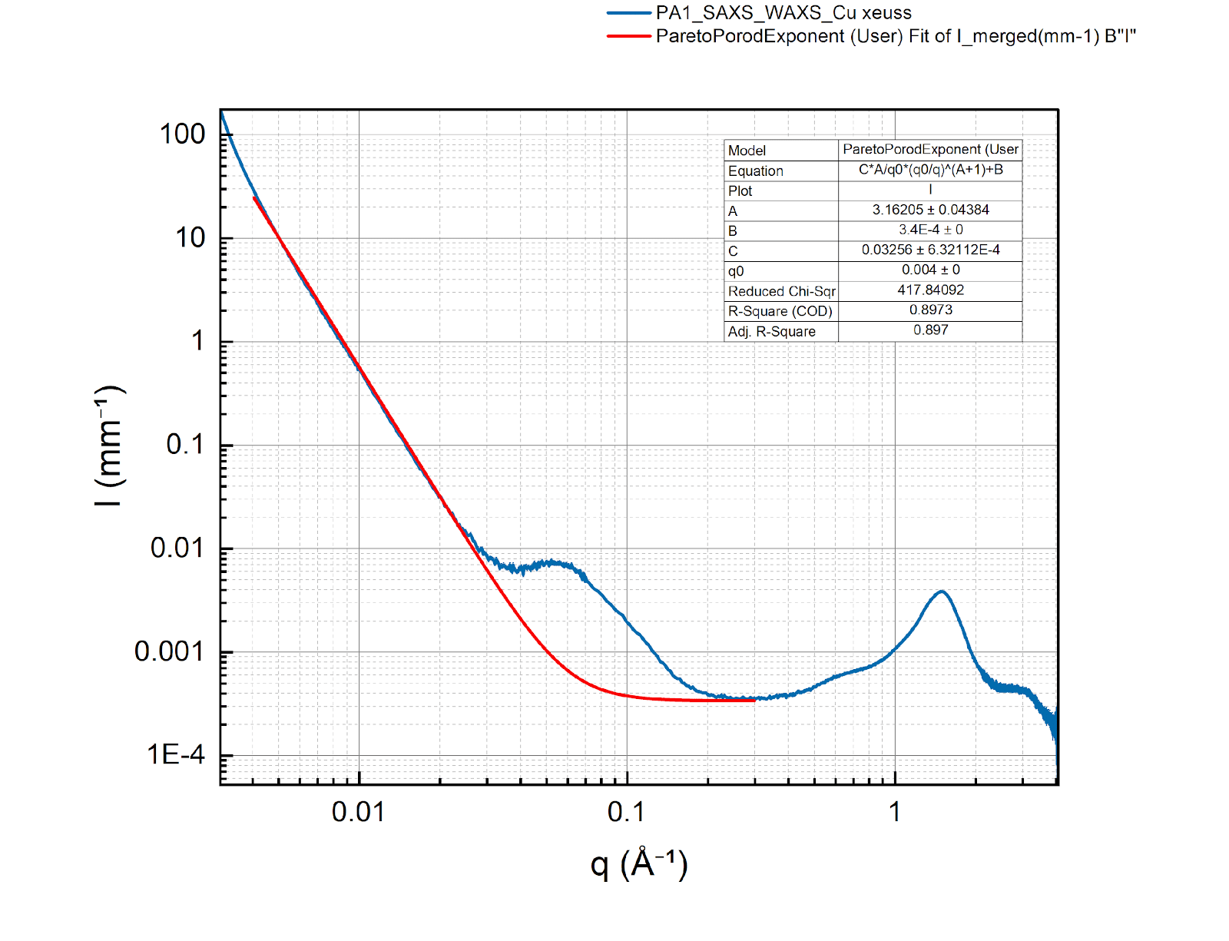

*Fig. 9. Small-angle matrix PA precipitated from solvent (blue curve). Approximation by the Porod power dependence, represented as a Pareto distribution (red curve).*

An approximation with a wide Lorentz-type peak at the end of the power decay was also used:

$$I\left(q\right)=\frac{A}{{\left(qR\right)}^{n}+\frac{C}{\left[1+{\left(\left|q-q_{0}\right|ξ\right)}^{m}\right]}}+B$$

where A is the scale factor of the Porod law; n is the exponent of the Porod law; R is the correlation size of scattering inhomogeneities according to the Porod law; C is the Lorentz scale factor; m is the Lorentz exponent for q; ξ is the length of the screening, and B is the "shelf" for the background.

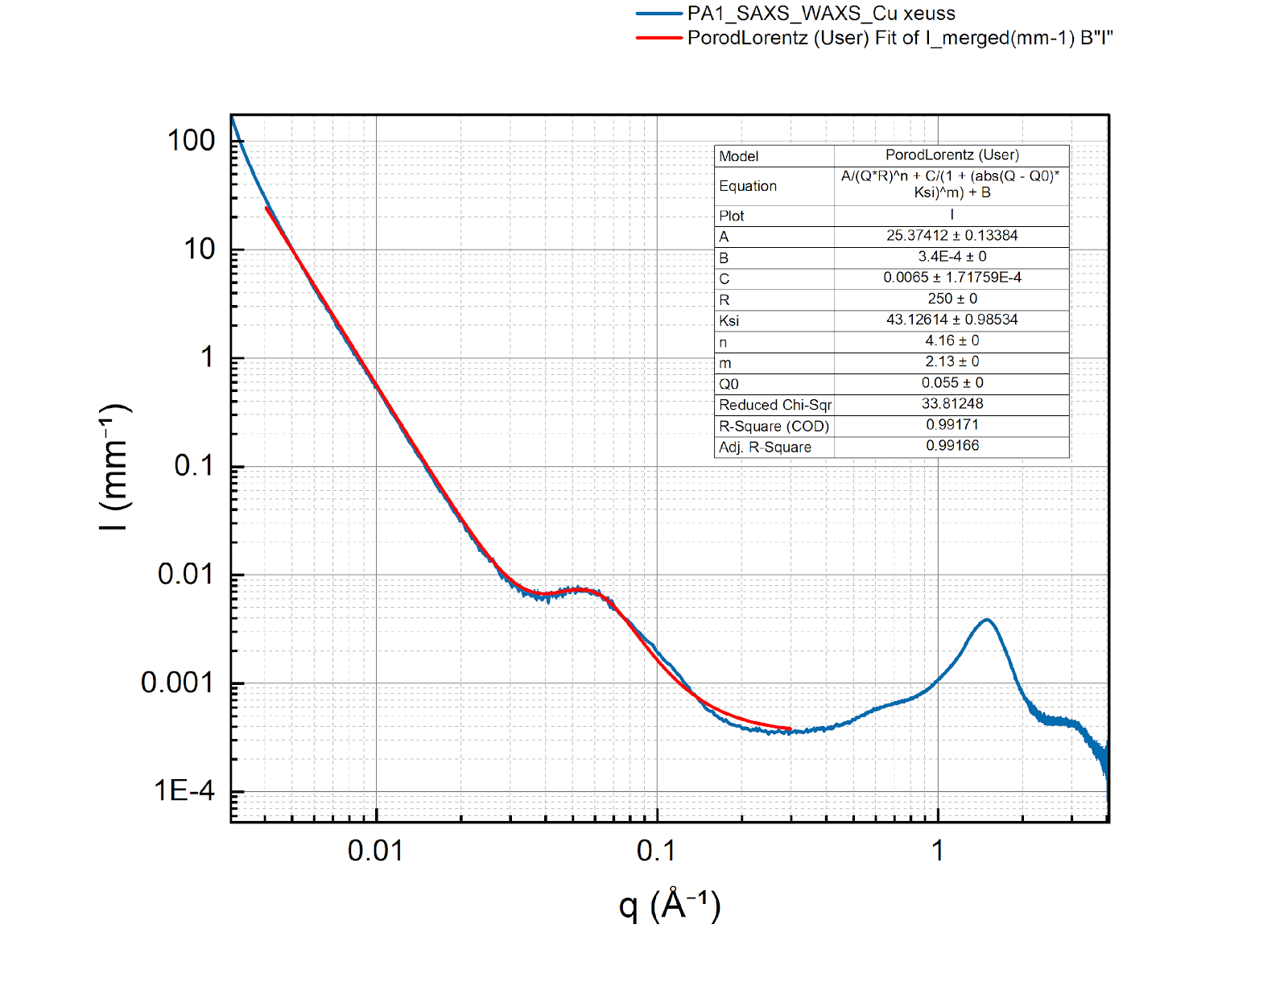

*Fig.10. Small-angle matrix PA precipitated from a solvent (blue curve). Approximation by a wide Lorentz-like peak at the end of the power dependence decline (red curve).*

The obtained approximation allows us to conclude that there is a short-range correlation order in the system with a characteristic distance *d*₀=2π/*q*₀=2π/0.055 Å = 114.2 Å for inhomogeneities of an almost spherical shape with a diameter of 43 Å. These can be rigid-chain domains formed by aromatic groups.

## **AFM**

In atomic force microscopy (AFM) experiments, NTEGRA PRIMA (NT-MDT Spectrum Instruments, Zelenograd, Russia) system was used. AFM images were recorded at intermittent contact mode, also known as tapping modem, with standard (NSG01_ Au) tips of 10 nm curvature radius (NT-MDT Spectrum Instruments, Zelenograd, Russia) at room temperature. The imaging rate was 0.3 Hz.

The samples were prepared according to the developed methodology.

The 1% by weight solution IC-PEG3000 in N-MP was added to distilled water in a ratio of 1:1000. Before the experiment, a glass cuvette with a sample was placed in an ultrasonic dispersion bath for one minute. A drop of this solution was applied to the freshly prepared mica. The solution was kept on mica for 5 minutes, after which the mica was washed with water. Then the mica was dried at room temperature for 30 minutes to finally get rid of moisture.

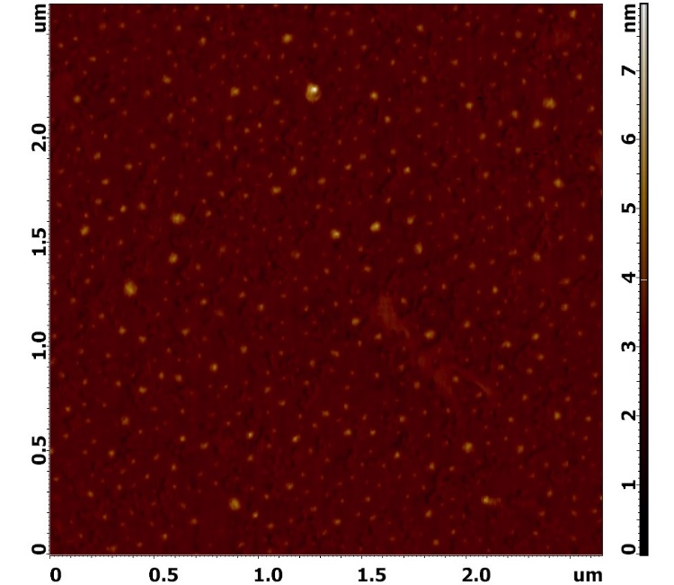

*Fig. 11. AFM image of the 1% by weight solution IC-PEG3000 in N-MP ( 2.5 × 2.5 um, 1024 × 1024 pixels) at RT*

Based on the results of image processing, the following histogram of the distribution of particle diameters was obtained:

**

*Fig.12. Histogram of particle diameter distribution*

## **DLS**

A solution of 1% by weight was prepared solution IС-PEG 3000 in N-MP in a ratio of 1:1000 in distilled water. Before the experiment, a glass cuvette with a sample was placed in an ultrasonic dispersion bath for 1 minute. The following particle size distribution was obtained by the DLS method: 30.53 ± 7.12 nm.

**

*Fig. 13. 1% by weight solution IС-PEG 3000 in N-MP in a ratio of 1:1000 in distilled water*

After 1.5 hours, the analysis was repeated as 46.81 ± 17.58 nm.

**

*Fig. 14. 1% by weight solution IС-PEG 3000 in N-MP in a ratio of 1:1000 in distilled water.*

Then the sample cuvette was left in the device overnight. The next day, the particle size distribution was analyzed again, and the following result was obtained as 26.7 ± 3.56 nm.

**

*Fig. 15. 1% by weight solution IС-PEG 3000 in N-MP in a ratio of 1:1000 in distilled water*

# **Conclusion**

During the START program, methods of small-angle scattering, atomic force microscopy, and dynamic light scattering were studied. During the work, skills were acquired on such installations as Xeuss 3.0, AFM, Photocor Complex. Small-angle scattering curves were obtained and processed in the Sas View 4.2.2 program, AFM images in the Nova program, and histograms of the hydrodynamic radius distribution were additionally obtained. The test sample was a copolymer based on indolo[3,2-b]carbazole and polyethylene glycol 3000.

According to the results of processing the small-angle scattering curve for IС-PEG 3000 mixed with a polymer matrix PA (fig. 10), precipitate from solvent, we can talk about large spherical inhomogeneities with sizes exceeding 50 nm, these sizes can be correlated with tangles of macromolecules. Bragg peaks were found in the regions of large transferred for the copolymer itself (curve 1, fig. 9). Analyzing the histogram obtained using AFM (fig.12), we can to some extent talk about a bimodal distribution of particle sizes: 27 nm and 33 nm for IС-PEG 3000. Analyzing the data with DLS (fig.15) it can be assumed that the hydrodynamic radius of IС-PEG 3000 is equal to 27 nm with a high degree of polydispersity

The knowledge acquired during the START program will become a starting point for me in the development of my scientific activity. And skills in complementary methods, such as SAXS, AFM, DLS, will help me become a high-class specialist in many scientific fields.

# **Gratitude**

The author expresses gratitude to Gorshkova Yu.E. for assistance in the process of mastering the presented research methods and mentoring throughout the practice. During the program, Yulia Evgenievna gave valuable advice and provided moral support.

The author also expresses gratitude to the UNC for the opportunity to complete the program, for lectures and excursions to JINR.

# **References**

1. Béchade, Jean-Luc & Mathon, Marie-Hélène & Carlan, Yann. (2015). Neutron analyses for nuclear materials: Texture, residual stresses and small angle scattering. EPJ Web of Conferences. 104. 10.1051/epjconf/201510401008.
2. Structure Analysis by Small Angle X-ray and Neutron Scattering L.A. Feigin and D.I. Svergun (1987), Plenum Press. PDF available on the Internet at <http://www.emblhamburg.de/ExternalInfo/Research/Sax/reprints/feigin_svergun_1987.pdf>
3. The SANS Toolbox, B. Hammouda, NIST (available as pdf: <http://www.ncnr.nist.gov/staff/hammouda/the_SANS_toolbox.pdf>)
4. Atomic_force_microscopy. [Electronic resource] URL: <https://en.wikipedia.org/wiki/Atomic_force_microscopy> (Accessed 12.10.2022)
5. Choudhary, R.C. & Kumari, Sarita & R V, Kumaraswamy & Pal, Ajay & Raliya, Ramesh & Biswas, Pratim & Saharan, Vinod. (2019). Characterization Methods for Chitosan- Based Nanomaterials. 10.1007/978-3-030-12496-0_5.
6. Виноградов В.В., Виноградов А.В., Морозов М.И., Румянцева В.И., Румянцева В.И. Физико-химические методы исследования материалов– СПб: Университет ИТМО, 2019. – 72 с.
7. Xenocs. [Electronic resource] URL: <https://www.xenocs.com/> (Accessed 13.10.2022)
8. SasView for Small Angle Scattering Analysis. URL: <https://www.sasview.org/> (Accessed 28.07.2022)