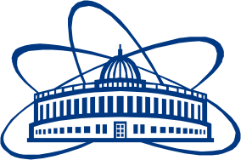

JOINT INSTITUTE FOR NUCLEAR RESEARCH
1
Veksler and Baldin laboratory of High Energy Physics

FINAL REPORT ON THE
START PROGRAMME

2
Superconducting Magnets for NICA Collider

Supervisor:
3
Dr. Victor Alexeevich Mironov

Student:
4
Sergey Belozerov, Belarus
Byelorussian State University
5
Participation period:
July 01 – August 01,
Summer Session 2022
Field 1 – Name of the JINR Laboratory
Field 2 – Name of the project
Field 3 – Supervisor’s name
Field 4 – Your name, country and name of the university
Field 5 – Period of participation in the Program, Session

Dubna, 2022

