

JOINT INSTITUTE FOR NUCLEAR RESEARCH
Frank Laboratory of Neutron Physics

FINAL REPORT ON THE START PROGRAMME

Calculation of cross sections of γ-quanta emission in neutron-inducded reactions for 48Ti

Supervisor:
Ph.D. Fedorov Nikita

Student:
Zuev Alexander, Russia,
Moscow State University

Participation period:
July 13 – August 23,
Summer Session 2025

Dubna 2025

Contents

1 Abstract 3
2 Introduction 3
3 Main Work 4
3.1 Extraction of the γ-ray cross-sections for transitions from continuum 4
3.2 Calculation of γ-ray emission cross-sections with γ-cascades 5
3.3 Testing of libraries for nuclear data extraction 6
3.4 Cascade CS dependence on neutron energy 7
3.5 Continuum CS dependence on neutron energy 8
4 Conclusions 10
5 Acknowledgements 11
6 References 11
7 Appendices 12

1 Abstract
Accurate information about γ-ray emission cross sections is crucial for understanding neutron interactions with nuclei. This work presents the development of a program for recursive computation of γ-transition cross sections using branching ratios and data of excited states formation in various neutron-induced reactions available in evaluated nuclear data libraries. In this work different codes for processing of nuclear data in the ENDF-6 format have been tested.

2 Introduction
A vast amount of evaluated nuclear data (END) has been collected by the scientific community, including libraries such as ROSFOND, ENDF, JEFF, JENDL, and CENDL [1-5]. It is important for systematizing and processing experimental data related to nuclear physics and engineering, containing information on scattering and reaction cross sections, nuclear structure, and decay parameters. Their accuracy must be carefully verified. The 48Ti isotope was chosen for analysis due to its large γ-ray emission cross section, high availability, and relative cost-effectiveness for producing homogeneous, impurity-free samples, making it suitable as a calibration standard for monitoring of fast neutron fluxes.
To measure γ-ray spectra and neutron-induced reaction cross sections, the Frank Laboratory of Neutron Physics at JINR developed the TANGRA (TAgged Neutrons and Gamma RAys) setup. The TANGRA collaboration focuses on detailed studies of reactions induced by neutrons with energies around 14 MeV and it is interested in comparison of the obtained data with available evaluations. As part of my internship, I worked on processing END data to obtain cross sections of cascade γ-transitions.

3 Main Work
The main work of this study is conducted within the framework of testing nuclear data processing libraries TalysLib [6] and EndfParserPy [7] for extraction of the content of the ENDF-6. ENDF-6 is the formatted files for consequent calculation of the γ-ray emission cross-sections.
TalysLib is the ROOT-based library for access to the Talys database and calculations, developed as part of the TANGRA project.
EndfParserPy is the class from the endf-parserpy package that allows reading and writing data in the ENDF-6 format.

3.1 Extraction of the γ-ray cross-sections for transitions from continuum
To obtain cross-sections of γ-quanta emission in transitions from continuum states from the ENDF-6 format the EndfParserPy library was used. Its functions were used to extract detailed data for various MT=91 reactions, which are responsible for the continuous γ-ray spectrum within MF=6. The extracted data included discrete energy points, corresponding cross sections and branching ratios, which were subsequently processed to construct the full energy-angular distributions at various energies of incident neutrons.
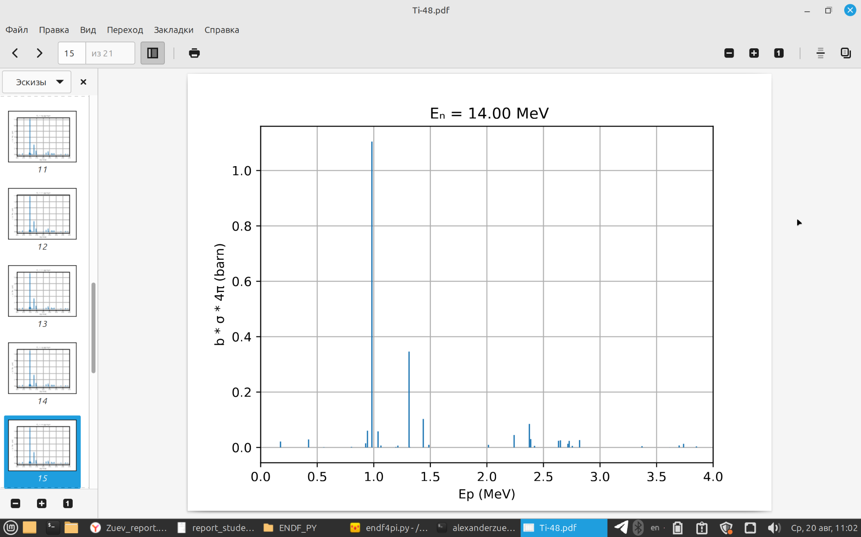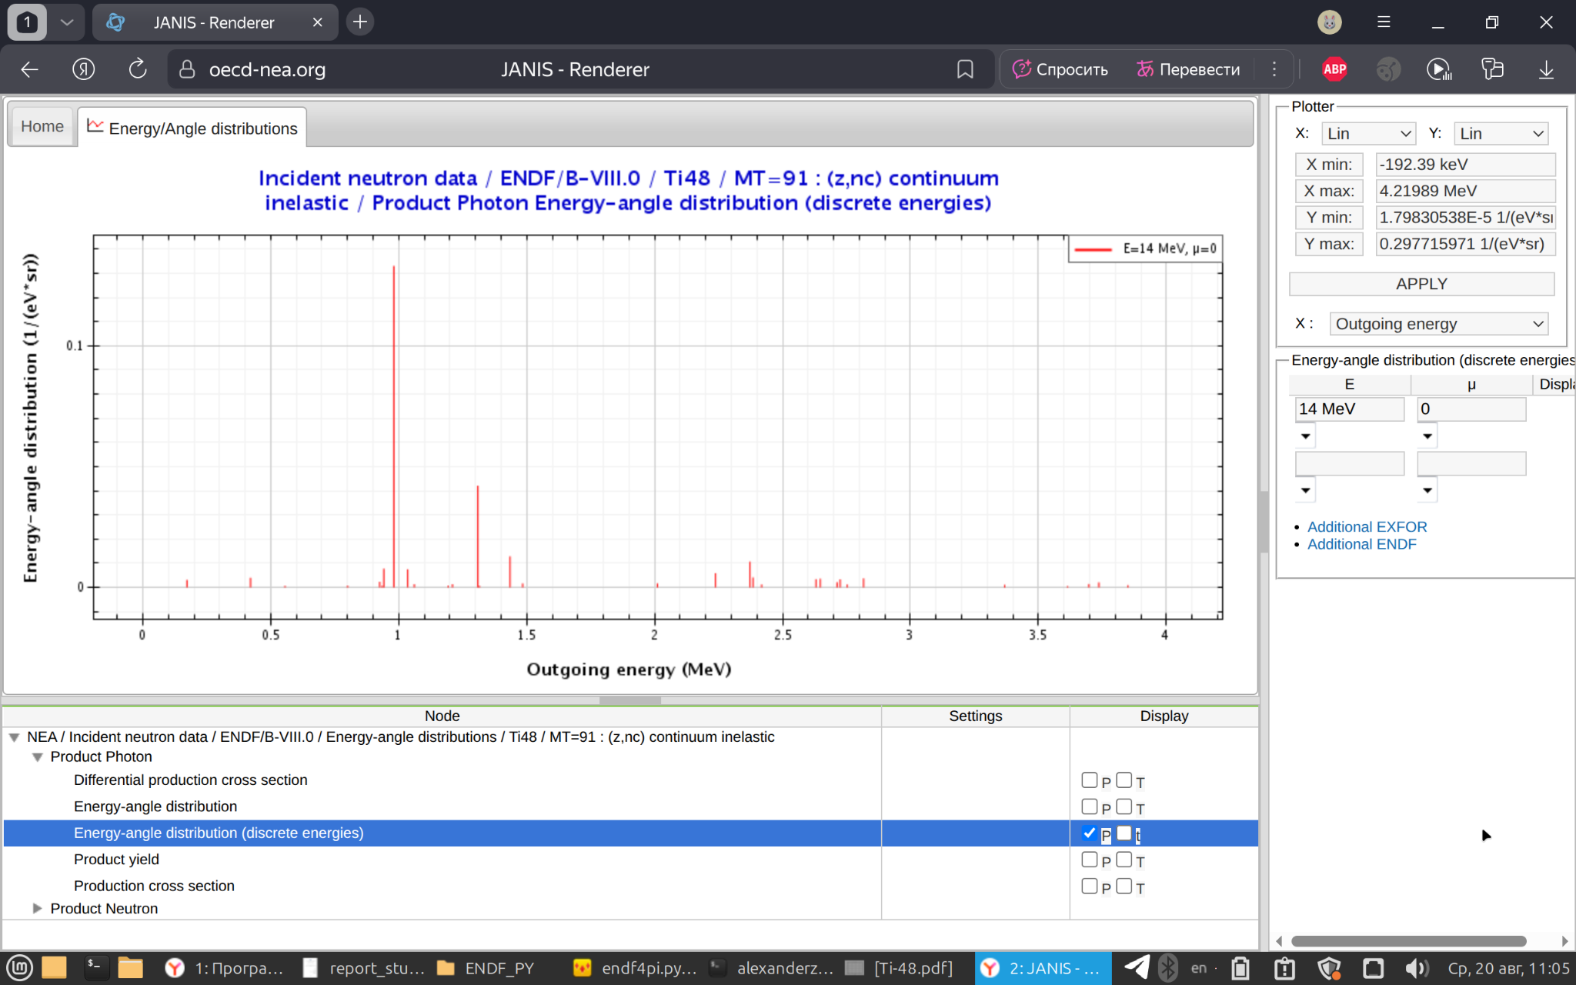
Figure 1. Dependence of cross section on energy of the emitted γ-quantum at incident neutron energy of 14 MeV, obtained by the algorithm (left) and from JANIS WEB (right).
In both cases, the underlying nuclear data were sourced from the ENDF/B-VIII library [8]. Comparison indicates a good agreement between the generated distributions and the reference, validating the correctness of the data extraction and processing algorithm.

3.2 Calculation of γ-ray emission cross-sections with γ-cascades
The calculation of reaction characteristics related to the excitation of individual TALYS levels requires additional information about their energies, spins, and parities, which can be obtained from evaluated nuclear data or calculated using various microscopic approaches. The computation of γ-ray emission cross sections $σ_{ij}$ for transitions from level i to level j requires accounting for cascade γ-transitions and branching ratios $γ_{ij}$, which are not measured for all known levels. The calculation of $σ_{ij}^{γ}$ is performed using the formula:
$σ_{ij}^{γ}= γ_{ij}(\sum_{k}{}σ_{k}^{L} γ_{ki} + σ_{i}^{L})$ + $σ_{i}^{C}$ (1)
Where $σ_{ij}^{γ}$ – is the cross section of the γ-transition from level i to level j,
$γ_{ij}$ – is the branching ratio (probability) for this transition,
$σ_{i}^{L}$ – is the total excitation cross section of level i in a binary reaction.
$σ_{i}^{C}$ – cross-section of the level population by gamma-transitions from continuum states.
The index $k$ corresponds to the level number in the γ-transition cascade leading to the excitation of level i.
In practice, the calculation of $σ_{ij}^{γ}$ is performed recursively: starting from the highest excited levels, the program takes into account branching ratios and calculates the contribution for cascades leading to lower levels $σ_{i}^{L}$.
The function implementing this algorithm is presented in Appendix 2.

3.3 Testing of libraries for nuclear data extraction
The first step was to perform a level-by-level comparison of the results obtained from the user libraries TalysLib and EndfParserPy based on ENDF/B-VIII data for the isotope 48Ti.
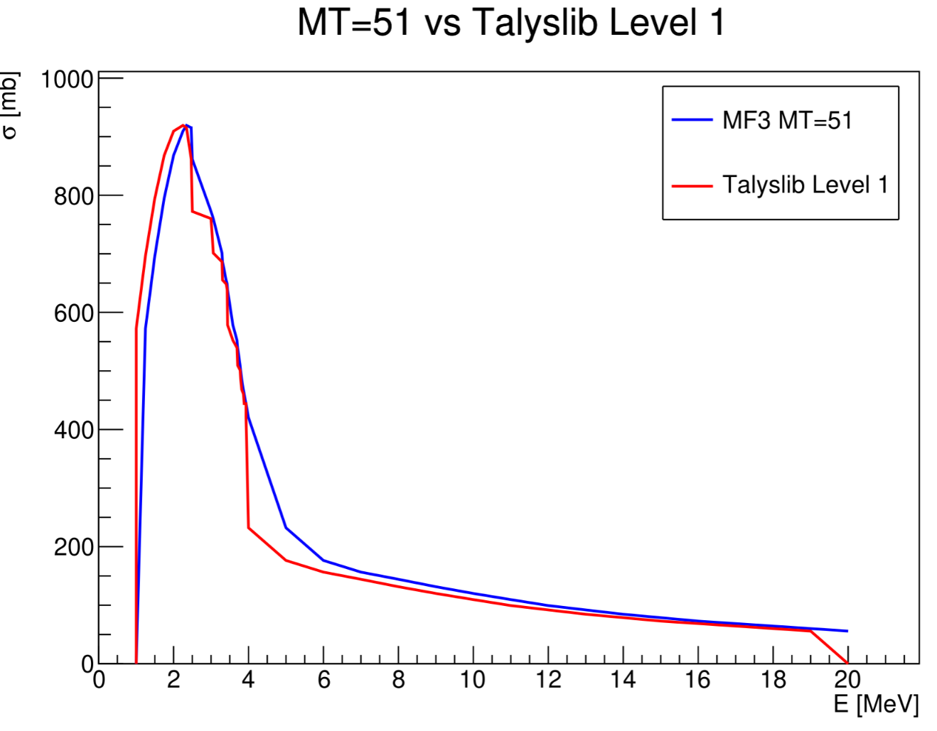
Figure 2. Comparison of cross sections obtained directly from the TalysLib and the EndfParserPy without using formula (1).
After performing the channel-by-channel comparison, discrepancies between the results of the TalysLib and the EndfParserPy for most levels became evident. While EndfParserPy consistently reproduces the expected cross sections in accordance with the ENDF/B-VIII, TalysLib shows deviations that are likely associated with incorrect reading of level cross sections in binary reactions.

3.4 Cascade CS dependence on neutron energy
The next objective was to construct the dependence of γ-transition cross sections on the energy of incident neutrons for cascade reactions using formula (1), and to compare the resulting curves with values obtained directly from the ENDF/B-VIII.
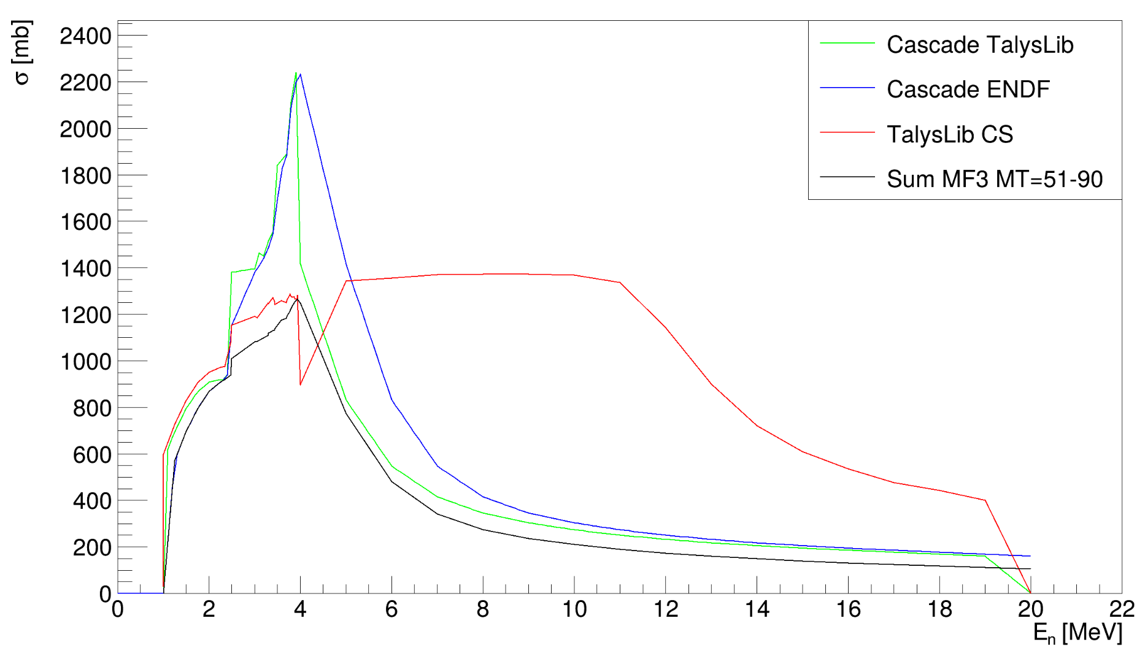
Figure 3. Dependence of the reaction cross section on the energy of the incident neutron, obtained using the recursive function (blue and green lines) and without it (red and black lines).
The difference between the TalysLib Cascade and the ENDF Cascade graphs lies in the method used to obtain the level cross sections, which were subsequently substituted into formula (1). The deviations in the graphs and abnormal “peak” at 4 MeV confirm the presence of an error in reading cross sections from the ENDF/B-VIII.

3.5 Continuum CS dependence on neutron energy
For the purposes of File 6 from the ENDF/B-VIIII, any reaction is defined by giving the production cross section for each reaction product in barns/steradian assuming azimuthal symmetry:
$σ_{i}^{}(μ, E, E^{/}) =σ(E)y_{i}(E)f_{i}(μ, E, E^{/})/2π$ (2)
where:
i denotes one particular product,
E is the incident energy,
$E^{/}$ is the energy of the product emitted with cosine μ,
$σ$(E) is the interaction cross section,
$y_{i}(E)$ is the product yield or multiplicity for particle i (although, for fission, this interpretation depends on the JP flag below), and $f_{i}$ is:
$f_{i}(μ, E, E^{/}) =\sum_{l=0}^{NA}{} (2l-1)f_{i}(E, E^{/}) P_{l}(μ)/2$ (3)
where:
NA is the amount of angular parameters,
LANG is the indicator which selects the angular representation to be used,
LAW Flag to distinguish between different representations of the distribution function, $f_{i}$ [8],
NEP is the amount of secondary energy points in the distribution,
ND is the amount of discrete energies given. The first ND≥0 entries in the list of NEP energies are discrete, and the remaining (NEP-ND)≥ 0 entries are to be used with LEP to describe a continuous distribution.
In the data for the isotope 48Ti, parameter LANG = 1 (Legendre coefficients are used), and parameter LAW = 1, NA = 0 (isotropic distributions), which was verified using EndfParserPy. Also, due to the specifics of the File 6, the $f_{i}(E, E^{/})$ presented in formula (3) is denoted by the letter b.
The sum from formula (3) was represented by a single term:
$f_{i}(μ, E, E^{/}) =b_{0}(E, E^{/}) P_{0}(0)/2 = b_{0}/2$ (4)
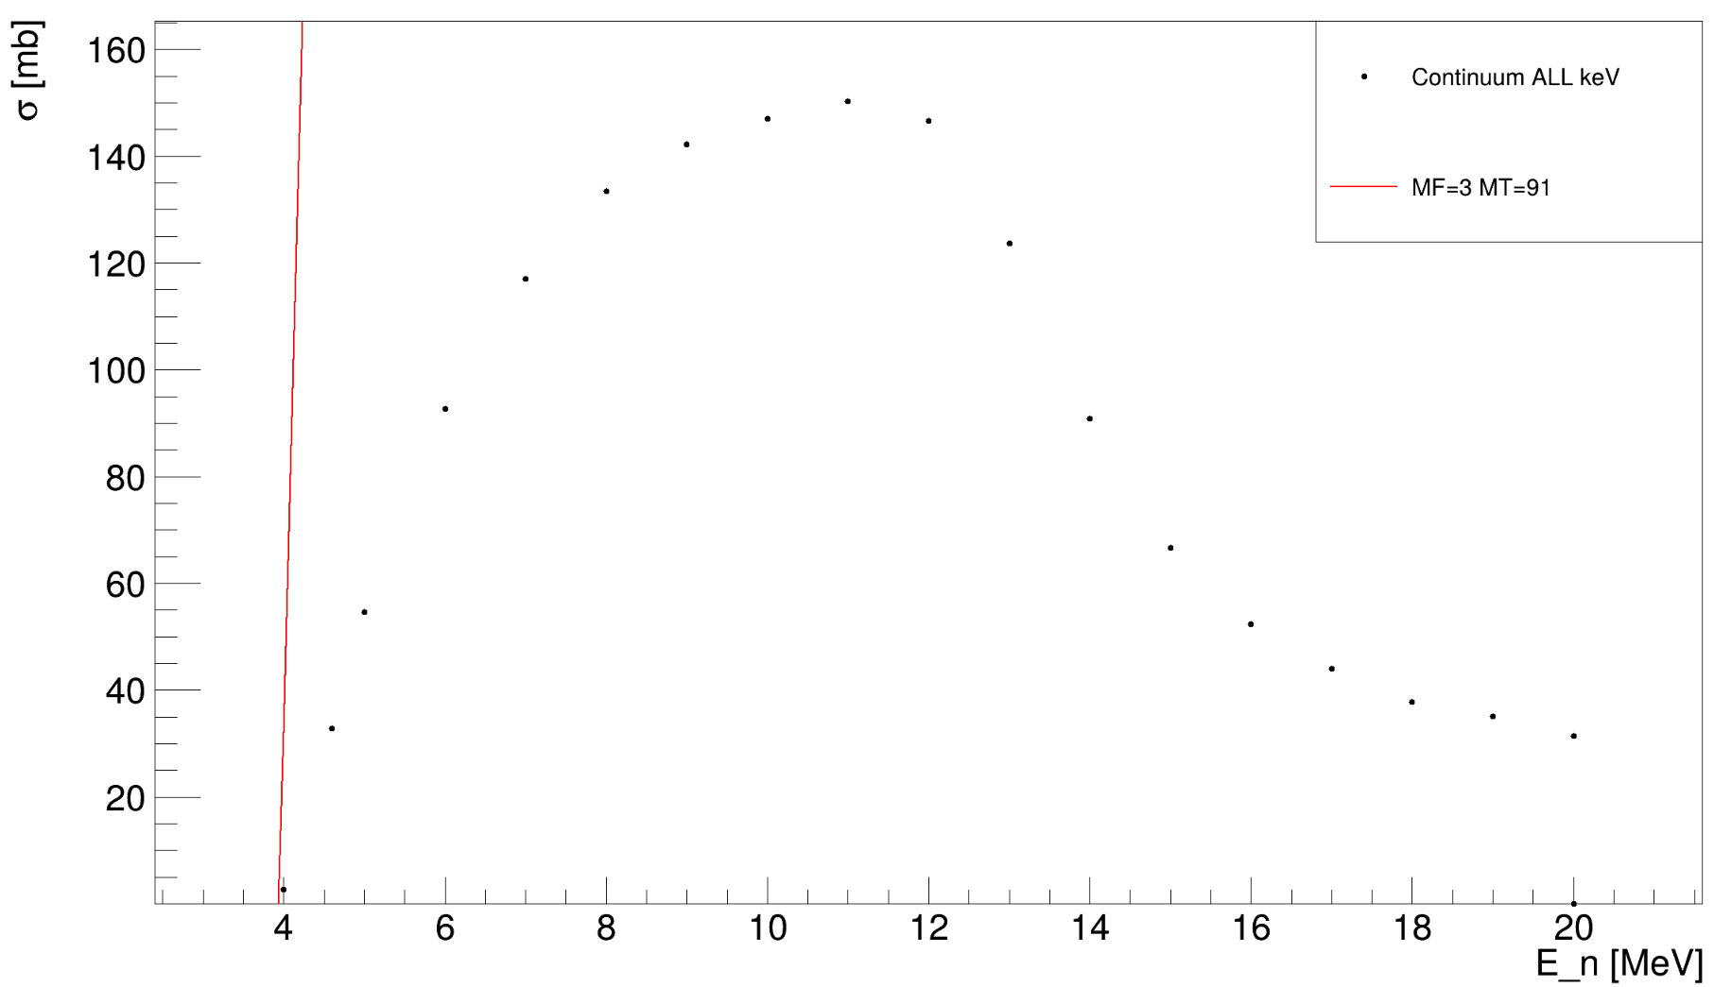
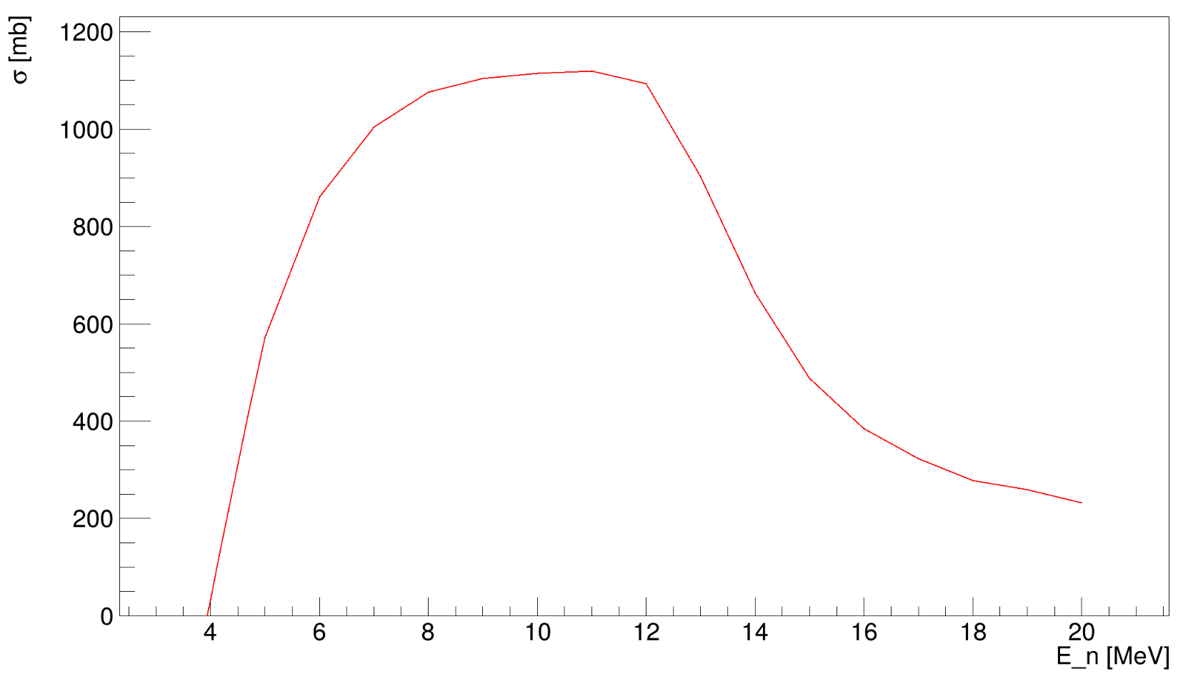
Figure 4. Dependence of continuum CS on the energy of incident neutron.
The obtained graphs qualitatively match; however, the order of magnitudes does not coincide. During the calculation of the cascade cross sections by the program, a condition was applied that discards the first ND lines, which correspond to discrete lines. It is likely that in this case, incorrect reading occurs with the EndfParserPy methods.

4 Conclusions
Development and testing of the software for recursive calculation of γ-ray emission cross sections, accounting for cascade transitions and branching ratios, demonstrated on the 48Ti isotope have been performed. The accuracy of data extraction from the ENDF/B-VIII library was shown to have the direct impact of the cross section calculations, as confirmed by comparing results from the TalysLib and the EndfParserPy.
Level-by-level comparison revealed significant discrepancies, with EndfParserPy reliably reproducing the ENDF/B-VIII data, while TalysLib exhibited systematic deviations likely due to incorrect reading of cross sections in binary reactions. Analysis of the neutron energy dependence highlighted errors in the TalysLib's data handling, evidenced by anomalous peaks in the graphs. This study underscores the critical need for rigorous validation of nuclear data processing tools to ensure reliable reaction modeling.
Future work will focus on refining data extraction algorithms, addressing identified inconsistencies, and expanding the approach to other isotopes and reaction types to further enhance the precision of cascade γ-transition cross section calculations.

5 Acknowledgements

I would like to thank my JINR scientific supervisor Nikita Fedorov for his guidance and help during the work process. I’m also grateful to the whole START team for the financial support and assistance in solving various issues. Thanks to the TANGRA team for the opportunity to work with the HPGe (High-Purity Germanium) detector.

References
[1]https://www.ippe.ru/reactors/reactor-constants-datacenter/rosfond-neutron-database
[2] https://www.nndc.bnl.gov/endf/
[3] https://oecd-nea.org/dbdata/jeff/
[4] https://wwwndc.jaea.go.jp/jendl/jendl.html
[5]https://www.researchgate.net/publication/345965652_CENDL-32_The_new_version_of_Chinese_general_purpose_evaluated_nuclear_data_library
[6] https://github.com/terawatt93/TalysLib
[7] https://endf-parserpy.readthedocs.io/en/latest/guide/reading_writing_endf.html
[8] Trkov A., Herman M., Brown D. A. et.al., ENDF-6 Formats Manual: Data Formats and Procedures for the Evaluated Nuclear Data Files ENDF/B-VI, ENDF/B-VII and ENDF/B-VIII, National Nuclear Data Center, Brookhaven National Laboratory, Upton, NY, 2018.
[9] Development and use of the method of labeled neutrons with an energy of 14 MeV to study nuclear reactions and determine the elemental structure of substances containing carbon, oxygen or chromium. 2022. Dimitar Grozdanov, Dubna.
[5] Fedorov N. A., Grozdanov D. N., Kopatch Yu. N. et.al., European Physical Journal A (IF: 2,345). 2021. Vol. 57, no. 6. P. 194.
[6] NEA Nuclear Data High Priority Request List. URL: https://www.oecd-nea.org/dbdata/hprl/

Appendix

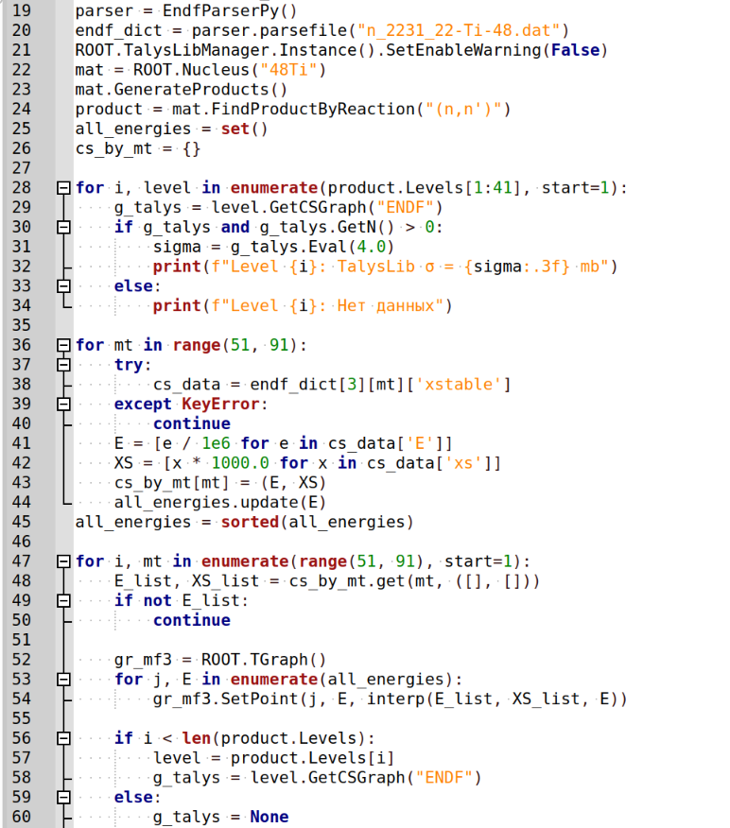
Appendix 1. Python function for constructing level-by-level dependence of the cross section on the energy of the incident neutron using TalysLib methods and direct extraction from MF3.

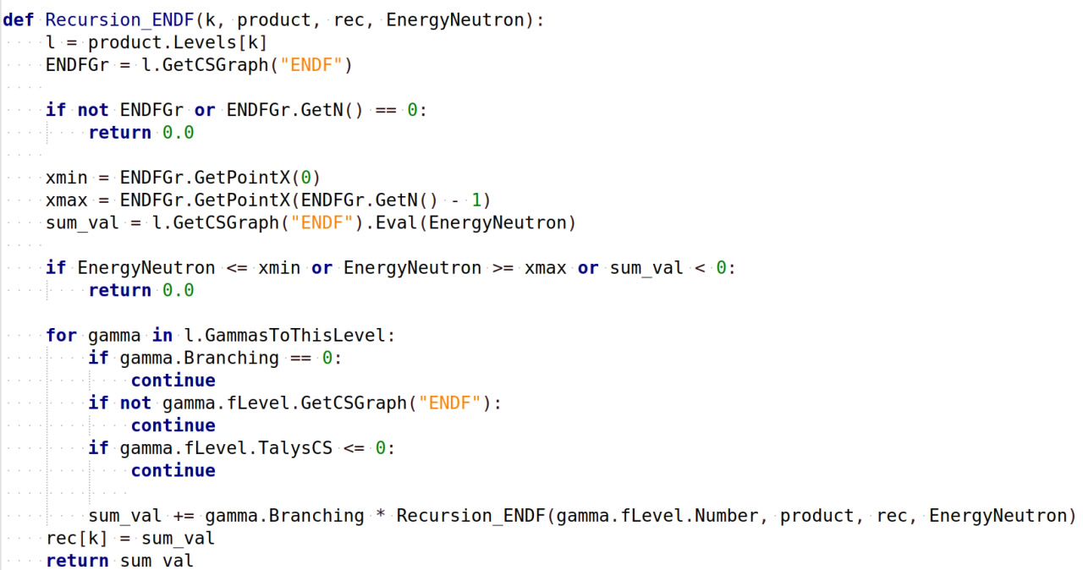

Appendix 2. Python function for calculating cascade cross sections using TalysLib methods on the example of the ENDF/B-VIII library.

