

JOINT INSTITUTE FOR NUCLEAR RESEARCH

Meshcheryakov Laboratory of Information Technologies

**FINAL REPORT ON THE**

**START PROGRAMME**

*RECONSTRUCTION OF MUON COORDINATES IN CATHODE-STRIP CHAMBERS*

**Supervisor:**

Dr Nikolay Nikolaevich Voytishin

**Student:**

Dmitry Fomenok, Belarus  
Gomel State Technical University

**Participation period:**

August 04 – September 14

Summer Session 2024

Abstract

In this paper, we study the problem of reconstructing the coordinates of muons in the cathode-strip chambers of the compact muon solenoid of the Large Hadron Collider.

The operation of the standard algorithm is described, promising algorithms are considered, their software implementation is carried out, and the obtained reconstruction results are analyzed.

The result of this work on increasing the accuracy of coordinates is very important for the subsequent reconstruction of muon trajectories.

Contents

Abstract 2

Contents 3

Introduction 4

1 Cathode-strip chambers of CMS expirement 5

2 Input data 6

3 Standart algorithm for reconstruction 7

4 First approach 8

5 Direct optimizations of parameters 10

6 Optimization using wavelet-analysis 11

7 Analyses of the obtained results 14

Conclusion 16

References 17

Acknowledgement 18

Introduction

The second stage of the Large Hadron Collider operation is ongoing, which is characterized by higher luminosity and multiplicity of overlapping events. This imposes increased requirements on each subsystem of the CMS experiment, including the cathode-strip chambers.

Under conditions of high multiplicity, the strip coordinate is reconstructed with a bad precision (30-60% of the strip width) on a single plane of the cathode-strip chambers. This is due to the fact that for a cluster consisting of overlapping signals, the usual mass center algorithm is used when calculating coordinates.

To improve the accuracy of reconstruction the strip coordinate, a new algorithm for local reconstruction in cathode-strip chambers using wavelet analysis was introduced.

During participation in the START program, the detector design, standard and promising reconstruction algorithms were studied, a program was developed and tested in which new algorithms were implemented.

# 1 Cathode-strip chambers of CMS expirement

The Large Hadron Collider at CERN houses the Compact Muon Solenoid (CMS), one of two large universal particle detectors [1].

Figure 1 shows the detector's design.

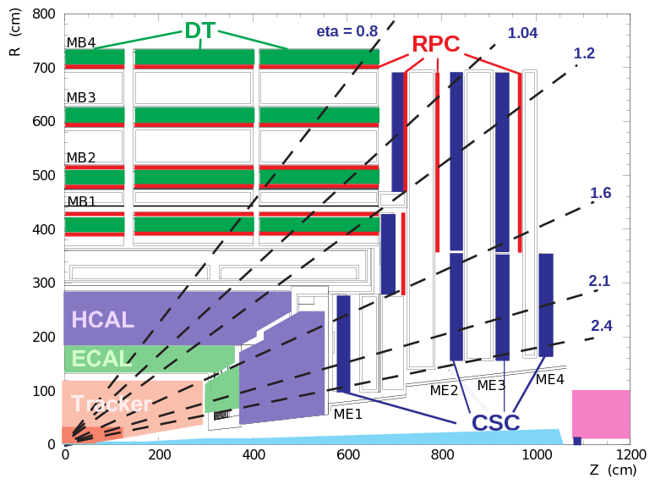

Figure 1 – Design of CMS detector

One of the main tasks of this detector is to detect muons. Almost all known particles, except muons and neutrinos, stop in calorimeters (ECAL and HCAL), so at the very end of the detector complex there are three types of muon detectors: drift tubes, cathode-strip chambers and chambers with resistive plates.

Cathode-strip chambers (CSC) are used for precision measurement of tracks at the ends of the detector area and consist of six planes of anode wires and seven planes of cathode strips perpendicular to them. The chamber is filled with a special gas mixture.

When a muon flies through the chamber, electrons are knocked out of the gas, which flows to the anode wires, forming an electron avalanche, and induces a charge on the cathode strips.

The CSC system includes more than 500 muon chambers, which form the muon stations (ME1-ME4). The total area covered by the CSCs is approximately 1000 square meters.

Figure 2 shows the structure of a cathode-strip chamber.

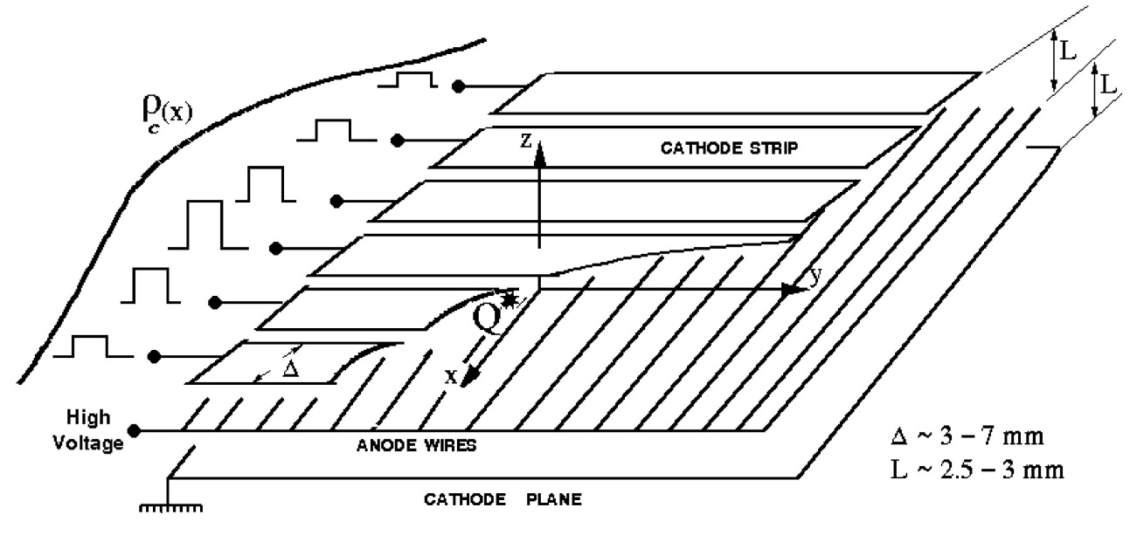

Figure 2 – Design of cathode-strip chamber

The problem of reconstructing the two-dimensional coordinate (in the polar coordinate system) of the muon passage arises. The $R$ coordinate can be measured with sufficient accuracy using wires, and the $φ$ coordinate must be calculated based on the charge distribution on the strips, which requires the use of special algorithms described later in the report.

# 2 Input data

During its operation, the detector registers the charge present on the strips of each chamber with a certain frequency.

The reconstruction is carried out in local coordinates of the detector plane, which are the strip numbers. The local coordinates after reconstruction can be transformed using a formula to obtain the desired coordinate $φ$.

The data obtained for each chamber are a matrix, the values of which are the charge, the columns correspond to the moments of time, and the rows correspond to the strips.

Since there is a charge on the strips even in the absence of flying muons, the original data are transformed: for each strip, its pedestal value is determined, which is subtracted from the charge on it at each moment of time, the resulting negative values are replaced by zero.

The pedestal value is defined as the arithmetic mean of the charge on the strip at the first and second moments of time.

After the transformation is performed, the moment of time at which the particles passed is determined. This is done by searching for the column in which the maximum charge value is present in the matrix. In the subsequent analysis of the signal, only the values from this column are used, which are further called the histogram $\{h_{i}\}$.

Simulated data are used as input data, since the generators provide up-to-date information on the coordinates of the passed particles, which allows us to estimate the accuracy of their reconstruction.

# 3 Standart algorithm for reconstruction

The charge distribution on the strips that occurs during the flight of one muon is described by the Gatti function [2], which can be approximated by the Gauss function (1), so called gaussian, which has three parameters: the amplitude $A$, coordinate of center $x_{0}$ and its standard derivation $σ$.

$$y\left(x\right)=Ae^{-\frac{{\left(x-x_{0}\right)}^{2}}{2σ^{2}}}(1)$$

The standard algorithm determines the coordinate of a particle by the center of mass of the charge distribution on several strips, which, in the case of a single particle (figure 3) or particles separated in space (figure 4), gives a fairly accurate value of the coordinate.

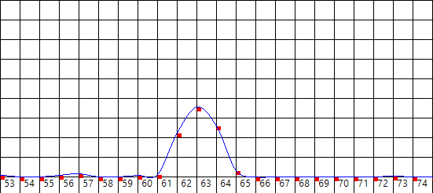

Figure 3 – Single particle

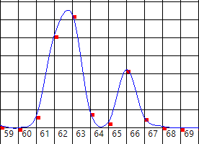

Figure 4 – Separated in space particles

A situation often arises when several particles that have passed the detector have close coordinates, resulting in the superposition of charges induced on the strips (figure 5).

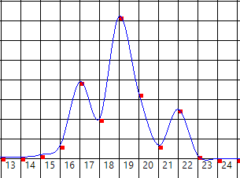

Figure 5 – Superposition of induced charges

In this case, a modification of the standard algorithm is used: the signal is approximately split in the supposed overlapping region, after which the center of mass algorithm is applied to each part. The error in the general case can be more than 0.25 strip widths, which is an unsatisfactory result and requires improvement.

There may be situations in which several particles had very close coordinates (figure 6), so the charge distribution is similar to the charge distribution from a single particle. In this case, the modification of the standard algorithm is not able to separate the superimposed signals. In this case, information is extracted only about one particle, which leads to an undesirable loss of information [3].

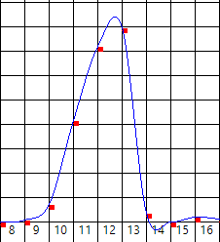

Figure 6 – Superimposed charge distribution

# 4 First approach

Since the detector provides information about the charge on each strip, and the coordinate reconstruction is required with an error of about 0.02-0.05 strip width, the histogram is supplemented with intermediate values, which are calculated using cubic spline interpolation. The resulting signal can be described by the sum of gaussian functions (2), where $n$ is the number of particles.

$$f\left(x\right)=\sum_{i=1}^{n}{A_{i}e^{-\frac{{\left(x-x_{0i}\right)}^{2}}{2σ_{i}^{2}}}}(2)$$

The following algorithm is used for estimation of parameters:

1. the maximum is located on the augmented histogram;
2. two adjacent points are selected;
3. the parameters of the gaussian are estimated using three points;
4. the values of the obtained gaussian are calculated at the points of the histogram;
5. the resulting values are subtracted from the values on the histogram, negative numbers are replaced by zero;
6. if the histogram still contains charge values significantly greater than zero, the process is repeated.

Estimation of the parameters of a gaussian at three points can be performed by composing a system of equations (3), where $y_{i}$ are histogram values, $x_{i}$ are coordinates of these points:

$$\left\{\begin{aligned}y_{1}=Ae^{-\frac{{\left(x_{1}-x_{0}\right)}^{2}}{2σ^{2}}} \\ y_{2}=Ae^{-\frac{{\left(x_{2}-x_{0}\right)}^{2}}{2σ^{2}}} \\ y_{3}=Ae^{-\frac{{\left(x_{3}-x_{0}\right)}^{2}}{2σ^{2}}}\end{aligned}\right.(3)$$

Here it is assumed that the values at the three points are the values of a gaussian function with parameters $A$, $σ$, $x_{0}$, and the points themselves are close enough that the charges in them are not distorted by the imposition of another gaussian.

Transforming the resulting system, we obtain (4), from which it is easy to find the values of the desired parameters:

$$\left\{\begin{aligned}A=y_{1}e^{\frac{{\left(x_{1}-x_{0}\right)}^{2}}{2σ^{2}}} \\ σ=\sqrt{\frac{{\left(x_{3}-x_{0}\right)}^{2}-{\left(x_{1}-x_{0}\right)}^{2}}{2\ln\left(\frac{y_{1}}{y_{3}}\right)}} \\ x_{0}=\frac{1}{2}\frac{\left(x_{2}^{2}-x_{1}^{2}\right)\ln\left(\frac{y_{1}}{y_{3}}\right)-\left(x_{3}^{2}-x_{1}^{2}\right)\ln\left(\frac{y_{1}}{y_{2}}\right)}{\left(x_{2}-x_{1}\right)\ln\left(\frac{y_{1}}{y_{3}}\right)-\left(x_{3}-x_{1}\right)\ln\left(\frac{y_{1}}{y_{2}}\right)}\end{aligned}(4)\right.$$

This algorithm allows to determine the number of particles, separate superimposed signals, detect signals of small amplitude, which were hidden by signals of larger amplitude from other particles and provides approximate values of coordinates. Since the obtained values do not have sufficient accuracy, then after this it is necessary to use other algorithms that will improve the first approach.

# 5 Direct optimizations of parameters

When substituting the found initial approximation of the parameters into (2), we obtain a gaussian function whose values are approximately equal to the values on the histogram at the corresponding points. To improve the approximation, we can compose a system (5) consisting of $3n$ equations (for each of the n particles, we need to find three parameters), solving which we can obtain more precise values of the parameters:

$$\left\{\begin{aligned}F_{i}=f\left(x_{c(i)}\right)- h_{c(i)}=0 \\ i=1,2,…,3n\end{aligned}\right.(5)$$

To improve accuracy and eliminate the distortion introduced by the spline, strips are selected from the original histogram (this selection is performed by the function $c(i)$). The strip with the maximum charge is selected first, then in descending order.

The resulting system is nonlinear and its solution can be carried out by Newton's method, which requires an initial approximation that was previously found by another algorithm [4].

The vector of the left sides of the equations is denoted as $F$ (6):

$$F=\left(f\left(x_{c\left(1\right)}\right)-h_{c\left(1\right)}, f\left(x_{c\left(2\right)}\right)-h_{c\left(2\right)},…,f\left(x_{c\left(3n\right)}\right)-h_{c\left(3n\right)}\right)(6)$$

The vector of required parameters is denoted as $X$ (7):

$$X=\left(A_{1},x_{01},σ_{1},A_{2},x_{02},σ_{2},…,A_{n},x_{0n},σ_{n}\right)(7)$$

For the algorithm a Jacobian matrix is required, which is the derivative of the vector function $F$ with respect to the vector argument $X$ (8):

$$J=\frac{dF}{dX}=\left[\begin{matrix}\frac{∂F_{1}}{∂A_{1}} & \frac{∂F_{1}}{∂x_{01}} & \frac{∂F_{1}}{∂σ_{1}} & … & \frac{∂F_{1}}{∂A_{n}} & \frac{∂F_{1}}{∂x_{0n}} & \frac{∂F_{1}}{∂σ_{n}} \\ \frac{∂F_{2}}{∂A_{1}} & \frac{∂F_{2}}{∂x_{01}} & \frac{∂F_{2}}{∂σ_{1}} & … & \frac{∂F_{2}}{∂A_{n}} & \frac{∂F_{2}}{∂x_{0n}} & \frac{∂F_{2}}{∂σ_{n}} \\ … & … & … & … & … & … & … \\ \frac{∂F_{3n}}{∂A_{1}} & \frac{∂F_{3n}}{∂x_{01}} & \frac{∂F_{3n}}{∂σ_{1}} & … & \frac{∂F_{3n}}{∂A_{n}} & \frac{∂F_{3n}}{∂x_{0n}} & \frac{∂F_{3n}}{∂σ_{n}}\end{matrix}\right](8)$$

The inverse matrix is found using the Gauss method.

The next approximation can be found using formula (9), the initial approximation is denoted by $X_{0}$:

$$X_{i+1}=X_{i}-J^{-1}F (9)$$

After finding the next approximation, for each parameter the difference with its value at the previous iteration is determined. If all the differences in absolute value are less than some specified accuracy, then the calculation is terminated. The found vector $X$ contains the sought coordinates of the particles.

This method allows you to get an answer in a small number of iterations, but may give an incorrect solution if the initial approximation is not accurate enough or the vector $F$ does not satisfy some conditions. The algorithm requires finding the inverse Jacobian matrix, which is a labor-intensive operation and takes up most of the calculation time.

# 6 Optimization using wavelet-analysis

The data recorded by the detector are subject to the influence of noise, the root-mean-square value of which can reach 10% of the useful signal level.

Since the Fourier transform has a number of well-known limitations, the wavelet transform (10) is used, where $φ(t)$ is some wavelet [5]:

$$W_{φ}f=W_{φ}\left(a,b\right)f=\frac{1}{\sqrt{C_{φ}}}\int_{-∞}^{+∞}{\frac{1}{\sqrt{\left|a\right|}}φ\left(\frac{b-x}{a}\right)f(x)dx} (10)$$

The normalization coefficient $C_{φ}$ can be determined by formula (11), where $Fφ(t)$ is the Fourier transform of $φ(t)$:

$$C_{φ}=2π\int_{-∞}^{+∞}{\frac{{\left|Fφ\left(t\right)\right|}^{2}}{t}dt (11)}$$

Since the shape of the original signal is described by a gaussian function, a wavelet is selected from the family of gauss wavelets defined by formula (12):

$$g_{n}\left(x\right)={\left(-1\right)}^{n+1}\frac{d^{n}}{{dx}^{n}}e^{-\frac{x^{2}}{2}} (12)$$

The normalizing coefficient is determined by the formula (13):

$$C_{g_{n}}=2π\left(n-1\right)!(13)$$

In this paper, the second-order gaussian wavelet $g_{2}$ is used, which is defined by formula (14), the normalization coefficient is equal to $2π$:

$$g_{2}(x)=(1-x^{2})e^{-\frac{x^{2}}{2}}(14)$$

The graph of this wavelet is shown in figure 7.

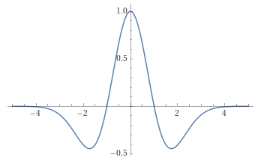

Figure 7 – Graph of wavelet $g_{2}$

For the family of Gaussian wavelets there is a differentiation formula (15):

$$\frac{d}{dx}g_{n}\left(x\right)=-g_{n+1}\left(x\right)(16)$$

There is formula for definite integral (16):

$$\int_{a}^{b}{g_{n}\left(x\right)dx=g_{n}\left(a\right)-g_{n}\left(b\right)(17)}$$

The most important property of Gaussian wavelets is the independence of the relative area $w(x)$ from the wavelet order, which is determined by formula (18) [6]:

$$w\left(x\right)=\frac{\int_{0}^{x}{{|g}_{n}\left(x\right)|dx}}{\int_{0}^{+∞}{{|g}_{n}\left(x\right)|dx}} (18)$$

When using wavelets, the assumption is made that each particle produces a charge distribution with approximately the same value of $σ$.

Applying the wavelet transform to formula (2), we obtain the formula (19):

$$Wf=W_{g_{2}}\left(a, b\right)f=\sum_{i=1}^{n}{A_{i}g_{2}(\frac{b-x_{0i}}{s})}(19)$$

The value of $s$ can be calculated using formula (20), where $a$ is the scale factor:

$$s=\sqrt{a^{2}+σ^{2}} (20)$$

To find the required parameters, the WTS (Wavelet Transform System) method is used for the second-order wavelet.

According to formula (21), the histogram is transformed, where $N$ is the count of histogram bins:

$${Wh= W}_{g_{2}}\left(a,b\right)h=\frac{s^{3}}{\sqrt{2π}σ^{3}}\sum_{n=1}^{N}{h_{n}\int_{x_{n-1}}^{x_{n}}{g_{2}(\frac{b-x}{a})dx}}(21)$$

The values of the transformed function and the histogram can be calculated at a certain set of points $\{b_{i}\}$ and, by equating them, we obtain a system of equations (22):

$$\left\{\begin{aligned}F_{i}=Wf\left(b_{i}\right)-Wh\left(b_{i}\right)=0 \\ i=1,2,…,2n+1\end{aligned}\right.(22)$$

In this case, the number of parameters is $2n + 1$: the amplitude and coordinate of each particle and the scale factor $a$.

The points $b_{i}$ are selected as follows: for each particle, two points (left and right) near the first approximation of the coordinate, the last point is the maximum point of the histogram.

The resulting system of equations can be similarly solved by Newton's method. The Jacobian matrix can be obtained in analytical form.

The scale factor can be written as (23), where w is the relative area of the wavelet:

$$a=\frac{x_{n}-x_{0}}{2}\sqrt{\frac{-1}{2ln⁡(1-w)}} (23)$$

In this program, the value $w=0.5$ was chosen, but in general its choice is quite free.

# 7 Analyses of the obtained results

After implementing the described algorithms, testing was conducted on 5000 sets of simulated data.

Figure 8 shows an example of separation of three particles using the wavelet transform. The initial approximation error was 0.48 strip widths, which was improved to 0.22. Additionally, one hidden particle was detected.

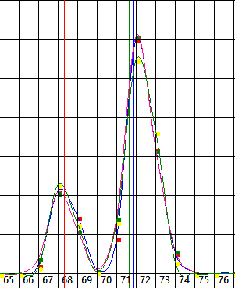

Figure 8 – Successful separation using wavelet-analysis

Figure 9 shows an example of successful determination of particle coordinates by the direct algorithm. The initial approximation gave an error of 0.15 of the strip width, which was improved to 0.05.

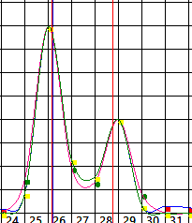

Figure 9 – Successful separation using direct algorithm

Figure 10 shows a case where it was not possible to solve the compiled system of equations. The initial approximation was found with an error of 0.16, and one additional hidden particle was discovered.

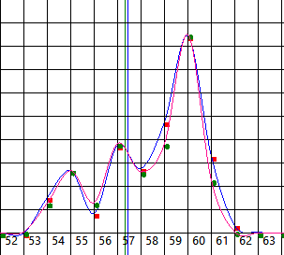

Figure 10 – Failed separation using wavelet-analysis

Unfortunately, it is not always possible to solve the compiled system of equations. For the wavelet transform, the result was obtained for 2360 data sets, for the direct algorithm only for 974.

Table 1 shows a comparison of the results obtained by the standard algorithm, the initial approximation and after improvement using wavelets.

Table 1 – Comparison of standard algorithm and wavelets

|  |  |  |  |
| --- | --- | --- | --- |
|  | Mean error | Variance | Standard deviation |
| Standard | -0.0006 | 0.1100 | 0.3317 |
| First approach | 0.2081 | 1.2864 | 1.1346 |
| Wavelet | 0.1929 | 1.4648 | 1.2103 |

Table 2 shows a comparison of the results obtained by the standard algorithm, the initial approximation, and after improvement using the direct algorithm.

Table 2 – Comparison of standard and direct algorithms

|  |  |  |  |
| --- | --- | --- | --- |
|  | Mean error | Variance | Standard deviation |
| Standard | -0.0002 | 0.0807 | 0.2841 |
| First approach | 0.2318 | 0.2705 | 0.5201 |
| Direct | 0.2289 | 0.2856 | 0.5346 |

From the obtained statistics it is evident that the developed algorithms have a systematic error, the detection of the causes of which and their elimination are a priority task, after which a correct comparison of the results and further refinement is possible.

Conclusion

During my participation in the START program, I studied the operation of the compact muon solenoid of the Large Hadron Collider and analyzed the problem of reconstructing the coordinates of particles in the detector.

Standard and promising algorithms for solving the problem were studied, a prototype of the program was written and the obtained results were analyzed.

Developing a full-fledged program is a labor-intensive process, for which the period of participation in START is not enough. At the moment, a significant part of the work has already been done and the possibility of detecting hidden particles, the detection of which was not carried out before, has been demonstrated.

In the future, it is planned to refine the written program, achieve the required accuracy, evaluate performance, optimize and implement it in the official CMS experiment software package.

References

1. G.L. Bayatian et al. CMS Physics : Technical Design Report Volume 1: Detector Performance and Software / The CMS collaboration - CERN, 2006
2. E.Gatti et al., Optimum geometry for strip cathodes or grids in MWPC for avalanche localization along the anode wires - Nucl. Instr. And Meth. 163(1979)83
3. H. Agakishiev et. al., Nucl. Instr. and Methods, A371 (1996)
4. V.M. Verzhbitsky Fundamentals of Numerical Methods - Higher School, 2002 (in Russian)
5. I. Daubechies Editor, Proc. of Symp. in Appl. Math, V 47, 1993
6. G.A. Ososkov, A.B. Shitov Community of JINR P11-97-347 - Dubna, 1997 (in Russian)

Acknowledgement

The author expresses gratitude to Nikolay Voytishin and Gennadiy Ososkov for their guidance, moral and technical support during the work, as well as for valuable recommendations. I am also grateful to the START team for the opportunity to take part in the program.