

JOINT INSTITUTE FOR NUCLEAR RESEARCH
Flerov Laboratory for Nuclear Reactions

FINAL REPORT ON THE
START PROGRAMME

Modelling of swift heavy ion (SHI) tracks in Ga₂O₃ using Monte-Carlo and molecular dynamics methods

Supervisor:
Dr. Ruslan Rymzhanov

Student:
Sergey Dvinskii, Russia
Far Eastern Federal University

Participation period:
24 August - 18 October,
Summer Session 2024

Dubna, 2024

Abstract

In this study, the SHI effects in Ga₂O₃ were studied using multiscale model¹, which covers several orders of magnitude in time, spanning from attoseconds to picoseconds. SHI impact and electron kinetics in the target were modeled using TREKIS program code², while atomic dynamics and subsequent recrystallization were modeled using LAMMPS³ software. Suitable inter-atomic potential for LAMMPS usage was found and obtained results were compared with experimental data⁴.

Table of contents
Abstract 2
Introduction 4
I. Monte-Carlo model of Ga₂O₃ using TREKIS 5
II. Molecular dynamics of Ga₂O₃ using LAMMPS 8
Conclusion 13
Acknowledgments 14
Contents 15

Introduction

β-Ga₂O₃ is an ultra-wide bandgap semiconductor and as such can be implemented in a variety of high-power and high-voltage devices⁵, with a high potential for space applications. Thus, it is necessary to study radiation damages in this material, spanning all sorts of radiation sources. One of these sources are swift heavy ions (SHIs), which are a part of cosmic rays.
Existing models which are used to describe process of tracks formation, such as inelastic thermal spike (i-TS), despite their simplicity venture beyond their limits of applicability, due to extreme nature of SHI tracks. Thus, it is rational to try different approach – create a model which describes each consecutive stage of the studied process and forms precise initial conditions for a subsequent step.
In this study a multiscale model is used to visualize the damages caused by SHI to a crystal of β-Ga₂O₃.
First, TREKIS code is used to describe the interaction between SHI beam and the targets lattice, including excitement of target’s electron system, transfer of energy from it to the atomic lattice and secondary cascades of ionisation. TREKIS code is a Monte-Carlo (MC) model which is based on dynamical structural factor and complex dielectric function formalisms. To achieve credibility, as MC is a random process, in this study the number of iterations was chosen to be 1000.
Then, LAMMPS software is used to model relaxation of the target. LAMMPS uses results obtained by TREKIS as initial conditions and then uses molecular dynamics (MD) to simulate physical movement of atoms by integrating their motion equations. It is necessary to choose suitable inter-atomic potential for any given material for the correct operation of LAMMPS, so such a model was found and tested.
Lastly, the acquired simulated results for Kr SHI with an energy of 460 MeV are compared with experimental data, obtained by transmission electron microscopy (TEM).

Monte-Carlo model of Ga₂O₃ using TREKIS

In Born approximation scattering cross section of a particle on a system of bound particles can be expressed as a product of cross section of interaction with a free diffuser and dynamical structural factor⁶ $S\left(\vec{q},ω\right)$. Dynamical structural factor is a Fourier-image of pair correlation function, and it considers space-time correlations in a system of diffusers. Also, dynamical structural factor is linked with the complex dielectric function, $ε\left(\vec{q},ω\right)$, and it allows for scattering cross section to be expressed as such:
$$\frac{ⅆ^{2}σ}{d\left(hω\right)ⅆ\left(hq\right)}=\frac{2{\left(Z_{e}\left(v,q\right)ⅇ\right)}^{2}}{n_{sc}πℏ^{2}v^{2}}\frac{1}{hq}\operatorname{Im}\left(\frac{-1}{ε\left(\vec{q},ω\right)}\right),$$
where $\operatorname{Im}\left(\frac{-1}{ε\left(\vec{q},ω\right)}\right)$ is an energy loss function. It is worth noting that for difficult systems, such as gallium oxide, analytical form of both complex dielectric function and loss function is unknown, so they are reconstructed using experimental and calculated data, using such formulas:
$$\operatorname{Im}\left(\frac{-1}{ε\left(\vec{q},ω\right)}\right)=\frac{2nk}{{\left(n^{2}-k^{2}\right)}^{2}+{\left(2nk\right)}^{2}},$$
$$\operatorname{Im}\left(\frac{-1}{ε\left(\vec{q},ω\right)}\right)=\frac{ε_{2}}{{ε_{1}}^{2}+{ε_{2}}^{2}},$$
$$\operatorname{Im}\left(\frac{-1}{ε\left(\vec{q},ω\right)}\right)=\frac{c}{λ_{a}ω}.$$
Analytical form is described as a set of oscillator functions:
$$\operatorname{Im}\left(\frac{-1}{ε\left(\vec{q},ω\right)}\right)=\sum_{i}{\frac{A_{i}γ_{i}ℏω}{{\left(ℏ^{2}ω^{2}-E_{0i}^{2}\right)}^{2}+{\left(γ_{i}ℏω\right)}^{2}}}.$$
Experimental and calculated curve is than approximated by variation of parameters $A_{i}$, $γ_{i}$, $E_{0i}$, where $i$ is a number of electron shell. The result of such a fit is presented in Fig. 1.
The test criterion for the loss function are kk- and f-sum rules:
$\lim_{ℏω_{max}→∞}P_{eff}=1$,
$\lim_{ℏω_{max}→∞}Z_{eff}=N_{e}$,
where $N_{e}$ is a number of electrons⁷. Results are presented in Table 1.
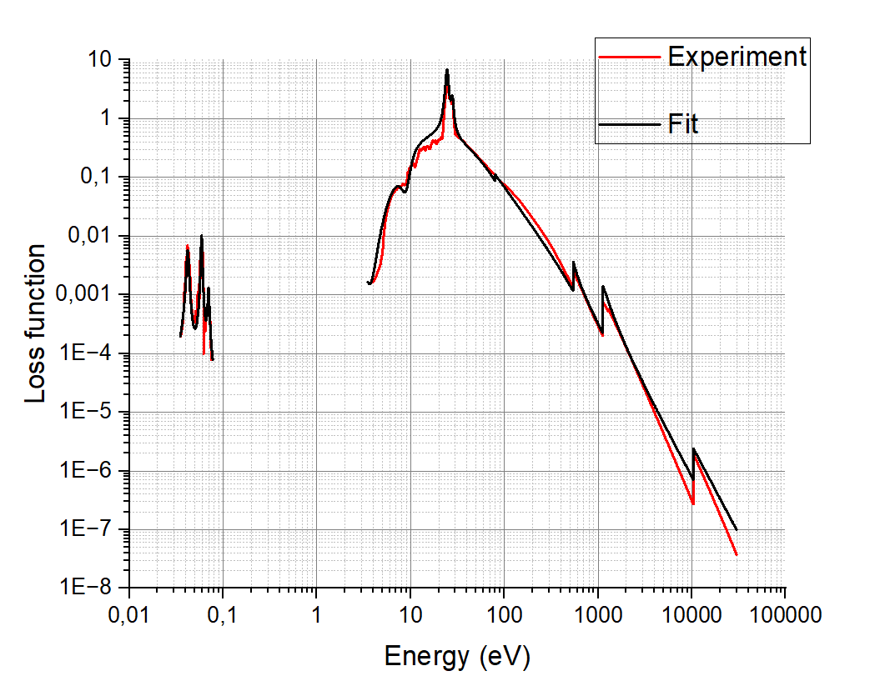
Fig. 1. Experimental and fitted loss function

Scattering on | $$E_{0i}$$ | $$A_{i}$$ | $$γ_{i}$$ | kk-sum | f-sum ($N_{e}$)
Valence band | 46 | 845 | 80 | 1.06727 | 44.1092 (44)
 | 24.5 | 280 | 1.8
 | 28 | 95 | 2.5
 | 5.5 | -2.79 | 7.15
M-shell Ga | 60 | 540 | 282 | 0.01028 | 16.1468 (16)
K-shell O | 415 | 820 | 100 | 0.00028 | 5.9468 (6)
L-shell Ga | 950 | 945 | 510 | 0.00017 | 16.0076 (16)
K-shell Ga | 1465 | 1178 | 1600 | 0 | 4.0087 (4)
Phonons | 4.2E-2 | 6.02E-4 | 2.5E-3 | 0.000704 | --
 | 5.9E-2 | 1.2E-3 | 2E-3
 | 7E-2 | 2.51E-4 | 3E-3
Total: |  |  |  | 1.078704 (1) | 86.2911 (86)
Table 1. Fit parameters and sum rules
As a testament to obtained in TREKIS results, energy losses for the SHI were compared to SRIM⁸ calculations for Xe, Kr and Ne ions. Results agree quite well with the Bragg peak varying for a maximum of 20% and are presented in Fig. 2.
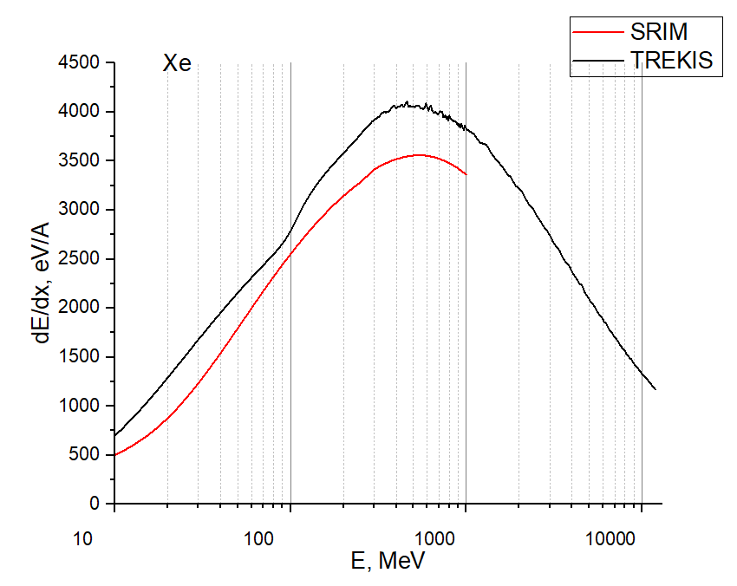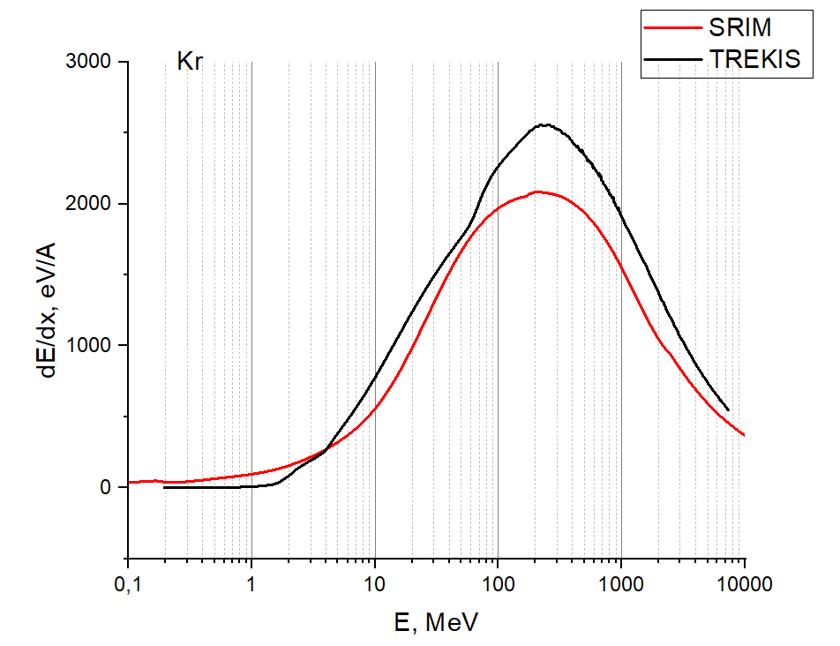
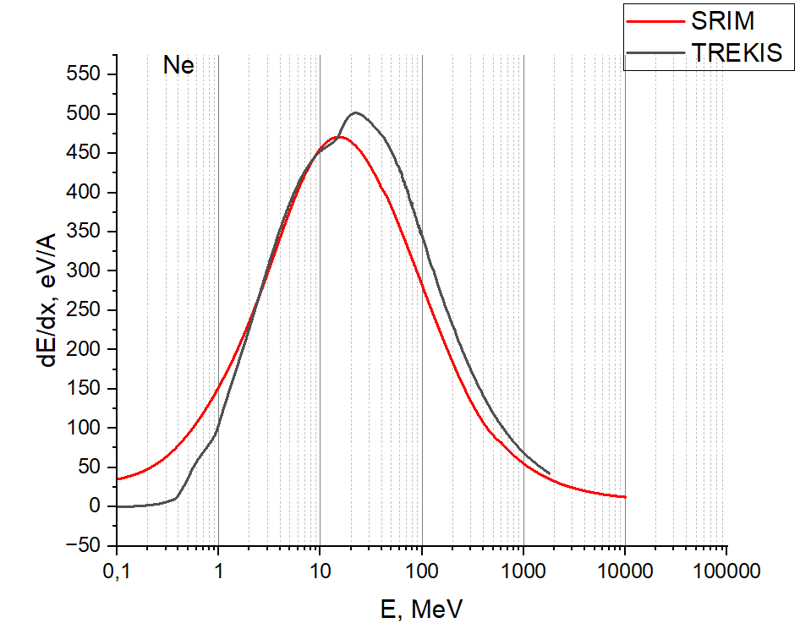
Fig. 2. Ion loss in TREKIS and SRIM

The end product of TREKIS for this study were radial energy density distributions in lattice for Xe on 160 MeV and Kr on 460 MeV which are presented in Fig. 3.
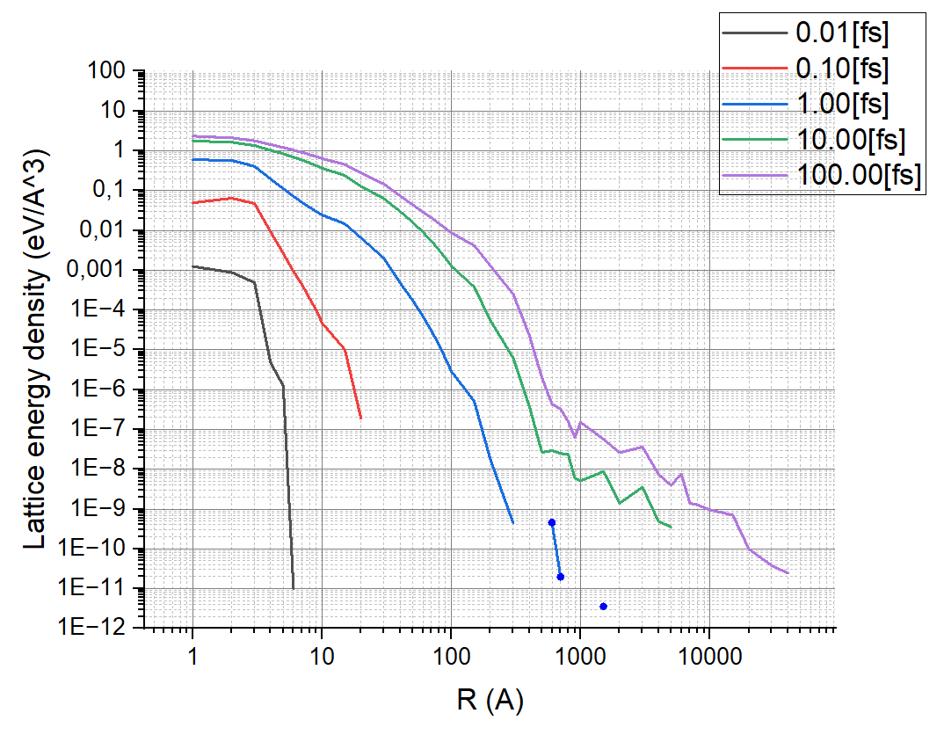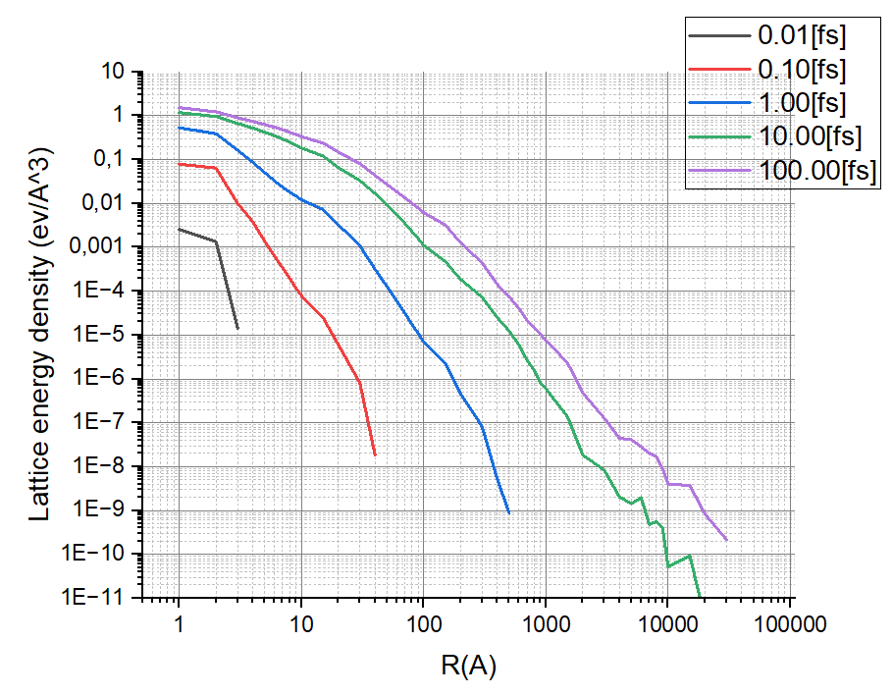
Fig. 3. Energy distributions for Xe (left) and Kr (right)

Molecular dynamics of Ga₂O₃ using LAMMPS

As was discussed previously, LAMMPS uses TREKIS’s output, namely obtained in part I radial energy density distributions, as its input, and then via integrating motion equations simulates evolution of our system through time.
In order to begin molecular dynamics calculations, it is necessary to define a structural cell. Cell geometry of β-Ga₂O₃ was taken from Materials Project⁹ website and is presented in Fig. 4. Ga atoms are denoted as green while O as red.
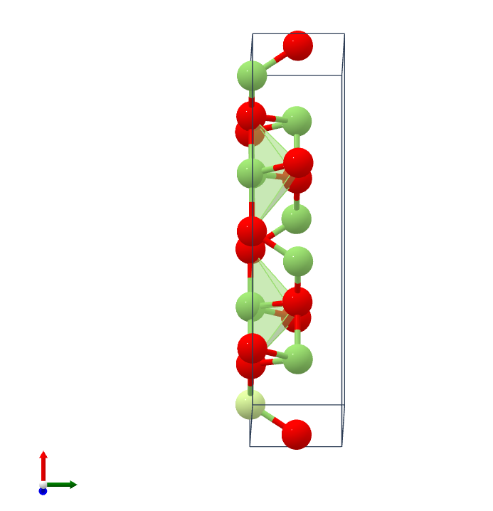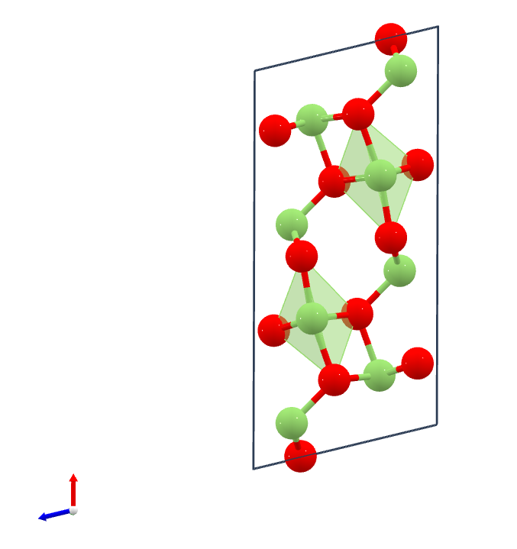
Fig. 4. Cell of β-Ga₂O₃

Buckingham potential described in A. Petkov et al.¹⁰ was chosen as an inter-atomic potential in this work, as it is commonly used to simulate thermal processes in oxides. This potential in its general form is expressed as:
$$E=Aexp\left(-\frac{r}{ρ}\right)-\frac{C}{r^{6}},$$
where r is distance between particles (up to a cutoff distance, 16 Å), $ρ$ is an ionic-pair dependent length parameter, A and C are interaction strength parameters. In later calculations, this potential was modified by adding the Ziegler-Biersack-Littmark (ZBL)⁸ screened nuclear repulsion which is used to describe high-energy collisions between atoms. It is implemented as a switching function which ramps the force, energy and curvature between an inner and outer cutoff (0.7 and 0.9 Å respectively). Its other arguments are nuclear charges of atoms, in our case 31 for Ga and 8 for O.
The melting of a crystal, consisting of 740 periodical atoms, as well as of an infinite thin film with a thickness of 30 Å were performed in LAMMPS to test chosen potential. Heating was simulated to 6000 K. Melting temperature was defined by computing dislocations of atoms relative to their equilibrium positions, with consecutive averaging over the number of atoms. The experimental value for a melting point of Ga₂O₃ is 2173 K while obtained are ~2600 K for a film and ~3000 K for a bulk. The difference in values is 16% for a film and about 28% for a bulk, which is plausible. The results are presented in Fig. 5.
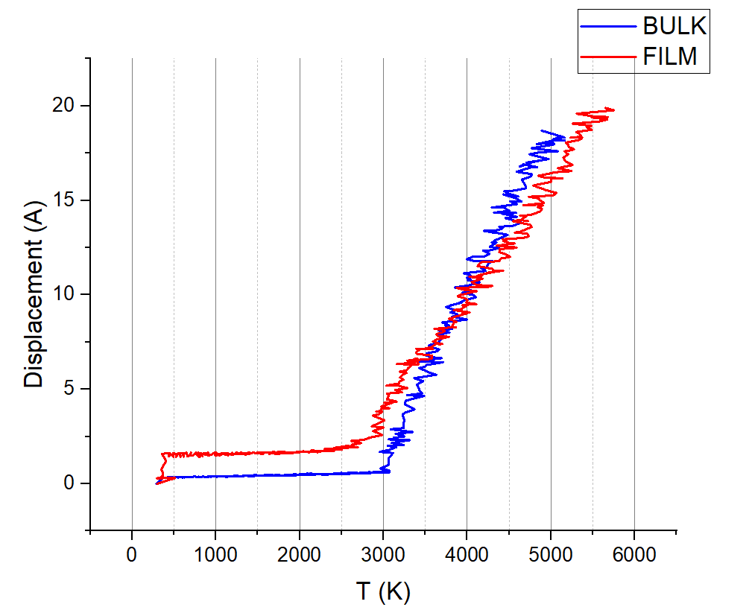
Fig. 5. Atom displacement in β-Ga₂O₃

Another criterion of testing was comparison of calculated and experimental elastic constants, and some of them are presented in Table 2. Experimental data was taken from K. Adachi et al¹¹.
Constant | Calculation, GPa | Experiment, GPa | Difference, %
C₁₁ | 260.3 | 242.8 ± 2.9 | 7
C₂₂ | 399.4 | 343.8 ± 3.8 | 14
C₃₃ | 411.4 | 347.4 ± 2.5 | 16
C₄₄ | 58.3 | 47.8 ± 0.2 | 18
C₅₅ | 82.2 | 88.6 ± 0.5 | 7
C₆₆ | 95.8 | 104 ± 0.5 | 9
C₁₂ | 123.2 | 128 ± 0.1 | 4
C₁₃ | 168.6 | 160 ± 1.5 | 5
C₂₃ | 96.1 | 70.9 ± 2.1 | 26
Table 1. Fit parameters and sum rules
Functionality check of multiscale model was performed by simulating formation of a track caused by SHI Xe with an energy 160 MeV in LAMMPS. Simulation target was a supercell consisting of 840000 atoms of Ga₂O₃, with initial velocity distributions obtained from TREKIS. This distribution is presented in Fig. 6. Heatmap indicates higher initial velocities of atoms near the centre of the track.
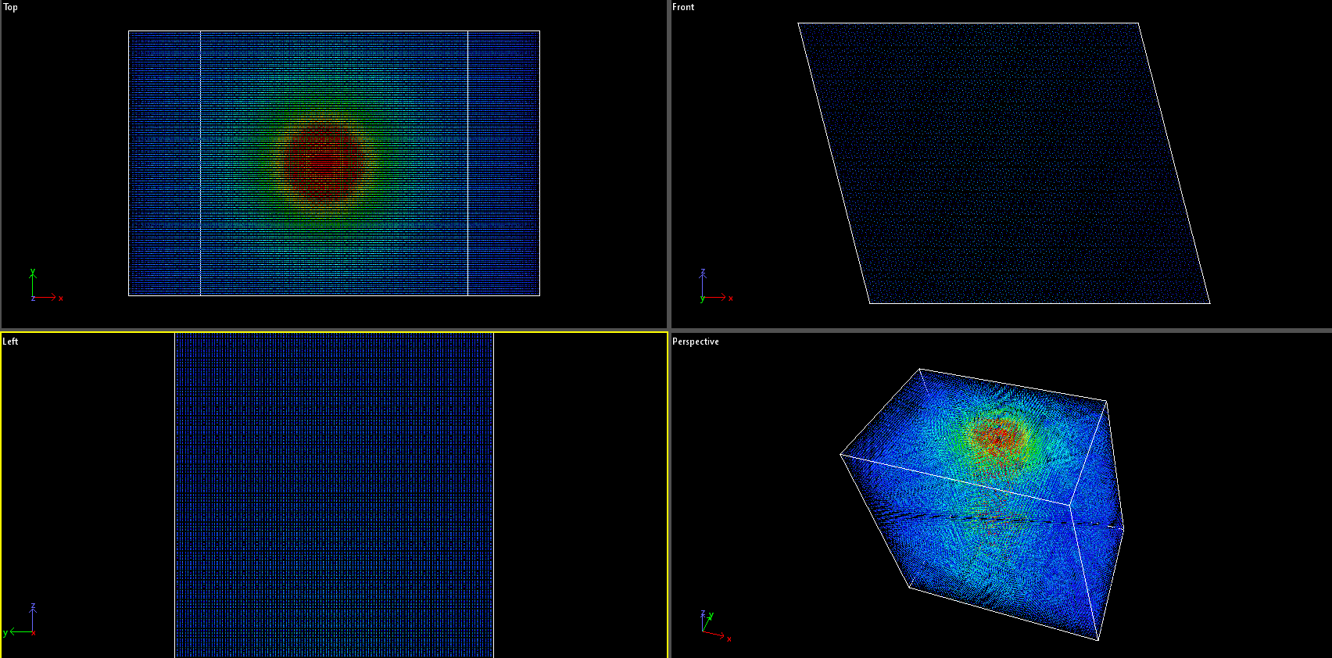
Fig. 6. Initial velocity distribution

During the initial energy deposition, the crystal structure in the centre is deformed and it can be seen at 1 ps timeframe in Fig. 7.
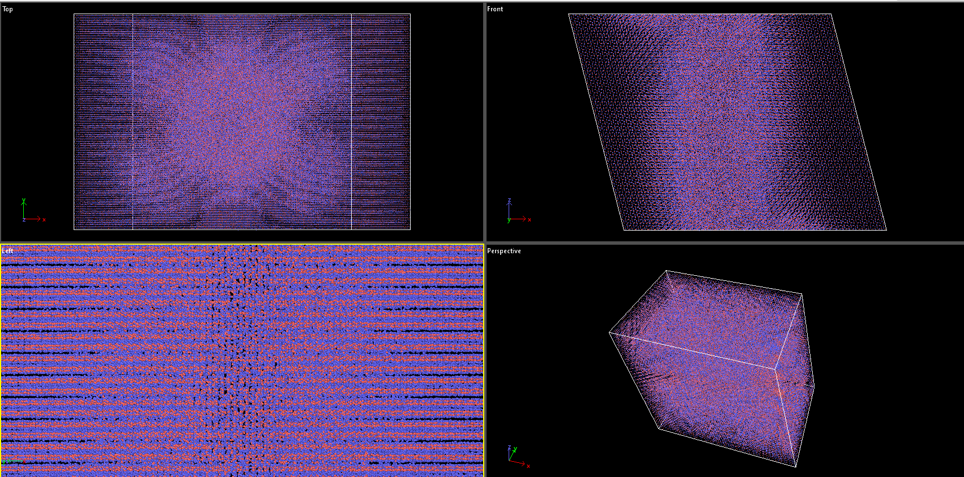
Fig. 7. Target at 1 ps

The resulting track, after it cooled down to the room temperature after 80 ps, is presented in Fig. 8. The melted centre is substantially smaller, with large parts of the target successfully recrystallised.
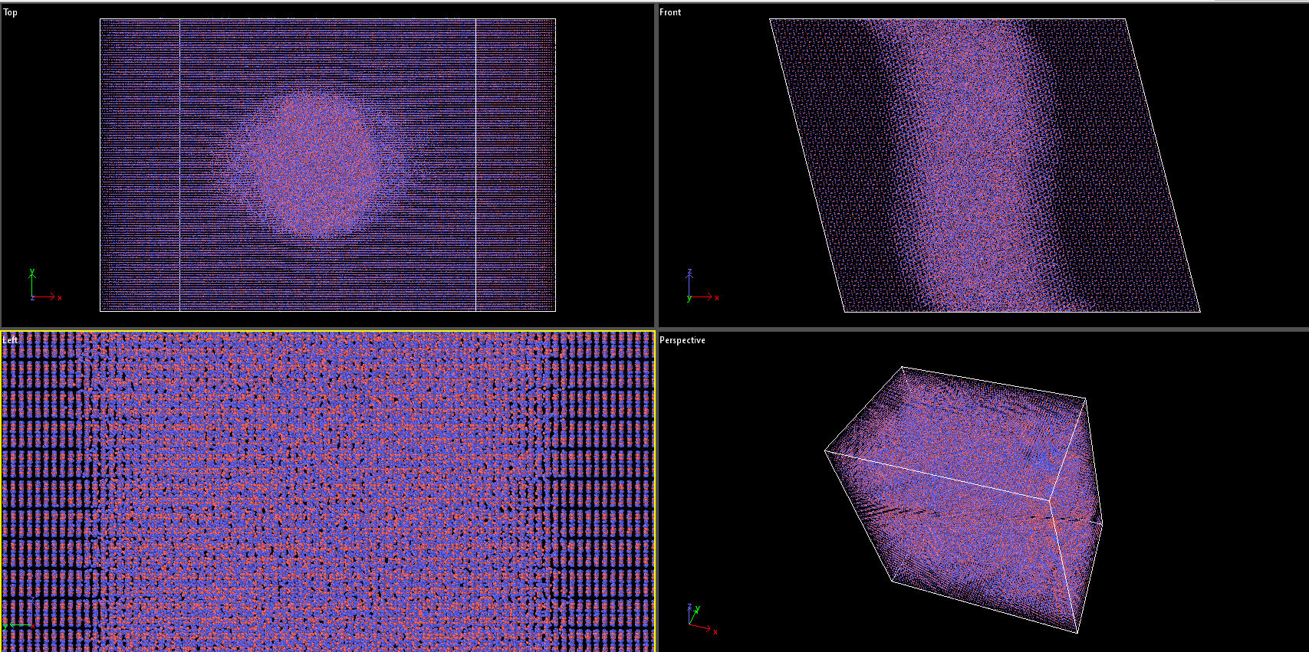
Fig. 8. Target at 80 ps

It is worth noting that without integrating ZBL part in Buckingham potential, the energy of the system quickly becomes too large, due to non-physicaly close distance between atoms. So, ZBL is added to negate this effect by introducing additional repulsion on sub-angstrom lengths.
To measure how well our model corresponds to real experimental data, the results of transmission electron microscopy (TEM) of a single β-Ga₂O₃ crystal by Kr ion with an energy of 460 MeV⁴. The TEM image can be seen in Fig. 9.
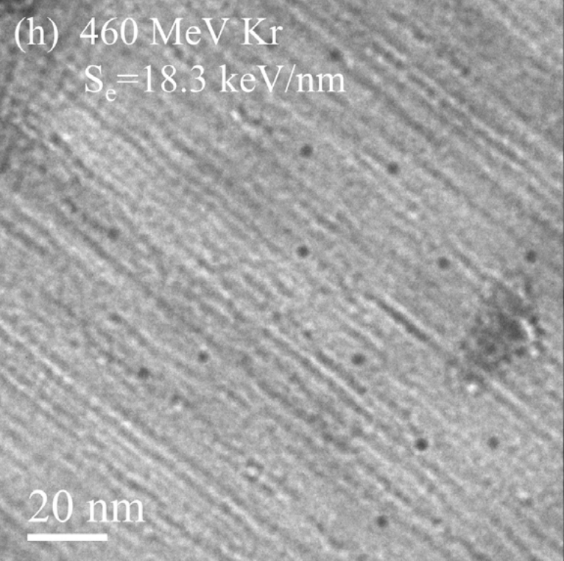
Fig. 9. TEM image of irradiated Ga₂O₃
Thus, the experimental diameter of ion track is measured to be 2.2±0.4 nm.
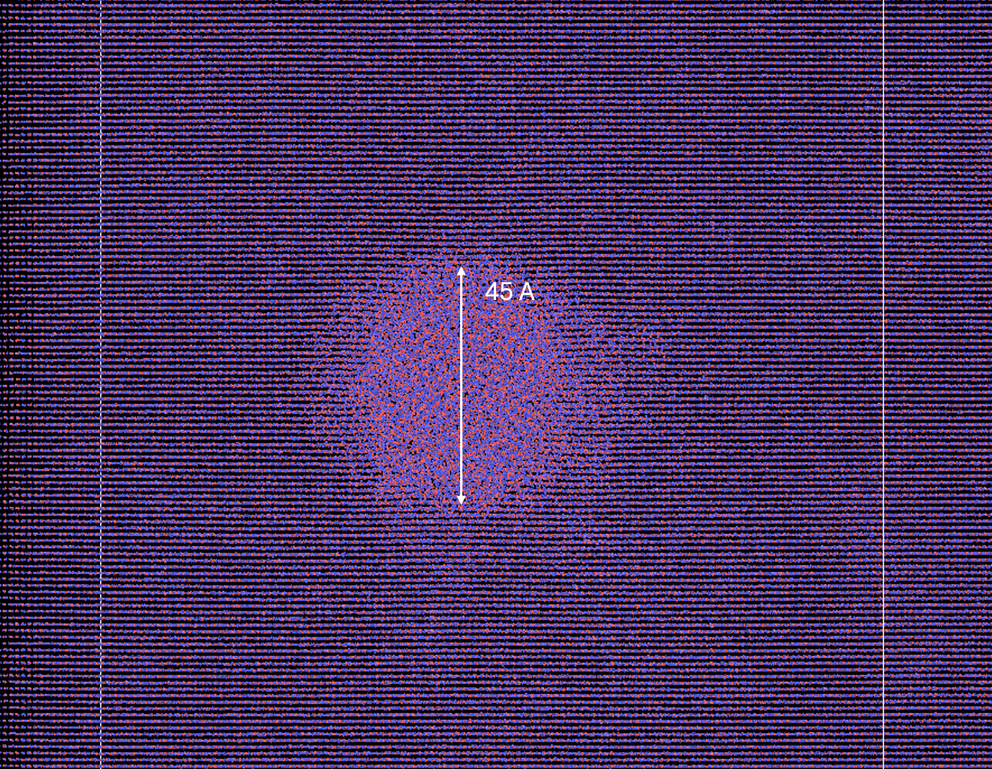
Fig. 10. Simulated target at 10 ps

Obtained result is 45 Å and is with good agreement with experimental data, thus proving credibility of the multiscale model used in this study.

Conclusion

In this study multiscale model was used to simulate track formation due to SHI irradiation in β-Ga₂O₃. TREKIS and LAMMPS software were used in conjunction to provide results which have a good correlation with experimental data. Energy loss function was reconstructed for TREKIS use and Buckingham potential with ZBL addition was tested for studied material. Various comparisons with different experiments and widely used tools were made to validate simulations.
Overall acceptable results enable further studies, particularly simulating SHI effects in metal-oxide-semiconductor field-effect transistors (MOSFET) made from Ga₂O₃, due to their high potential for space applications.

Acknowledgments

I would like to thank Dr. R. Rymzhanov and Dr. A.E. Volkov for their patience and guidance as well as their valuable time devoted to this project. I appreciated an opportunity to learn and improve my skills as a scientist, while also feeling what it’s like to be a part of a working process in a cutting-edge scientific organization. Also, I would like to express my gratitude to JINR as a whole and administration and staff of START program in particular.

Contents

1. Medvedev, N. et al. Frontiers, challenges, and solutions in modeling of swift heavy ion effects in materials. J. Appl. Phys. 133, (2023).
2. Medvedev, N. A., Rymzhanov, R. A. & Volkov, A. E. Time-resolved electron kinetics in swift heavy ion irradiated solids. J. Phys. D. Appl. Phys. 48, (2015).
3. Plimpton, S. Fast parallel algorithms for short-range molecular dynamics. J. Comput. Phys. 117, 1–19 (1995).
4. Ai, W. et al. Radiation damage in β-Ga2O3 induced by swift heavy ions. Jpn. J. Appl. Phys. 58, (2019).
5. Xia, Z. et al. β-Ga2O3 delta-doped field-effect transistors with current gain cutoff frequency of 27 GHz. IEEE Electron Device Lett. 40, 1052–1055 (2019).
6. Van Hove, L. Correlations in Space and Time and Born Approximation Scattering in Systems of Interacting Particles. Phys. Rev. 95, 249 (1954).
7. Akkerman, A. et al. Inelastic electron interactions in the energy range 50 eV to 10 keV in insulators: Alkali halides and metal oxides. Phys. Status Solidi B-Basic Res. 198, 769–784 (1996).
8. Ziegler, J. F. & Biersack, J. P. The Stopping and Range of Ions in Matter. Treatise Heavy-Ion Sci. 93–129 (1985) doi:10.1007/978-1-4615-8103-1_3.
9. Jain, A. et al. Commentary: The materials project: A materials genome approach to accelerating materials innovation. APL Mater. 1, 11002 (2013).
10. Petkov, A., Mishra, A., Pomeroy, J. W. & Kuball, M. Molecular dynamics study of thermal transport across Ga2O3-diamond interfaces. Appl. Phys. Lett. 122, (2023).
11. Adachi, K. et al. Unusual elasticity of monoclinic β-Ga2O3. J. Appl. Phys. 124, 85102 (2018).

