

JOINT INSTITUTE FOR NUCLEAR RESEARCH

Frank Laboratory of Neutron Physics (FLNP)

Raman Spectroscopy Sector

**FINAL REPORT ON THE**

**START PROGRAMME**

*DFT calculation of Raman spectra for MoS2/SiO2 system*

**Supervisor:**

Dr. Grigory Arzumanyan

**Student:**

Zubkov Lev, Russia  
Research Nuclear University MEPhI (Moscow Engineering Physics Institute)

**Participation period:**

September 15 – October 26,

Summer Session 2024

**Dubna, 2024**

# **ABSTRACT**

MoS₂, a two-dimensional transition metal dichalcogenide, exhibits excellent electronic and optical properties, making it a promising candidate for electronic and photonic devices. MoS2 monolayer is a van der Waals material, but when it grown on a substrate it can create chemical bonds between the monolayer and the substrate.

This study attempts to predict the formation of covalent bonds between sulfur and oxygen atoms in MoS2 monolayers grown by chemical vapor deposition on a SiO2 substrate. The research uses Density Functional Theory to investigate the structure, confirming the potential existence of such bonds through *ab initio* calculation. Additionally, the Raman spectrum of this structure is calculated. It is envisaged that these bonds can be experimentally identified using Raman scattering with a focus on the spectral range of 1000–1200 cm-1.

**CONTENTS**

1. INTRODUCTION 4

1.1 Background 4

1.2 Main problem 4

1.3 Findings 4

2. THEORETICAL BACKGROUND 6

2.1 Density Functional Theory 6

2.2 Computational Details 7

3. RESULT AND DISCUSSION 9

3.1 Relaxed structure 9

3.2 Calculated Raman spectrum 10

CONCLUSION 13

REFERENCES 14

ACKNOWLEDGEMENTS 16

# **1. INTRODUCTION**

## **1.1 Background**

MoS2 is a transition metal dichalcogenides are layered materials with weak van der Waals forces between layers and strong covalent bonds between atoms within the layers. This structure enables the creation of low-dimensional electronic devices with unique electronic and optical properties [1]. This material are semiconductors with a bandgap 1,8 eV in its two-dimensional form. Another reason for the popularity of two-dimensional MoS2 is the direct bandgap they exhibit, unlike their bulk crystal form, which has an indirect bandgap [2]. Devices based on Si–MoS2 are also used in highly sensitive photodetectors with low Noise Equivalent Power [3].

## **1.2 Main problem**

Two-dimensional materials are often highly susceptible to the influence of the substrate [4], which can deform them and alter their electronic properties, such as electron mobility and bandgap width. For example, in MoS2/SiO2 structures, strong adhesion is observed, which is associated with the interaction between the positive charge of sulfur and the negative oxygen ion [5].

The presence of chemical bonds between MoS2 and the substrate leads to changes in its electronic structure, potentially transforming it from a direct bandgap semiconductor to an indirect bandgap semiconductor [2].

## **1.3 Findings**

The modeling of a monolayer on the SiO2 surface assumes that the MoS2 layer is held in place by van der Waals forces. The authors of [6] model this exact system; however, the model does not match experimental data. Therefore, it is hypothesized that during chemical vapor deposition (CVD) growth, bonds form between the oxygen atoms in the substrate and the sulfur atoms in MoS2 [7].

Theoretical calculations conducted in this work are primarily aimed at explaining experimental results obtained in the laboratory. The samples studied in the laboratory consist of a monolayer of MoS2 grown on an SiO2 substrate via CVD. These samples were further analyzed by Raman spectroscopy (figure 1). The formation of sulfur-oxygen bonds could be the cause of these peaks [7], to predict it bond vibrations, DFT calculations were performed.

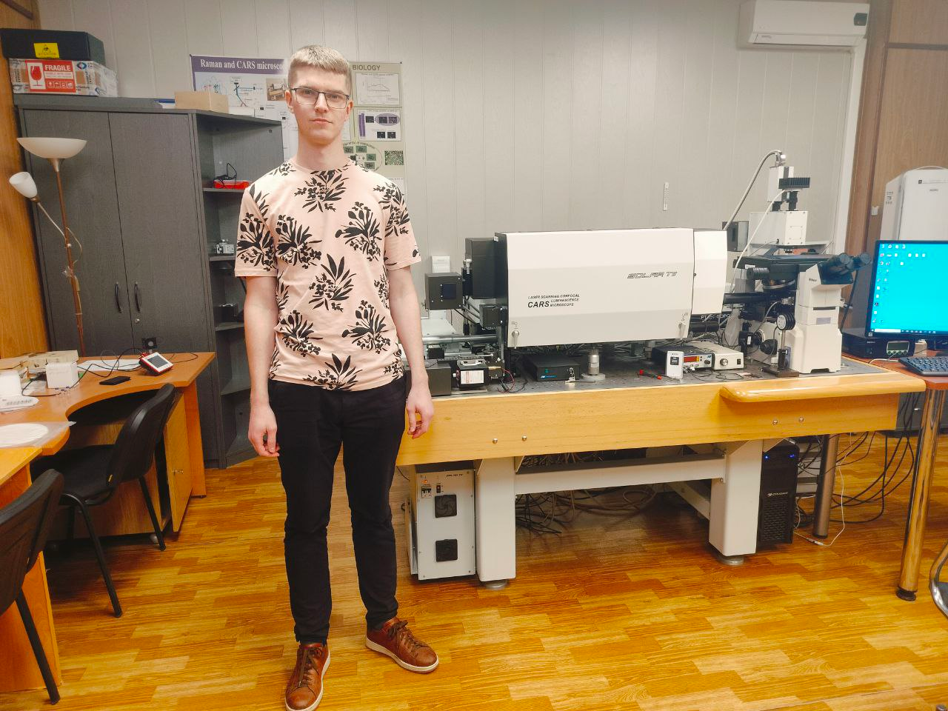

Figure 1 – Me and the Coherent anti-Stokes Raman spectrometer in the laboratory.

# **2. THEORETICAL BACKGROUND**

## **2.1 Density Functional Theory**

Theoretical calculation of Raman spectra was complete through Density Functional Theory (DFT) and Density Functional Perturbation Theory (DFPT). According to the Hohenberg-Kohn theorems, the ground state of a many-electron system is determined solely by the electron density, which depends on three spatial coordinates. The ground-state energy is then the minimum of the energy functional:

$$\begin{aligned}E\left[ρ\right]=T\left[ρ\right]+V_{ext}\left[ρ\right]+J\left[ρ\right]+E_{xc}\left[ρ\right]\#\left(1\right)\end{aligned}$$

where $T\left[ρ\right]$ is the kinetic energy of non-interacting electrons, $V_{ext}\left[ρ\right]$ is the energy of interaction with the external nuclear potential, $J\left[ρ\right]$ is the Coulomb energy of electron-electron interaction and $E_{xc}\left[ρ\right]$ is the exchange-correlation functional [8].

The exchange-correlation functional describes the interactions between electrons. Due to the complexity of its analytical form, it is usually approximated using various methods. The main approximations are [9]:

* LDA (Local Density Approximation): the functional depends only on the local electron density:
$$\begin{aligned}E_{XC}^{LDA}\left[ρ\right]=\int{dr^{3}f\left(ρ\left(r\right)\right)}\#\left(2\right)\end{aligned}$$

* GGA (Generalized Gradient Approximation): the functional also takes into account the gradient of the electron density $∇ρ\left(r\right).$

$$\begin{aligned}E_{XC}^{GGA}\left[ρ\right]=\int{dr^{3}f\left(ρ\left(r\right), ∇ρ\left(r\right)\right)} \#\left(3\right)\end{aligned}$$

To describe the electron density, the Kohn-Sham formalism is used. This allows the Schrödinger equation to be reduced to a single-particle form:

$$\begin{aligned}\left(-\frac{ℏ^{2}}{2m}∇^{2}+V_{eff}\left(r\right)\right)ψ_{i}\left(r\right)=ϵ_{i}ψ_{i}\left(r\right),\#\left(4\right)\end{aligned}$$

where $ψ_{i}\left(r\right)$ is the wavefunction of the *i*-th orbital, $V_{eff}\left(r\right)$ is the effective external potential. The electron density is then given by:

$$\begin{aligned}n\left(r\right)=\sum_{i}^{N}{{\left|ψ_{i}\left(r\right)\right|}^{2}}.\#\left(5\right)\end{aligned}$$

The DFPT method [9] is used to calculate phonon spectra. It assumes small perturbations are introduced into the system, and the system's reaction is observed - dynamic or dielectric. Through this calculation, properties such as the Raman spectrum, IR spectrum, and others can be calculations.

## **2.2 Computational Details**

Non-resonant Raman spectra calculations for the MoS2/SiO2 structure were performed at the Γ-point in reciprocal space. The Quantum Espresso software package was used for these first-principles calculations [10] , which includes a built-in function for Raman spectrum analysis.

For the optimization of the entire structure and calculations, the norm-conserving pseudopotential method and the LDA exchange-correlation functional were used. The LDA functional typically underestimates bond lengths [11], , which leads to deviations from experimental data. Theoretical limitations do not allow the use of another exchange-correlation functional for Raman spectrum calculations. The structures were optimized using the Broyden-Fletcher-Goldfarb-Shanno (BFGS) algorithm, with an energy convergence threshold set to 10-7 Ry/atom and forces set to 10-6 Ry/Å. A 4×4×1 k-point mesh was used for both the optimization and self-consistent calculations. The energy cutoff for wave functions was set at 60 eV, for the wavefunction at 240 eV, and the self-consistent calculation convergence threshold was 10-8 Ry. Additionally, 20 Å of vacuum was added along the z-axis above the MoS2 monolayer to account for the monolayer-only structure. In the SiO2 structure, oxygen atoms with dangling bonds in the lower layer were passivated with hydrogen atoms. This pseudo-hydrogen passivation improves the accuracy of the calculations and accelerates convergence [12].

The Raman spectrum represents the vibrational spectrum corresponding to characteristic phonon modes. For fitting the calculated frequencies of the Raman spectrum, a Gaussian function was used [13]:

$$I\left(ω\right)=I_{0}exp\left[-{\left(\frac{ω-ω_{0}}{Г}\right)}^{2}\right]$$

where $I_{0}$ is the intensity with of the maximum the frequency $ω_{0}$, Г is the full width at half maximum (FWHM). This parameter can be found from the experiment and has a different value for each characteristic frequency, and can also depend on the thickness of the layer of the sample under study [14].

# **3. RESULT AND DISCUSSION**

## **3.1 Relaxed structure**

SiO2 was used as the substrate for MoS2. Under normal conditions, crystalline SiO2 takes the form of α-quartz. Its unit cell is shown in figure 2a. The structure relaxation was performed using DFT. As a result of the bulk structure relaxation, it was found that the lattice parameter is *a*=*b*=4,844 Å. The structure of the MoS2 monolayer is shown in figure 2b, with a lattice parameter of *a*=*b*=3,091 Å.

|  |  |
| --- | --- |
| **O**  **Si** | **S**  **S**  **Mo** |
|  |  |
| a) | b) |

Figure 2 – Relaxed cell of a) α- SiO2 and b) MoS2.

To create a composite based on MoS2and SiO2, a supercell was constructed with dimensions of 3x3 for MoS2 and 2x2 for SiO2 (figure 3). A vacuum layer of 15 Å was added on top. The lower surface of the SiO2 was passivated with pseudo-hydrogen. As a result of the relaxation process, the MoS2 film adhered to the surface of the SiO2, forming S-O bonds. In these bonds, the oxygen atom is positioned beneath sulfur, which is consistent with the findings of [2]. The formation of such bonds caused slight deformation of the MoS2 film, leading to a disruption of the lattice symmetry. The lattice parameters of the relaxed cell were *a* = 9.22573 Å, *b* = 9.23201 Å. The lengths of the S-O bonds ranged from 1.519 Å to 1.574 Å.

|  |  |
| --- | --- |
|  |  |
|  |  |

Figure 3 – Relaxed MoS2/α- SiO2. Yellow – S, purple – Mo, red – O, blue – Si, white – H.

## **3.2 Calculated Raman spectrum**

DFPT is used to calculate the non-resonant Raman scattering spectrum. To do this, the phonon spectrum is computed at the Gamma point. Figure 4 shows the phonon spectrum of bulk α-SiO2. This spectrum is typical of Raman scattering, similar to that presented in other works [15]. In the range of 1000-1200 cm-1, scattering peaks are observed, which are associated with SiO4 tetrahedra(α-SiO2 is made up of many layers of these tetrahedrons, like on figure 3) [15].

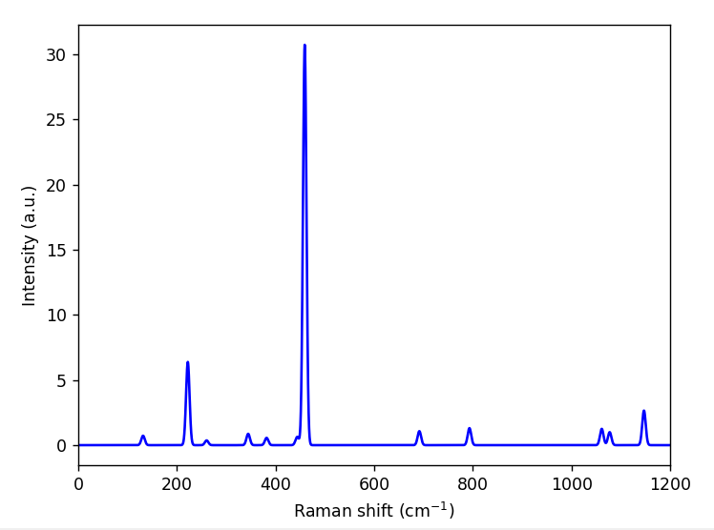

Figure 4 – Raman spectrum of -SiO2.

The Raman scattering spectra for the MoS2/SiO2 structure are shown in figures 5(a, b). Figure 5a depicts the region primarily associated with vibrations in the MoS2 monolayer. A peak from the substrate is observed around 500 cm-1, while the range of 375–405 cm-1 corresponds to the vibrational modes in MoS₂ - E2g and A1g. Figure 5b shows the spectrum in the shift range of 1100–1300 cm-1. The presence of peaks in this spectrum is linked to two processes: vibrations of SiO4 octahedra and S-O bonds. These vibrations occur in a single plane and are illustrated in figure 6. The "comb" of peaks observed in the Raman scattering spectra in figures 5(a,b) is related to the supercell size and the number of Si layers along the z-axis [15].

|  |  |
| --- | --- |
| a) | b)  SiO2  SiO2 + S-O bond |

Figure 5 – Raman spectra of MoS2/SiO2 a)300-500 cm-1 b) 1100-1300 cm-1.

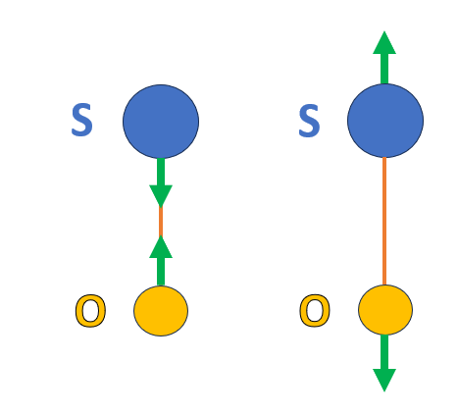

Figure 6 – Vibrational mode of S-O bond.

# **CONCLUSION**

The study investigates the influence of the substrate on a monolayer of MoS2 grown on SiO2. It was determined that the MoS₂ monolayer can bond to the substrate through the formation of sulfur-oxygen bonds. These bonds form when oxygen atoms are positioned directly beneath sulfur atoms at a distance of up 1.5 to 1.6 Å. The formation of these bonds leads to the appearance of peaks in the Raman scattering spectrum in the range of 1100-1200 cm-1. However, precise identification of the presence or absence of these bonds in experiments is not possible because scattering peaks from the substrate are also observed in this region (as vibrations of SO4 octahedra occur in the same range).

Additionally, there is a problem with matching the spectra of the SiO2 substrate to the theoretical predictions. The discrepancies may arise for several reasons:

1. The structure of the measured substrate differs significantly from the calculated - SiO2,
2. The calculations do not account for laser polarization, which has a significant impact on the measurement results.

This problem creates difficulties in interpreting the theoretical results and compared to the experimental data.

As a further development, it is necessary to focus on the study of the substrate used in the growth of monolayers. There is already an assumption about the formation of a bond between the substrate and MoS2, so this study is useful in the synthesis of films.

# **REFERENCES**

1. Krishnan U. et al. A synoptic review of MoS2: Synthesis to applications // Superlattices and Microstructures. 2019. Vol. 128. P. 274–297.

2. Sung H.-J., Choe D.-H., Chang K.J. The effects of surface polarity and dangling bonds on the electronic properties of monolayer and bilayer MoS 2 on *α* -quartz // New J. Phys. 2014. Vol. 16, № 11. P. 113055.

3. Shin G.H. et al. Si–MoS 2 Vertical Heterojunction for a Photodetector with High Responsivity and Low Noise Equivalent Power // ACS Appl. Mater. Interfaces. 2019. Vol. 11, № 7. P. 7626–7634.

4. Deng S. et al. Adhesion Energy of MoS 2 Thin Films on Silicon-Based Substrates Determined via the Attributes of a Single MoS 2 Wrinkle // ACS Appl. Mater. Interfaces. 2017. Vol. 9, № 8. P. 7812–7818.

5. Torres J. et al. Adhesion Energies of 2D Graphene and MoS 2 to Silicon and Metal Substrates // Physica Status Solidi (a). 2018. Vol. 215, № 1. P. 1700512.

6. Sohn W. et al. Microscopic evidence of strong interactions between chemical vapor deposited 2D MoS2 film and SiO2 growth template // Nano Convergence. 2021. Vol. 8, № 1. P. 11.

7. Sohn W. et al. Microscopic evidence of strong interactions between chemical vapor deposited 2D MoS2 film and SiO2 growth template // Nano Convergence. 2021. Vol. 8, № 1. P. 11.

8. Jacob C.R., Neugebauer J. Subsystem density‐functional theory // WIREs Comput Mol Sci. 2014. Vol. 4, № 4. P. 325–362.

9. Baroni S. et al. Phonons and related crystal properties from density-functional perturbation theory // Rev. Mod. Phys. 2001. Vol. 73, № 2. P. 515–562.

10. Giannozzi P. et al. QUANTUM ESPRESSO: a modular and open-source software project for quantum simulations of materials // J. Phys.: Condens. Matter. 2009. Vol. 21, № 39. P. 395502.

11. Guerrero E., Strubbe D.A. Structure, Thermodynamics, and Raman Spectroscopy of Rhenium-Doped Bulk MoS 2 from First Principles // J. Phys. Chem. C. 2022. Vol. 126, № 43. P. 18393–18403.

12. Sznajder M. DFT-based modelling of carbon adsorption on the AlN surfaces and influence of point defects on the stability of diamond/AlN interfaces // Diamond and Related Materials. 2020. Vol. 103. P. 107694.

13. Tai F.C. et al. Multipeak fitting analysis of Raman spectra on DLCH film // J Raman Spectroscopy. 2009. Vol. 40, № 8. P. 1055–1059.

14. Chakraborty B. et al. Layer‐dependent resonant Raman scattering of a few layer MoS 2 // J Raman Spectroscopy. 2013. Vol. 44, № 1. P. 92–96.

15. Smirnov M. et al. Density-Functional Study of the Si/SiO2 Interfaces in Short-Period Superlattices: Vibrational States and Raman Spectra // Photonics. 2023. Vol. 10, № 8. P. 902.

# **ACKNOWLEDGEMENTS**

I truly grateful my gratitude and best wishes to my supervisor, Dr. Grigory Arzumanyan, for introducing me to the subject, as well as for his continuous monitoring and support throughout the entire Summer Student Program. I would also like to thank Tri Pham, Khlood Ahmed Ali. Victoria Vartic and the rest of the team for their valuable help, guidance, and advice during various stages of the project. Thanks to their support, I was able to successfully complete my internship. I am also grateful for the excellent working atmosphere in the laboratory.

Finally, I want to thank the Joint Institute for Nuclear Research for the opportunity to visit their institute and work on a real problem as part of a scientific group. I am especially grateful for the financial and organizational assistance provided.