JOINT INSTITUTE FOR NUCLEAR RESEARCH
THE FRANK LABARATORY OF NEUTRON PHYSICS

FINAL REPORT ON THE
START PROGRAMME

Peculiarities of Disulfide Molybdenum (MoS₂) Raman Spectra

Supervisor:
Grigory Arzumanyan,
Head, Department of Raman spectroscopy, Frank Laboratory of Neutron physics, JINR, Dubna, Russia

Student:
Mukimboev Firdavs, Uzbekistan
Student of National University of Uzbekistan

Participation period:
February 11 – March 23,
START Winter Session 2024

Dubna 2024
Table of Contents
- Abstract……………………………………………………………………..3
- Introduction………………………………………………………………...4
- Materials and methods……………………………………………………..6
  - Raman spectroscopy……………………………………………………6
  - Samples, molybdenum disulfide (MoS₂) ………………………………8
  - The practical part……………………………………………………..11
- Conclusion…………………………………………………………………15
- Literature………………………………………………………………….16

- ABSTRACT
During the internship practice, the acquaintance with special scientific literature on low-dimensional materials such as molybdenum disulfide, in particular, took place. The technique of working on a modern Raman spectrometer was mastered, as well as measuring and processing Raman and photoluminescence spectra of samples of single and few-monolayer-thick molybdenum disulfide MoS₂, which belongs to a new emerging class of materials: 2-dimensional semiconductors. The interest in the 2-dimensional materials is fueled by the search for alternatives to graphene, which is hardly suitable for electronic devices because of the lack of a band gap. A unique combination of physical properties, including flexibility, high electron mobility, and optical transparency combined with a large band gap tunable from indirect 1.2 eV for bulk to direct 1.9 eV for a monolayer, makes MoS₂ attractive for a variety of electronic and optoelectronic devices. In this study, a large number of MoS₂ Raman spectra with high spectral resolution have been obtained and processed. This made it possible to identify monolayer and few-layer samples of this semiconductor and, thereby, determine some of its characteristic features.

INTRODUCTION
The interest in 2-dimensional (2D) semiconductors is to a large extent fueled by the highly successful miniaturization of Si-based electronic devices for higher packing density, faster circuit speed, and lower power dissipation. However, this long miniaturization drive extending existing material systems is approaching the physical limit for their operation. The new awareness of graphene with its unique properties has aroused considerable interest in 2D semiconductors and their potential use in electronics and mechanical systems. Unfortunately, graphene appears to be hardly suitable for device applications because of the lack of band gap and, consequently, inability to switch off field-effect transistors (FETs) based on this material. Therefore, other 2D materials, particularly the monolayer varieties, are emerging as a new class of materials with a wide range of electrical properties and potential practical applications. Molybdenum disulfide (MoS₂) and related materials, such as tungsten disulfide, as well as Mo and W diselenides, are important members of the layered transition-metal dichalcogenides (TMDs) and have attracted a good deal of attention recently because, as alluded to above, of their useful electronic and mechanical properties. These materials have band gaps in the visible or near-infrared region of the electromagnetic spectrum and reportedly have potential applications as building blocks in even solar cells. Furthermore, the layered crystal structure of these materials allows tuning of their electronic properties by either doping between weakly bonded layers or fabricating thin nanostructured materials. The metal and chalcogen atoms have the oxidation states of +4 and –2, respectively. The crystal structure of bulk MoS₂ is formed by vertically stacked 2D layers with strong covalent bonding between atoms within a given layer and very weak van der Waals bonding between the adjacent layers. Within a single X-M-X layer, the M and X atoms form a 2D hexagonal sublattice. Depending on the stacking sequence along the hexagonal c axis, a number of structural polytypes are possible. Natural MoS₂ crystals with the trigonal prismatic (2H) and rhombohedral (3R) phases are common, the 2H trigonal prismatic being the most widespread. In 1923, Dickinson and Pauling first determined the crystal structure of the 2H-MoS₂ polytype, known as molybdenite. Figure 1 shows the structure of bulk MoS₂ crystal. Each layer, 6.5 A˚ thick, consists of a plane of hexagonally packed Mo atoms sandwiched between 2 S atom planes. The structure belongs to the space group P6 3/mmc (trigonal prism). The lattice parameters of bulk MoS₂ are a = 3.15 and c = 12.3 A˚. Depending of the Mo atom coordination, single layers of MoS₂ can exist in 2 polytypes: trigonal prismatic (D3h point group) and octahedral (D3d point group), as illustrated in Figure 2. The semiconducting trigonal prismatic phase is thermodynamically stable, while the metallic octahedral phase is unstable and can be formed upon, for example, Li intercalation.
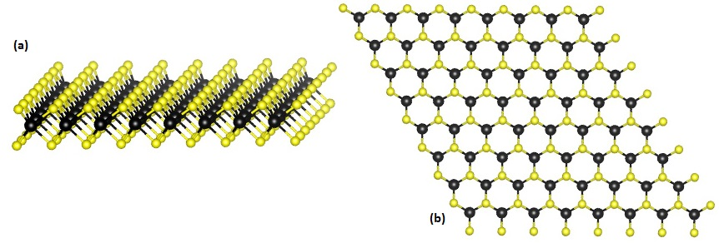
Figure 2.1. a) Layered structure of MoS₂, space group P6 3 /mmc, and b) basal projection of the atomic positions. Large purple spheres represent Mo atoms; small yellow spheres, S atoms. The hexagonal primitive unit cell is outlined by solid lines.

3. MATERIALS AND METHODS
3.1. Raman spectroscopy
The interaction of light on materials is very different it may be transmitted, reflected, or scattered; the wavelength of the light affects the interaction with materials in different colors. This study of light is called spectroscopy. Based on this an Indian physicist C.V. Raman and, independently, Soviet scientists L.I. Mandelstam and G.S. Landsberg, observed the scattering phenomenon where the light is scattered by the molecules and hence this phenomenon was named Raman scattering. The analysis/characterization technique that deals with Raman scattering is Raman spectroscopy.

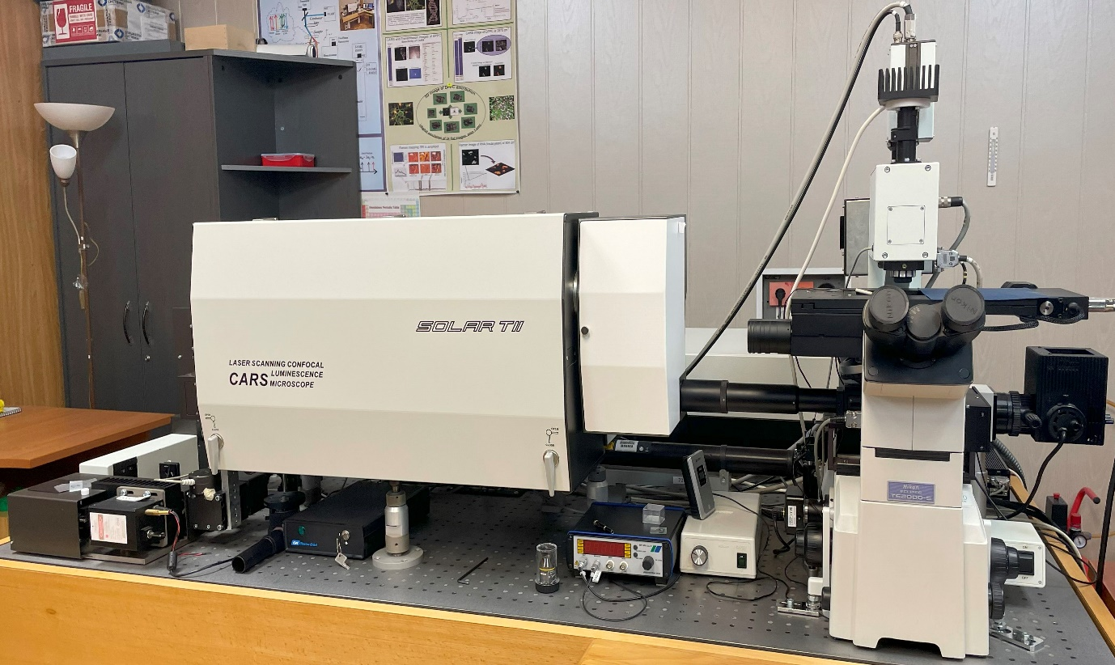
Figure 3.1. General view on the multiifunctional 3D Scanning Laser Microscope – “Confotec CARS”.

Information on Raman spectroscopy
The information that is obtained from the Raman spectroscopy is useful in analyzing various aspects of the material compositions. The Raman shifts and relative intensities of all Raman bands of the material allow identifying the chemical structure of material. The individual band changes and shifts which are seen as narrow, or broad can be varied with the intensity of the light. These changes can reveal information about the stresses in the sample and variation in crystallinity. The amount of material and its composition can also be identified, the variations in spectra with the position of the samples also reveal the changes in the material’s homogeneity.
Working principle
The irradiation of a molecule with a monochromatic light always results in two types of light scattering, elastic and inelastic. The working principle of Raman spectroscopy is based on the inelastic scattering of monochromatic light from a laser source which changes its frequency upon interaction with the material due to excitation of molecular vibrations in which either the photon may lose some amount of energy or gains energy. This shift in wavelength depends upon the chemical structure of the molecules responsible for scattering. Raman measurement gives the vibrational spectrum of the analyte, which can be treated as its “fingerprint,” allows easy interpretation and identification. The obtained Raman spectrum provide information about the rotational, vibrational, and other low-frequency transitions in the molecules. This technique can be used in studying the materials like solid, powder, liquid, and gaseous nature.

Main components of Raman spectrometer
- Laser source: The laser source is used for the excitation of the sample and resulting scattered light.
- Injection/rejection filter: The filter delivers the laser to the sample and allows the scattered Raman light to pass through to the spectrograph.
- Spectrograph and detector: The spectrograph is used to disperse the light into separated wavelengths and measure the light intensity at each wavelength.
- Microscope: The microscope with micro-objectives (x40, x60 and x100) is used to focus the laser light onto a point on the sample surface and collects the Raman light.
- Computer: It provides instrumental control and data handling and manipulation.

3.1. Molybdenum Disulfide (MoS₂)
Molybdenum disulfide belongs to a class of materials called 'transition metal dichalcogenides' (TMDCs). Materials in this class have the chemical formula MX₂, where M is a transition metal atom (groups 4-12 in the periodic table) and X is a chalcogen (group 16). The chemical formula of molybdenum disulfide is MoS₂.The crystal structure of molybdenum disulfide (MoS₂) takes the form of a hexagonal plane of S atoms on either side of a hexagonal plane of Mo atoms. These triple planes stack on top of each other, with strong covalent bonds between the Mo and S atoms, but weak van der Waals forcing holding layers together. This allows them to be mechanically separated to form 2-dimensional sheets of MoS₂.
Following on from the huge research interest in graphene, MoS₂ was the next 2-dimensional material to be investigated for potential device application. Due to its direct bandgap, it has a great advantage over graphene for several applications, including optical sensors and field-effect transistors.
MoS₂ occurs naturally as the mineral 'molybdenite'. In its bulk form, it appears as a dark, shiny solid. The weak interlayer interactions allow sheets to easily slide over one another, so it is often used as a lubricant. It can also be used as an alternative to graphite in high-vacuum applications, but it does have a lower maximum operating temperature than graphite. Bulk MoS₂ is a semiconductor with an indirect bandgap of ~1.2eV, and therefore of limited interest to the optoelectronics industry. Individual layers of MoS₂ have radically different properties compared to the bulk. Removing interlayer interactions and confining electrons into a single plane results in the formation of a direct bandgap with an increased energy of ~1.89eV (visible red). A single monolayer of MoS₂ can absorb 10% of incident light with energy above the bandgap. When compared to a bulk crystal, a 1000-fold increase in photoluminescence intensity is observed, but it remains relatively weak - with a photoluminescence quantum yield of about 0.4%. However, this can be dramatically increased (to over 95%) by removing defects that are responsible for non-radiative recombination.
In my practice, I measured several samples from Yakutsk, MoS₂ (CVD) (see fig 3.5). In the research stage, monolayers, bulk, triangles, monolayer polygons (hexagonal) types of MoS₂ structures were studied.

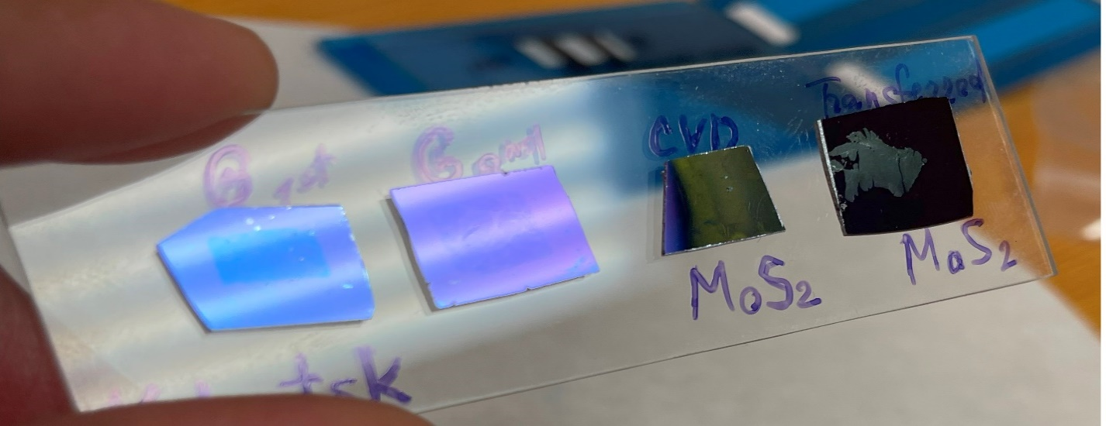
Figure 3.3.1. Two-dimensional nanomaterials.
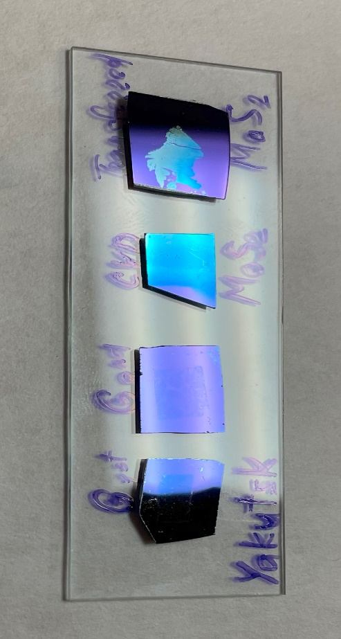
Figure 3.3.2. Two-dimensional nanomaterials. a) Graphene (G 1st), b) Graphene (G 2nd), c) disulfide molybdenum (MoS₂ CVD), d) disulfide molybdenum (MoS₂ transferred).
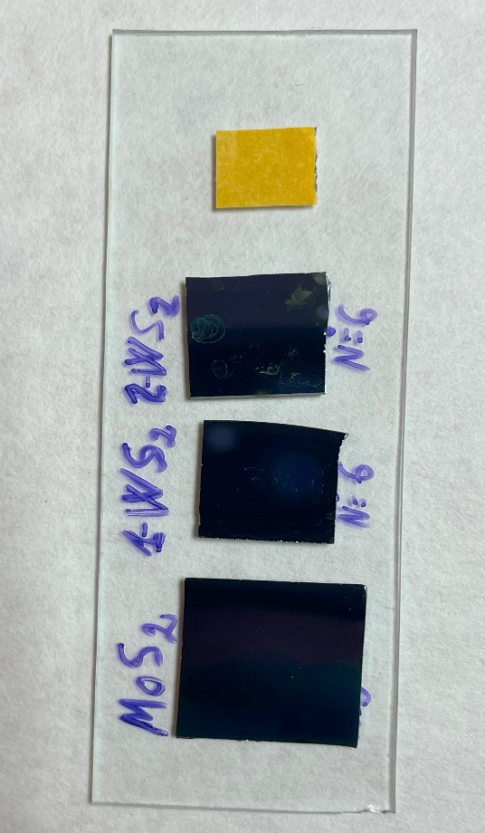
Figure 3.4. Two-dimensional nanomaterials, new exemples from Yakutsk. a) disulfide molybdenum (MoS₂,), b) tungsten disulfide (WS₂ 1st), c) tungsten disulfide (WS₂ 2nd)

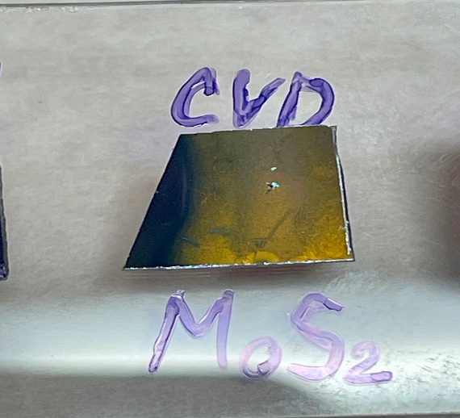
Figure 3.5. MoS₂ CVD. The MoS₂ sample where MoS₂ images of triangles, stars, bulks were taken. on page 10-12.

3.3. The practical part
I was introduced to the software at the start of my bachelor (surface physics) by a few of my colleagues. They all said I should start using it as it was excellent. They were not wrong! The software is extremely easy to use well right out of the blocks. The presentation of data is truly superb, and frankly makes excel plots look extremely dated. Templates can be made as you work to speed up analysis and presenting. Data can be instantly presented in many types of plots and overlays. As a physics constantly looking at spectra, one of my favorite Origin features is the zoomed inset, which can be added with one click. I really cannot say enough for Origin. The software and after service is truly excellent. All the results obtained were processed in the “Origin pro” program. The main thing in processing the results was to get great attention to the highest peaks, to smooth out and cut off the necessary part of our result. In our paintings, we can to see the necessary part of the peaks was given during the experiment, it is these two peaks that show MoS₂.
At the end of the complete study of molybdenum disulfide, to compare the spectrum of MoS₂. All the changes that we studied were transferred from a quartz substrate to a silicon (Si) substrate or were applied to a silicon (Si) substrate in a monolayer manner without transfer. The settings of the Raman spectrometer were adjusted 40x and 100x magnification objectives, and a diffraction grating with a period of 1200, while using a green laser more suitable and safe for our images (the wavelength is 532nm). It is very easy to distinguish bulk from monolayer, if the difference between the maximum peaks “d” is greater than d > 19, then this is considered a multilayer coating.
If the difference between the maximum peaks “d” is less than d < 19, then such a coating can be considered a monolayer, as shown in (fig 3.6.1). There is another way to distinguish a multilayer from a monolayer, if you carefully observe it on a microscope (x100), you can notice a distinctive feature in brightness and structure. a monolayer looks most like a triangle and its entire surface of monotonous light, and a multilayer is in most cases the imposition of several layers on one surface and their structure differs most from simple monotonous triangles and in the middle of a multilayer MoS₂ the color is not monotonous.
Bulk_1: 381,2 – 406 = 24,8 cm⁻¹
Bulk_2: 381,8 – 404,4 = 22,6 cm⁻¹
Since the value of d comes out to be greater than 19, these values are multi-layered it can be noticed that in hexagonal and triangle views the distance between the maxima is less than d < 19 and this states that it is a monolayer, (fig. 3.7.2 and 3.7.3).

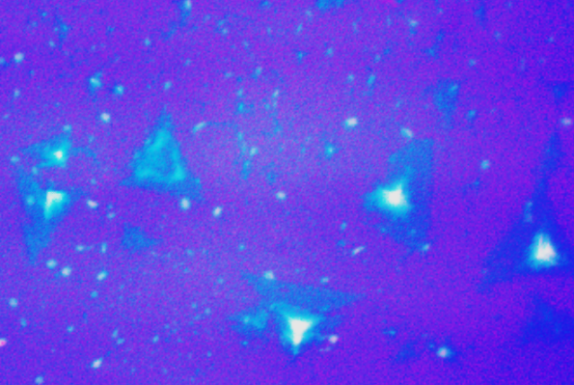
Bulk
1
2

Figure 3.6.1. Microphotography Molybdenum Disulfide (MoS₂ CVD), bulk
Figure 3.6.2. The figure shows the spectra of two BULK, MoS₂ on silicon (Si).
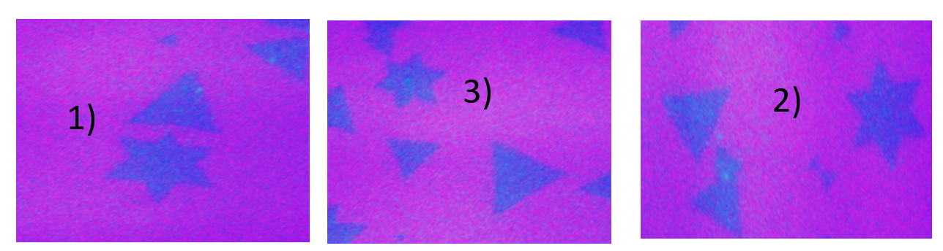
Figure 3.7.1. Microphotography Molybdenum Disulfide (MoS₂ CVD), stars (1,2,3)

Figure 3.7.2. The figure shows the spectra of three STARS, MoS₂ on silicon (Si).
Figure 3.7.3. The figure shows the spectra of three TRIANGLE, MoS₂ on Si.

It was very useful for me to study a lot here. The laboratory aimed at studying 2d materials attracted my interest, and my supervisor Grigory Arzumanyan and many scientists from our laboratory helped me in this. (fig 3.8.2)

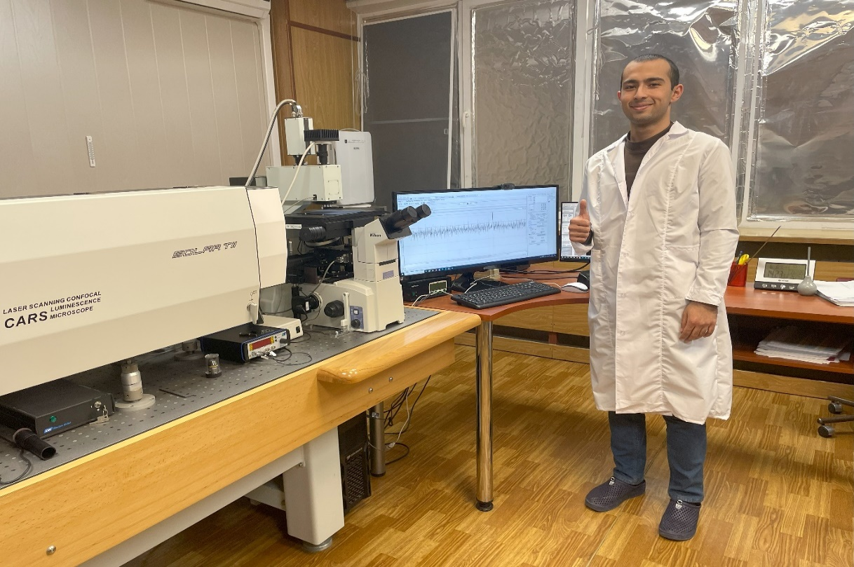
Figure 3.8.1. Firdavs Mukimboev: next to the “CARS” microscope
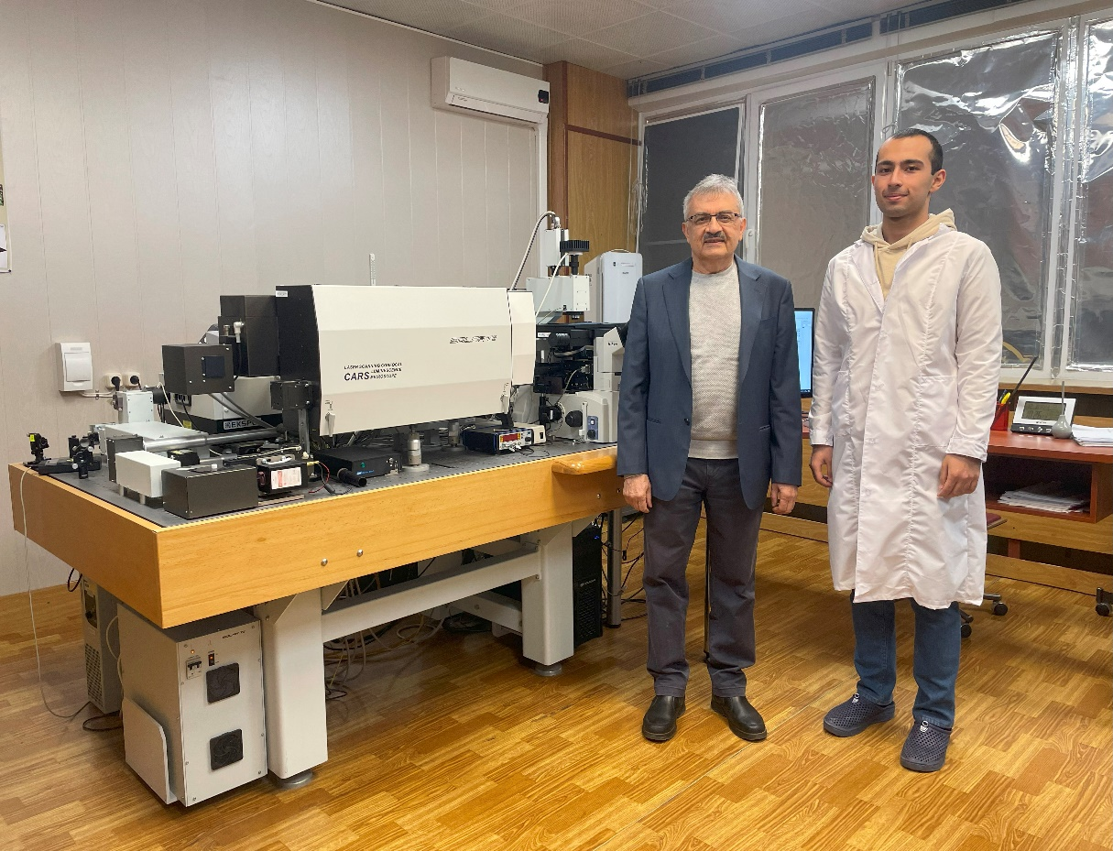
Figure 3.8.2. On the left Dr. G. Arzumanyan

CONCLUSION
In my six-week practice, I learned a lot about Raman spectroscopy and about 2D materials in general. my laboratory consisted of studying 2D materials on MoS₂ samples on a silicon substrate. In my practice, I have learned a lot about the Raman spectrometer, and how the Raman spectrometer is well sensitive to low-frequency waves. which helps in determining the number of layers in 2D materials. In this short time, I was able to study the Ramon spectrometer and study the structure of many 2D materials, especially molybdenum disulfide. Molybdenum disulfide is a highly refined crystalline powder of gray-blue or black color with a characteristic metallic luster. It has a soft oily structure. Visually resembles graphite. Molybdenum disulfide is a semiconductor, therefore, in principle, it can be used to manufacture diodes, transistors and other elements of solid-state electronics. But the volumetric MoS2 turned out to be, by its properties, a rather mediocre semiconductor, inferior to silicon and other widely used substances. Since the whole world, in search of how to save more energy and achieve great progress in nanoelectronics, has begun in advanced electronics, logic gates are supposed to be made several nanometers thick, or even one atom thick. They tried to create such transistors based on graphene, but graphene is a semi—metal. Because of this, too large leakage currents are observed in experimental transistors. The principle of controlling them will also have to be developed differently, since current flows in graphene transistors regardless of the gate voltage. In addition, all of them were obtained in laboratory conditions, which are extremely difficult to adapt for industrial production. Molybdenum disulfide has been considered as an alternative to graphene for many years. Unfortunately, the reliability of these circuits was low, the parameters were contradictory, and the microstructure itself was unstable. A new study has found the key to solving these problems. this laboratory work made a very big impression on 2D materials in me and gave me a new motivation for striving for new knowledge in the nanoelectronics world.

ACKNOWLEDGEMENTS
Heartfelt thanks to my supervisor Dr Grigory Arzumanyan: he always found time to discuss and answer my questions, even the most trivial ones. I learnt much from his expertise. I want to thank also Mamatkulov Kaxramon, Arinbek Ersultan and Vicroriya Vartic and all the staff members of the of the sector of Raman spectroscopy: it has been a pleasure for me to be warmly welcomed in such a “scientific family”. Warm thanks go to JINR Directorate for this great research opportunity and for the financial support. I am much obliged to mention here the kindness and constant support of the administration and members of the local organizing committee of the START program.

LITERATURE
- В.А. Асеев, А.Н. Бабкина, Л.Ю. Миронов, Р.К. Нурыев. Спектроскопические методы исследования материалов фотоники.
- А.К. Брель, Е.А.Василькова, Л.Н. Ниязов А.А. Хайдаров, В.Н. Ахмедов. Спектральные методы анализа органических соединений.
- Волков Алексей Игоревич. Электродные материалы на основе дисульфида молибдена для электрохимических источников энергии.
- Ким К.К., Панычев А.Ю., Колесова А.В. Валинский О.С., Евстафьев А.М., Никитин В.В., Теличенко С.А. Зайцев А.А., Крылов А.В., Урушев С.В., Ромен Ю.С. Влияния дисульфида молибдена.
- Shobha Shukla, Sumit Saxena and Eric Mazur.
Investigation of Optical Properties of layered MoS₂.
- Rusen Yan, Simone Bertolazzi, Jacopo Brivio, Tian Fang, Aniruddha Konar, A. Glen Birdwell, N. V. Nguyen, Andras Kis, Debdeep Jena, and Huili Grace Xing.
Raman and Photoluminescence Study of Dielectric and Thermal Effects on Atomically Thin MoS₂
- Mingxiao Ye, Dustin Winslow, Dongyan Zhang, Ravindra Pandey and Yoke Khin Yap.
Recent Advancement on the Optical Properties of Two-Dimensional Molybdenum Disulfide (MoS₂) Thin Films.
- Anatoliy Mikhailovich Yaremko, Volodymyr Oleksandrovych Yukhymchuk, Yuriy Anatolijovych Romanyuk, Jan Baran and Marcel Placidi.
Theoretical and Experimental Study of Phonon Spectra of Bulk and Nano-SizedMoS₂ Layer Crystals.

