JOINT INSTITUTE OF NUCLEAR RESEARCH
Laboratory of Information Technologies (MLIT)

FINAL REPORT ON THE
START PROGRAMME

Devising an Algorithm for the Detection of Λ⁰ and Κ⁰_{S} Particles in the NICA MPD Experiment

Maria Apitonian
American University of Armenia
A Alikhanyan National Laboratory
Yerevan, Armenia
Supervisor: Dr. Alexander Ayriyan
Session: Summer 2022
24 July – 17 September

Dubna 2022
Table of Contents

Abstract 3
1 Introduction 4
2 Project goals 7
3 Scope of Work 8
4 Methods 9
5 Results 10
6 Conclusions 15
References 17
Acknowledgements 18
Appendices 19

Devising an Algorithm for the Detection

of $Λ^{0}$ and $K_{S}^{0}$ Particles in the NICA

MPD Experiment

Abstract
The realization of NICA’s research goals is contingent upon efficient particle identification. This report presents an algorithm for detection of $Λ^{0}$ and $K_{s}^{0}$, the lightest baryon and meson containing strange quarks. In the quest to study QGP, these particles can serve as indicators of strangeness enhancement. The relevant decay modes are $K_{s}^{0}→ π^{+}+π^{-}$ and $Λ^{0}→ p^{+}+π^{-}$.
Cuts were applied on: PV DCA of daughter particles, DCA between pair tracks, PV DCA of $V^{0}$ trajectory, and PV to SV distance. The value for cuts related to fundamental properties of the particles, such as maximum allowed $p_{t}^{Arm}$, was taken from prior research on $K_{s}^{0}$ and $Λ^{0}$ production, while cuts for initial condition sensitive parameters were adjusted manually.
The algorithm utilizes MpdRoot MiniDst, ROOT, and C++ libraries on UrQMD-generated data. Its PID efficiency was tested through the Armenteros-Podolanski plot, which yielded well-defined and value-appropriate curves in the $K_{s}^{0}$ and $Λ^{0}$ regions.

Introduction
The goal of the project is to devise an algorithm for the detection of neutral kaons and lambda baryons by the Multi-Purpose Detector. For this purpose, the project will utilize Monte Carlo simulated data and analyze and test various algorithms on it using software resources of the MPD. This particular source code made use of various ROOT libraries for general graphing and calculation purposes, as well as specialized MpdRoot libraries (mainly under the MpdDst package) for accessing specific features of the MPD detection system.
The primary goal of the source code is to use information available to the MPD detector to find potential $K_{S}^{0}$ and $Λ^{0}$ particles, the lightest neutral meson and baryon respectively that contain a strange quark. The detection of these particles can play a crucial role in the study of quark-gluon plasma, where their strangeness can help check for the strangeness production enhancement [1] that is known to happen in QGP.
Unstable, neutral particles cannot be registered through a detector directly, as they are not influenced by the magnetic field. For this reason, namely unstable, neutrally charged particles are most often detected through the measurement of secondary daughter particles that they decay into. Hence, devising an algorithm involves finding and filtering out potential pairs of such secondary particles through a series of cuts.
The $K_{S}^{0}$ kaon [2], also known as the K-short, is an unstable meson consisting of a down quark and a strange antiquark. It has a lifetime of $8.958×{10}^{-11}s$ and most often decays into a pair of pions as such:
$$K_{S}^{0}→ π^{+}+π^{-}$$
$$K_{S}^{0}→ π^{0}+π^{0}$$
Considering the second decay mode requires detecting tertiary particles that the neutral pions have decayed into, tracking them to secondary vertices, then tracking those to a primary vertex. As errors associated with such calculations would be too big, this decay mode has been omitted from the algorithm, and only kaons decaying into pions and antipions have been considered. This decay mode makes up for (69.20 ± 0.05)% of all total decays.
The Lambda baryons are subatomic particles consisting of 3 quarks – an up quark, a down quark, and an additional higher generation quark. The variations of lambda particles are $Λ^{0}$ with composition $uds$, $Λ_{b}^{0}$ with composition $udb$, $Λ_{c}^{+}$ with composition $udc$, and $Λ_{t}^{+}$ with composition $udt$. This paper is concerned with $Λ^{0}$ [2], the first discovered and longest living variation of the lambda baryon with a measured lifetime of $2.631×{10}^{-10}s$. The two decay modes, accounting for >99% of decays of the strange lambda baryon are shown below.
$$Λ^{0}→ p^{+}+π^{-}$$
$$Λ^{0}→n^{0}+π^{0}$$
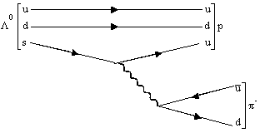
Once again, due to the complications that come with neutral pion and, especially, neutron detections, only the first decay mode will be considered, accounting for (63.9 ± 0.5)% of all possible decays. The decay concerned is mediated by the weak force, as is typical for particles in this lifetime range, and involves a decay of the strange quark into an up quark and a $W^{-}$ boson. The up quark is joined with the remaining ud quarks to make a proton, and the $W^{-}$ boson undergoes decay into a $π^{-}$ meson (see Figure 1).
Figure 1. Lambda decay by the weak force
Hence, in the case of both particles, the algorithm will deal with detection of two oppositely charged pairs of tracks that come from a common secondary vertex region. The accuracy of the algorithm in correctly spotting pairs will be tested through the Armenteros-Podolanski plot [3], a method proposed in in 1954 for the dynamic analysis of various $V^{0}$ particles. It provides a neat graphical representation for the distinction of $Λ^{0}$ and $K_{s}^{0}$ particles and performs dynamic analysis based on daughter particle momenta alone, with no assumptions regarding mass.
The method considers a dimensionless $α$ parameter against the transverse momentum $p_{t}^{Arm}$ of one of the daughter particles. The alpha parameter gives a relation between the longitudinal momenta of the daughter particles. It is calculated as:
$$α=\frac{p_{L}^{+}-p_{L}^{-}}{p_{L}^{+}+p_{L}^{-}}$$
where $p_{L}^{+}$ and $p_{L}^{-}$ are the longitudinal momenta of the positive and negative daughter particle respectively. The second parameter, $p_{t}^{Arm}$, gives the component of the daughter particles’ momenta which are perpendicular to the direction of the neutral particle’s momentum [4]. The two parameters and their relations to instantaneous momenta at the secondary vertex are shown in the figure below.
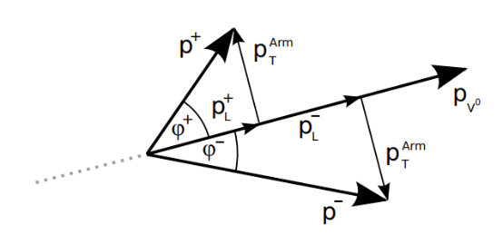
Figure 2. Geometric representation of components used by Armenteros-Podolanski [4]
The transverse momentum of the particle is measured in units of GeV/c. Given correct application of the Armenteros-Podolanski method, the theoretically allowed values for $Λ^{0}$ and $K_{s}^{0}$ generate a plot like Figure 3 below.
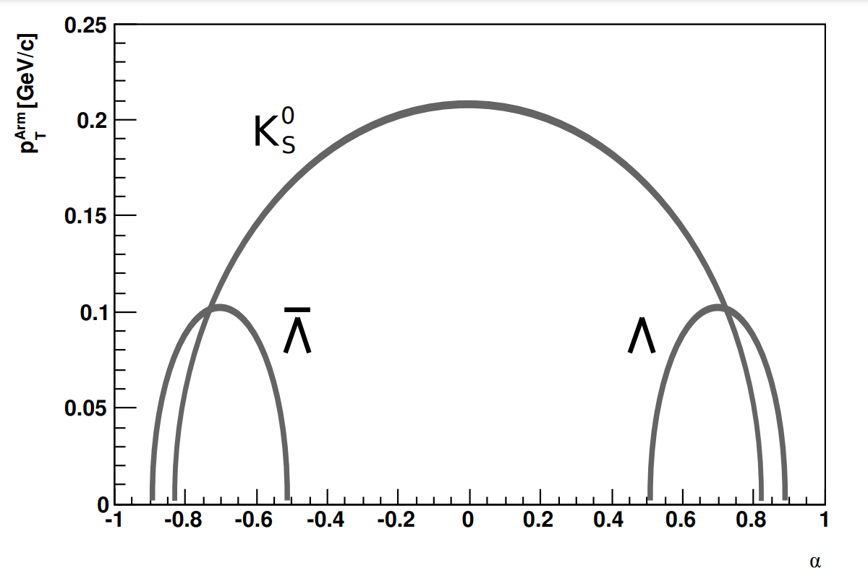
Figure 3. Theoretical values for $α$ and $p_{t}^{Arm}$ of the particles [5]
As the figure shows, the lambda particle has a theoretical peak at $p_{t,Arm}=0.2 GeV/c$, while the kaon has a peak around $p_{t,Arm}=0.1 GeV/c$. In terms of the $α$ parameter, given $M→m_{1}+m_{2}$, Armenteros and Podolanski derive the mean $α^{*}$ value for a particle to be:
$$α^{*}=\frac{m_{1}^{2}-m_{2}^{2}}{M^{2}}$$
As $K_{s}^{0}$ decays into two oppositely charged pions with the same mass, this directly implies a centrality at $α=0$. The central value for $Λ^{0}$ can also be derived similarly and shown to fall around $α=0.692$.
With its derived algorithm and applied cuts, this project was able to regenerate plots for the particles which match the aforementioned theoretical values. There is, however, a high background which needs to be cleared out with additional cuts.

Project goals
The project falls under preparations for the NICA MPD experiment, and has the essential goal of using MPD software, simulation, and Monte Carlo data to recreate experimental conditions and attempt to perform successful detection under these conditions. As mentioned above, accurate detection of the target particles can be critical in the study of quark-gluon plasma, as their abundance could serve as an indicator of strangeness enhancement.
The primary goal, hence, is efficient, fast, and accurate detection of $K_{s}^{0}$ and $Λ^{0}$ particles. A series of cuts will be applied to reduce background and spot the target particles. The algorithm’s efficiency will be tested through its ability to regenerate the theoretical curves seen in Figure 3. Plotting all derived pairs into an Armenteros-Podolanski plot will help visualize the $K_{s}^{0}$ and $Λ^{0}$ particles present after the application of cuts.

Scope of Work
The source code concludes findings of the particle by generating the aforementioned Armenteros-Podolanski plot with all relevant entries. The consistencies between the final plot parameters and theoretical values, presented in Conclusions, serve as indicators of the general success of the algorithm. The limitations of the algorithm, such as the high background and the lack of particle-specific information usage (e.g. mass) and some future prospects for fixing these limitations are also discussed below. Additionally, it is noteworthy that the plot generated in this work will not display a curve for $\overline{Λ^{0}}$ particles, as the scope of the work falls in high energy physics with UrQMD Monte Carlo data in the 9.2 GeV range.
Being a NICA MPD project, the derived algorithm must also primarily rely on the MPD MiniEvent libraries under the MiniDst package. Additionally, some ROOT and C++ libraries will also be used for plotting and calculations. For an exhaustive list of the libraries used, see Appendix 1.
In the source code, multiple cuts were made to minimize background. The value for each of the applied cuts was determined through several rounds of testing. In this prospect, there were large limitations. Even simplified versions of the source code had a high time complexity with a triple nested for-loop over events, positive tracks, and negative track respectively. Combined with absence of well-suited hardware for such a task, it took a long time to run on a singular data file. Due to these performance and time limitations, cut parameters were tested on small chunks of data. The parameter establishment process is presented in Results.
The final image, which took around 8 hours to generate, utilized a total of 30 data files with $2.16×{10}^{8}$ events and generated 85,042 relevant entries.

Methods
The MPD MiniEvent package provides a built-in calculation for the primary vertex and magnetic field of each event. These, along with the number of tracks, are retrieved as event constants in the source code to be used for later calculations. The distance of closest approach (DCA) of a track to the primary vertex is checked by tracking back its helical path to the primary vertex region and checking the closest approach distance in three-dimensional space. Alongside filtering out primary particles, two loops were run over all tracks. In order to reduce the number of iterations performed and to avoid returning double data for each pair, one loop was designated to positive tracks, and the other to negative.
The next important step in checking whether two particles form a pair is finding the DCA between their tracks. For this, the tracks’ PhysicalHelix [6], an MpdRoot class containing information regarding the helical trajectory of each track, was retrieved. This was then used to retrieve coordinates of the tracks at the point of closest approach between their helices and, finally, calculate the DCA between them. See Appendix 3 for the relevant section of the source code. Subsequently, after confirming the tracks as a potential pair, we must add their momenta and reconstruct the straight-line path of the neutral particle that they were born from. This step, presented in Appendix 4, involves constructing a straight-line equation using the total momentum vector and the secondary vertex coordinates. Using a similar process, a final cut regarding the neutral particles DCA from the primary vertex was applied. Cut parameters were defined separately in the code and can easily be adjusted given the specific experiment.
After successful application of all cuts, necessary data for the calculation of Armenteros-Podolanski data must be retrieved. To maintain a compact code in this section of the calculations, the C++ vector library was used. The projection of the daughter particles’ longitudinal momenta on the center of mass axis is first calculated. These projections are passed on for calculations of the $α$ parameter. Then, using the total momentum direction as a reference axis, perpendicular components of the daughter momenta are calculated. To check that calculations are correct, an extra test was run to make sure that the transverse components are equal for both daughter particles.
The source code can take both .root or .ls files as input, enabling it to run one or more data files at a time. The outputted data is also saved in a .root file in order to enable further work with these calculations, should the need for such work arise.

Results
Prior to the generation of the final plot, values of most cuts were manually adjusted to fit the background levels in the provided UrQMD data files. Figure 4 shows the primary vertex DCA for all particles (left), primary particles (middle), and secondary particles (right) in an arbitrary data file.
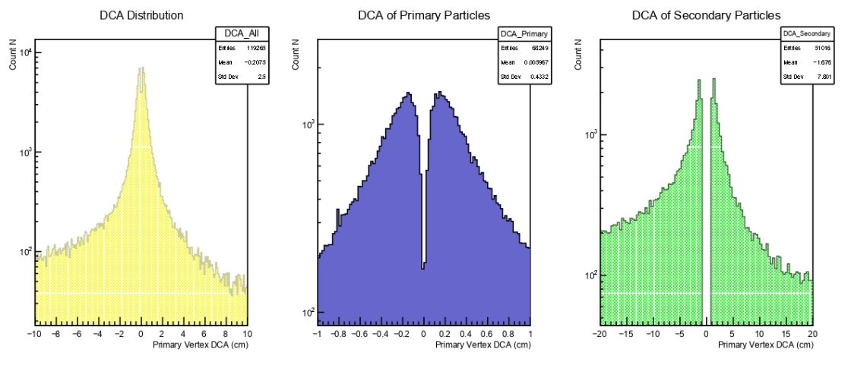
Figure 4. DCA from Primary Vertex for all tracks
The amount for this cut was finalized after multiple test rounds with the specific data files. It was slightly adjusted to a final DCA<1.1 cm cutoff for a particle to be considered secondary. Sample tests related to this value can be seen in the figure below, displaying the results for applying a cut of 1.1cm and 2.5cm respectively. Intermediate values were also tested, and 1.1cm was found to be optimal, given that larger values for this cut reduced definition the number of points too dramatically. A decision was made that it is better to keep the background points that come with a $DCA∈(1.1, 2.5)$, then try to eliminate them through further cuts. The reason behind this decision is the large loss of points in the $Λ^{0}$ region that is experienced otherwise.
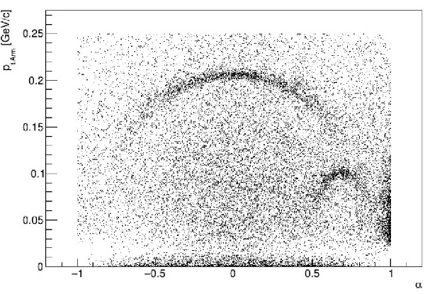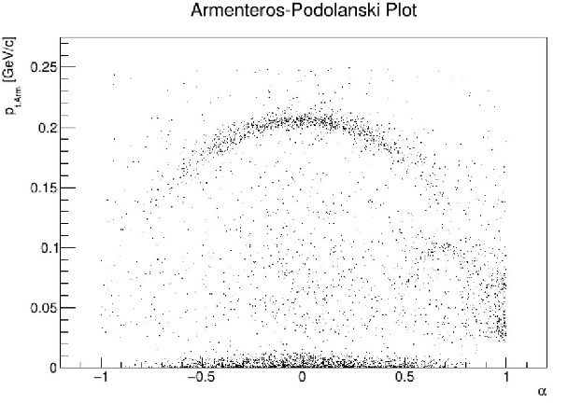
Figure 5. DCA of secondary tracks from primary vertex; DCA>1.1cm (Left), DCA>2.5cm (Right)
The next crucial parameter in pair detection is the DCA between the helical trajectories travelled by the pair. This DCA will later be used to pinpoint the secondary vertex region.
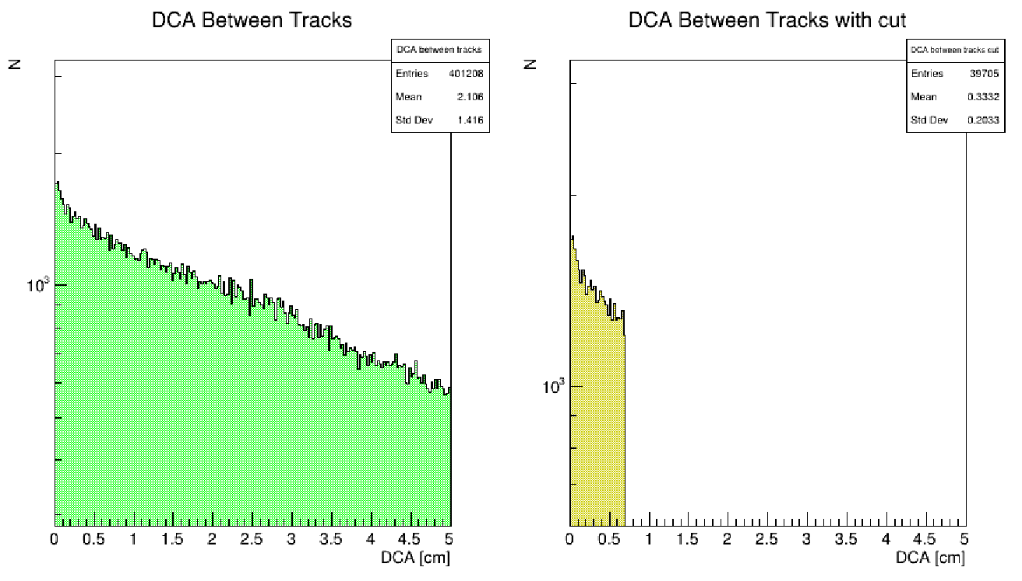
Figure 6. DCA between every pair of positive and negative tracks before and after cut
Figure 6 shows a sample of 100 events with recorded DCA values for every permutation of positive and negative tracks. As we can see, after the application of this cut, the mean distance between potential pair tracks is 0.33cm with a standard deviation of 0.20.
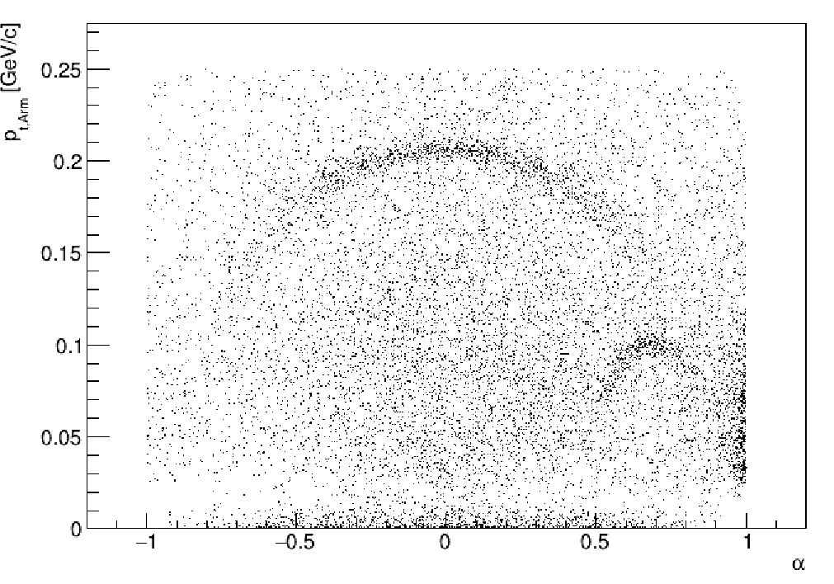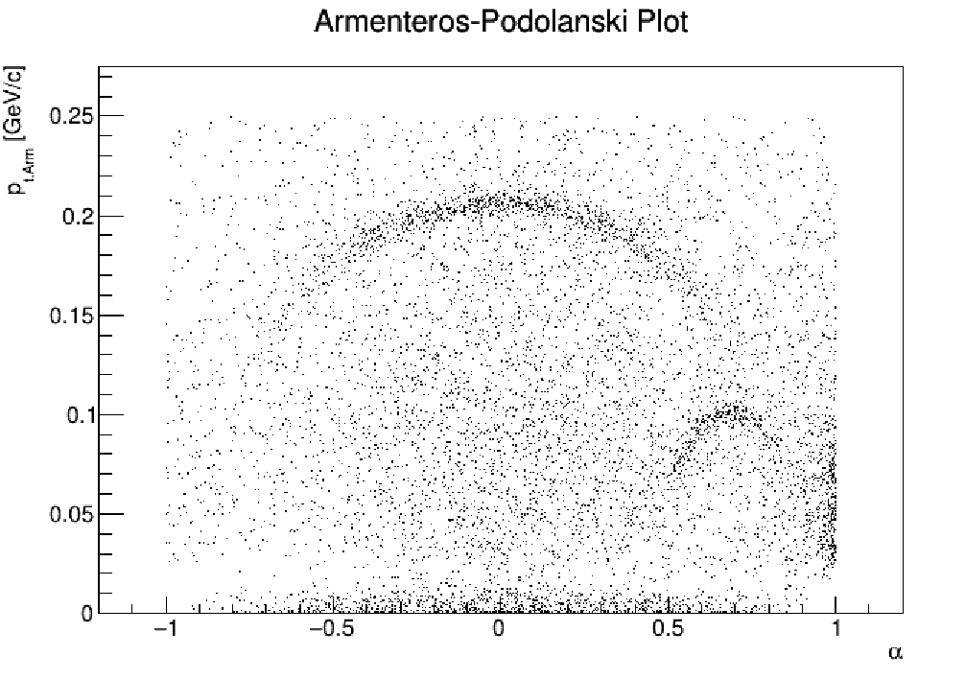
Figure 7. Adjusting DCA between tracks over 5 data files; DCA<0.7cm (Left), DCA<0.4cm (Right)
Reducing the DCA between tracks any further reduces both background and target particles in similar amounts. In other words, while the cut on the right of Figure 7 reduces background, it also visibly takes away $Λ^{0}$ and $K_{s}^{0}$ particles, as both curves are shorter and less dense. Therefore, it would be unproductive to decrease this cut to a value lower than 0.7cm, and other methods of reducing background must be seeked.
As mentioned above, to test potential pairs, the sum of their momentum vectors must track back to the primary vertex like a primary particle. To ensure this requirement is met, a another DCA cut was applied. Figure 8 displays a sample comparison reflecting the DCA between the primary vertex and the neutral particle’s center-of-mass axis.
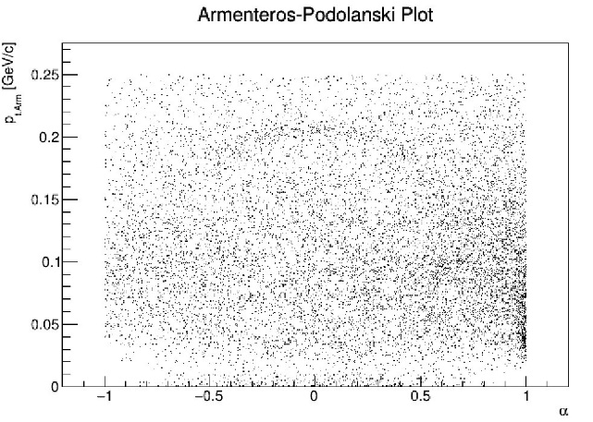
Figure 8. Adjusting DCA of $V^{0}$ to primary vertex; DCA<1.1cm (Left), DCA<0.5cm (Right)
In initial testing of primary and secondary particles, 1.1cm was selected to be the cutoff for particles to be considered secondary. As Figure 8 shows, having the DCA cut for the neutral particle to match this initial DCA cut of 1.1cm results in significantly high background without notable definition in relevant regions. Moreover, definition in the region for $Λ^{0}$ particles is completely lost given these higher values. After testing multiple intermediate values, a final cut of DCA<0.5cm was selected. The results of applying this cut to the same data file from Figure 8 are shown below in Figure 9.
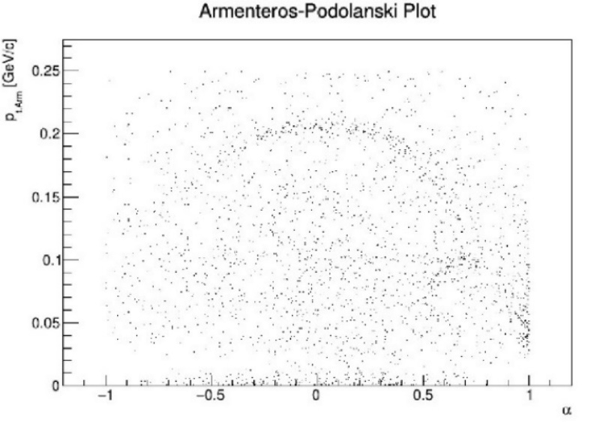
Figure 9.Adjusting DCA of V^0 to primary vertex, DCA<0.5cm
The distance between the primary and secondary vertices is an indicator of how much the target particle travelled before its decay. Using the lifetimes of $Λ^{0}$ and $K_{s}^{0}$, and assuming speeds close to the speed of light, the minimum limit for these distances are 7.8cm and 2.7cm respectively. As the investigation aims to find both $Λ^{0}$ and $K_{s}^{0}$ particles, for our purposes the value of this cut should not be more than 2.7cm, as to not exclude potential kaons.
On the contrary, as there may be large errors involved in primary and secondary vertex calculations, there was an idea to decrease this value even further, giving room for the detection of particles that might have been lost due to errors in PV coordinates. However, as can be seen from the figure below, there was virtually no difference from lowering this cut value further. Moreover, the small differences present (10% in bottom row of Figure 10) were mostly reflected in background.
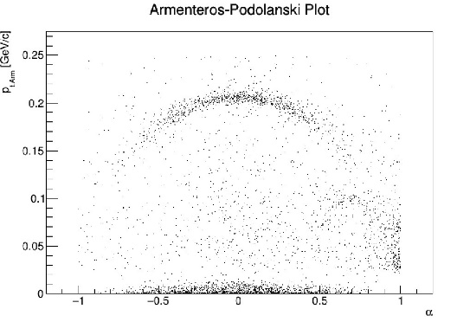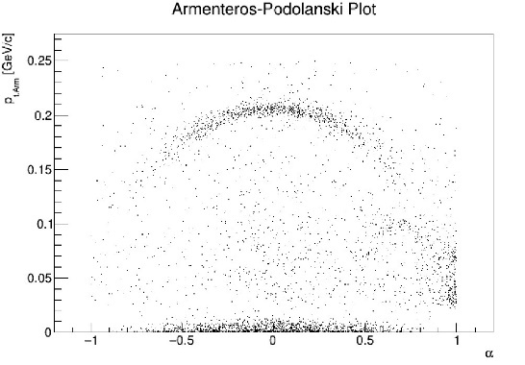
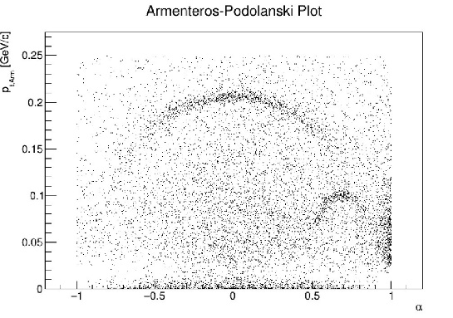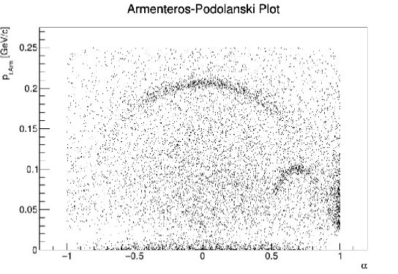
Figure 10. Applying SV to PV distance cut
Top row: High secondary particle cutoff, DCA>2.7cm (Left), DCA>1.8cm (Right)
Bottom row: Low secondary particle cutoff, DCA>2.7cm (Left), DCA>2.0cm (Right)
One can infer that the particles lost due to PV calculation errors have already been cleared out by the initial PV cut, and cannot be restored through lowering this cut further than its theoretical limit.
The final cut values selected are summarized and displayed in Appendix 2 as they appear in the code. Using these cut values on 20 data files, the image seen in Figure 11 was generated. It contains $4×{10}^{4}$ entries and displays the theoretical curves for $Λ^{0}$ and $K_{s}^{0}$.
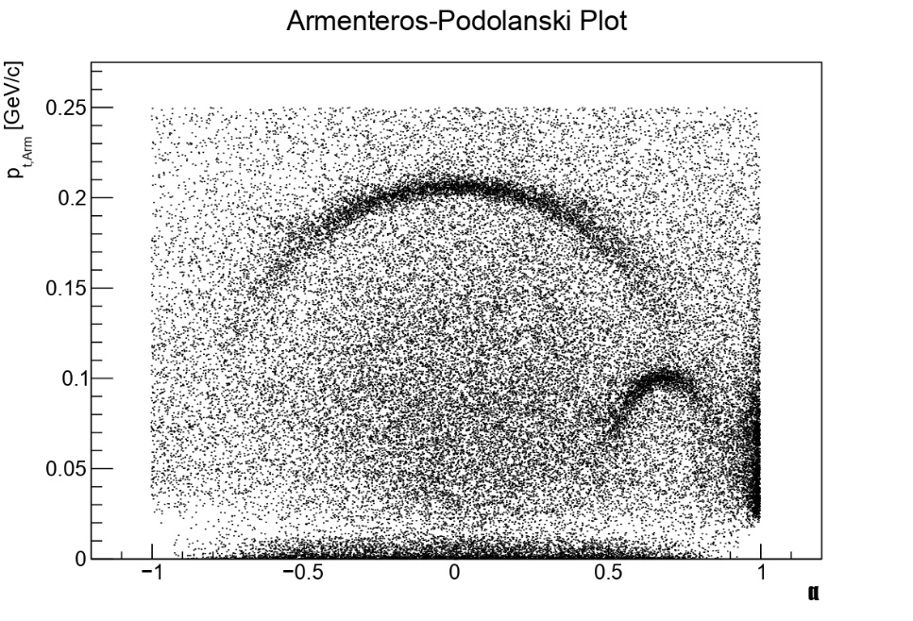
Figure 11. Application of selected cuts on ${10}^{4}$ events

Conclusions
The results of all applied cuts over the $2.16×{10}^{8}$ events provided is shown below. An intrinsic limitation of the study is that the algorithm’s specifications were adjusted to data from UrQMD generations of 9.2GeV Bi+Bi collisions. Therefore, any selected parameters will likely have to be adjusted for the analysis of Au+Au collisions in MPD experiments, as there will be differences in energies and differences in ratios of particles produced (hence, a difference in background).
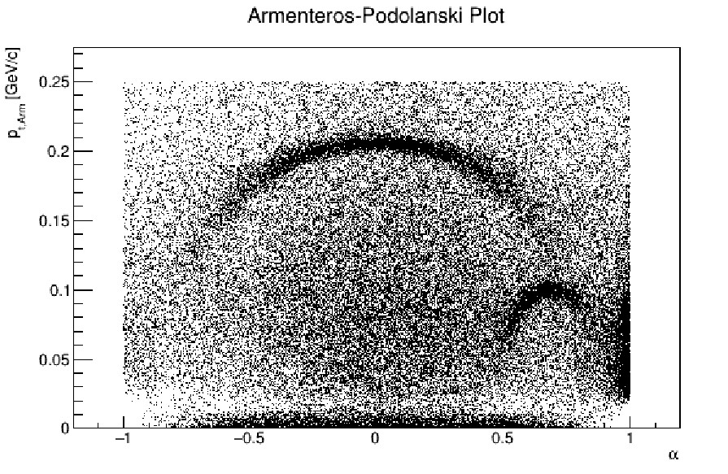
Figure 12. Armenteros-Podolanski plot over all data files (85042 found points)
As Figure 12 displays, the larger curve is centered at $α=0$, and has a peak around the 0.2 GeV/c line. Both of these properties align with theoretical descriptions of $K_{s}^{0}$ decay, which outlines that since the decay products are oppositely charged daughter particles with identical mass, the difference of their longitudinal momenta (and, consequently, $α$) should approach 0. The theoretical central value for $Λ^{0}$, meanwhile, should be at $α=0.692$, as calculated above. This is also reflected in the generated plot, which displays a central value in the $α≈0.7$ region. The transverse momentum for $Λ^{0}$ daughter particles peaks around 0.1GeV/c, which, once again, matches the theoretical plot shown in Figure 3. Consistencies with theory are an indicator of the algorithm’s effectiveness in spotting the target particles.
Nevertheless, despite effective spotting of target particles, there is an ineffective elimination of background, calling for additional cuts. Prospects for further improvement of the algorithm and the application of further cuts require separating $Λ^{0}$ and $K_{s}^{0}$ particles and applying additional cuts that are specific to the properties of either target particle. Proposed improvements of the algorithm include:
- Cuts on the angle formed between the longitudinal momenta of the daughter particles and the center of mass axis of the primary particle.
- Considering data from the TOF and combining time-of-flight information with momentum information from the TPC to retrieve mass. Invariant mass cuts can then be applied accordingly.
- After separating the identification algorithm for the two particles, applying another SV to PV distance cut based on the lifetime of $Λ^{0}$. This will help eliminate the high background observed in the $Λ^{0}$ region.
- Further work could also be done in terms of greater consideration of machine errors. For instance, considering machine-reported errors of primary vertex coordinates could allow application of more elaborate PV cuts.
To conclude, the algorithm provides a tested and mostly effective template for $Λ^{0}$ and $K_{s}^{0}$ detection, which can be developed further to complement specific project goals and to further reduce background.

References

[1] | J. Rafelski and B. Muller, “Strangeness Production In The Quark-Gluon Plasma,” Phys. Rev. Lett, vol. 48, no. 1066, 1983.
[2] | R. L. Workman, V. D. Burkert, V. Crede, E. Klempt, U. Thoma, L. Tiator, K. Agashe, G. Aielli, B. C. Allanach, C. Amsler, M. Antonelli, E. C. Aschenauer, D. M. Asner, H. Baer, S. Banerjee, R. M. Barnett, L. Baudis, C. W. Bauer and J. J. Beatty, “Particle Listings in Review of Particle Physics,” Prog. Theor. Exp. Phys, vol. 083C01, no. 2022, pp. 1123-2184, 2022.
[3] | J. Podolanski and R. Armenteros, “III. Analysis of V-events,” Lond. Edinb. Dublin philos. mag. j. sci., vol. 45, no. 360, pp. 13-30, 1954.
[4] | Е. А. Строковский, “Критерий Арментероса-Подолянского,” in Лекции по основам кинематики элементарных процессов, Москва, Московский Государственный Университет, 2010, pp. 101-104.
[5] | T. Czopowicz, “Study of K0S meson production in NA61 experiment at the CERN SPS,” Warsaw University of Technology, 2010.
[6] | G. Nigmatkulov, MpdMiniPhysicalHelix class: Parametrization of a physical helix that uses ROOT classes, Joint Institute of Nuclear Research, 2020.

Acknowledgements
I would like to deeply thank Dr. Alexander Ayriyan for supervising this project and for being a helpful and understanding consultant during its difficult stages. His regular checkups helped us move along the project while keeping our knowledge in check. The realization of this project would have been impossible without his guidance.
I would also like to extend warm thanks to Dr. Alexey Aparin and Dr. Artem Korobitsin for introducing us to the problem and helping with the usage of the MpdDst package. Through their guidance and provision of resources, they both assisted hugely in turning my theoretical understanding of the project into a compact code.
Finally, I would like to thank Elena Karpova, Julia Rybachuk, and the rest of the START team for organizing this great opportunity and enrichening our stay with various excursions and events.

Appendices
Appendix 1. C++, ROOT, and MpdRoot Libraries Used
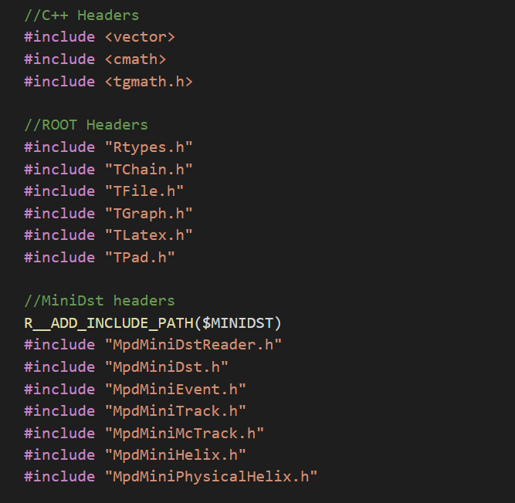

Appendix 2. Final cut constants
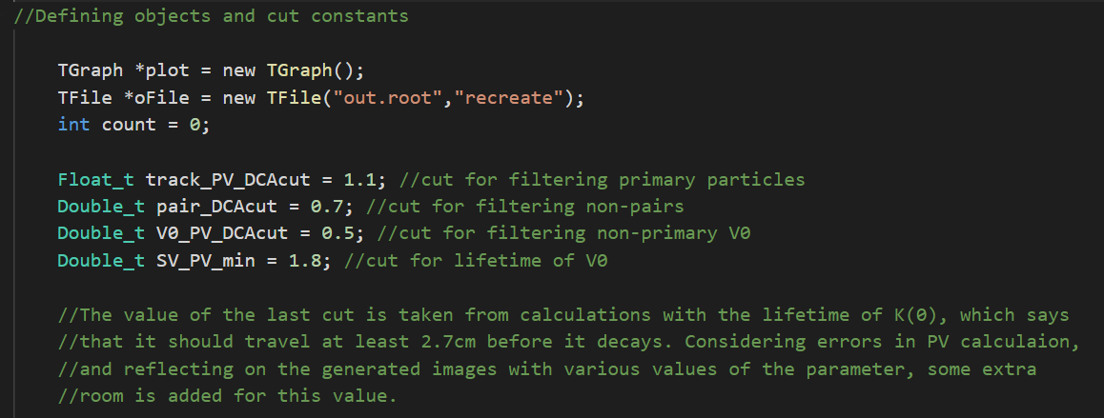
Appendix 3. Sample code: Applying cut on the DCA between oppositely charged tracks
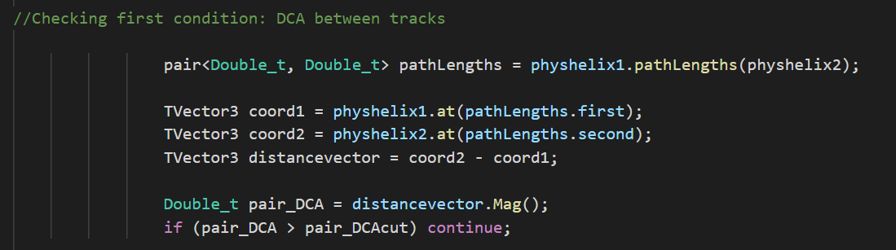

Appendix 4. Sample code: Applying cut on the DCA of the neutral particle’s path from the primary vertex
