JOINT INSTITUTE FOR NUCLEAR RESEARCH
Frank Laboratory of Neutron Physics

FINAL REPORT ON THE
START PROGRAMME

Development of a circuit of components for firmware an open source electronic device DT5560SE from CAEN in the SciCompiler programming environment designed to process signals from the detector.

supervisor:
Dr. VasilMichailovMilcov

student:
Rustam Gabdrakhmanov, Kazan Federal University

Participation period:
July17 – August26, 2022

Dubna, 2022
Abstract - The SCI(entific) Compiler is a Windows-based software that aims to accelerate the implementation of embedded pulse processing software in experimental instruments and is designed to create custom applications. In addition, the software provides a function to test and reconfigure the programmable logic integrated circuit (FPGA) in the digitizer DT5560 SE. The MCA HP high-resolution multichannel analyzer used in the circuit is one of the main components of the nuclear electronics system. The prototype of the scheme for analyzing data from a single detector is useful for educational purposes, as well as for testing SCI-Compiler library blocks and working with the digitizer DT5560SE. Also, the project can be used in physical experiments if the generator block is replaced with an analog input block. This will further expand the capabilities of the circuit, allowing to work with signal detectors.

- Introduction.
Digital pulse processing (DPP) using FPGAs allows you to achieve better scalability, repeatability, high quality signal processing compared to analog circuits. Therefore, having an FPGA platform in a DPP circuit is becoming more and more important. The advantage of using FPGAs over standard logic modules is that one such device includes the capabilities of hundreds of thousands of standard logic modules [1]. Such modules can be used to pulse process from detectors. For technicians who work with conventional programming languages, using hardware description languages such as VHDL or Verilog to develop firmware can be challenging[1]. The SCI - Compiler software is a good solution, as it does not require deep knowledge of the used device and its programming language. It automatically generates code that, starting with a graphical flowchart, calls Xilinx's Vivado CAD tool, which generates a VHDL code snippet. The SCI - Compiler programming environment uses a pre-built set of libraries containing blocks with a complex function. Each block can be thought of as a modular instrument (MCA, oscilloscope, digitizer, TDC, etc.) that the user can connect to each other [1]. One spectrometric channel via MCA HP logic module emulating high resolution multi-channel analyzer.

- Methods .
This report discusses the design and testing of a channel scheme for data processing based on the MCA HP block. This block is designed to filter and obtain the amplitude value of the input pulses. Based on it, you can create a histogram of the distribution of pulse amplitudes.
SCI - Compiler library blocks involved in the design of this circuit. On fig. 1 shows this block system.
Figure 1. Test block diagram.
All components in this circuit can be divided into three categories: controlled data blocks, MCA HP block, data representation blocks. The input data blocks are represented by the analog input, pulse generator and the configuration record registers of the multichannel analyzer. Data output blocks are represented by an oscilloscope and a block for plotting histograms. Also, the circuit uses an auxiliary block that allows you to connect the inputs and outputs of different bit depths, while there is a loss of information corresponding to the difference in bit depths . The blocks are synchronized by the internal generator of the programmable device with a frequency of 125 MHz. After the design of the circuit is completed, it is compiled, SCI - Compiler calls Vivado , which compiles the VHDL code that is used to flash the FPGA, in our case the FPGA in the DT 5560 SE . The SCI-Compiler also creates all the code necessary to implement the communication interface between the implemented project and the computer. It supports the following communication buses: USB3, Ethernet, Optical link and VME.
For the implementation of this project, the SCI - Compiler version of 2019 was used. DT 5560 SE 32-channel 14-bit 125 MHz digitizer with programmable FPGA Xilinx Zynq-7000 SoC Z-7030. Also, to simulate an analog signal, a digital emulator of fast detector signals DT 5810 was used with the accompanying software CAEN Digital Detector Emulator control Software .
  - .Controlled data blocks.
This scheme uses registers. A register is a component that allows you to store information that can be quickly accessed. Information can be written to memory at a dedicated address and is available until other information is written to the same register[2].
A signal generator is a block that allows you to generate a digital or analog output signal. In the configuration window, you can select the characteristics of the output signal fig. 2.
Figure 2 . Characteristics of the input signal for firmware testing.
An analog output is a block that receives data from a digitizer channel. When placing a block, a channel is selected.
  - .MCA HP.
This unit is part of a high performance multichannel analyzer for germanium and other high resolution detectors. MCA HP implements a complete pulse processing chain fig. 3.
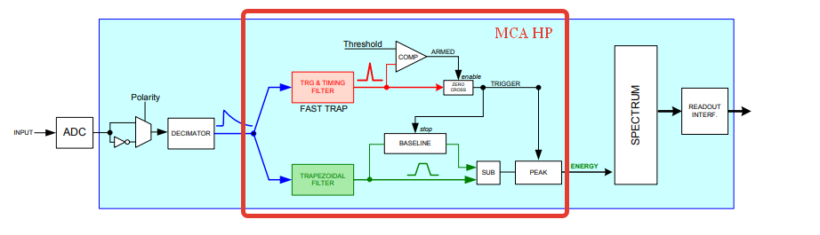
Figure 3. MCA HP Block Diagram as part of a DPP system on FPGA[3].
The input signal is branched into two branches: one for synchronization and triggering, the other for filtering and obtaining an amplitude proportional to the energy of the input signal.
Calculation of energy (pulse height) is carried out using a trapezoidal filter; there are many articles describing the principle of operation, as well as the corresponding equations and methods for implementing this filter, for example: (NIM A 345 (1994) 337: “Digital Synthesis of pulse shapes in real time for high resolution radiation spectroscopy ” by V. T. Jordanovand G. F. Knoll). For the purposes of this report, a trapezoidal filter can be briefly described as a filter capable of converting the exponential decay signal generated by a charge-sensitive preamplifier into a flat-top trapezoid whose height is proportional to the amplitude of the input pulse[3]. The following inputs are used to adjust the trapezoidal filter:
- TRAP _ K is the value of the signal integration time window (Rise time in Fig. 4), which is selected depending on the characteristics of the detector. A long shaping time gives better resolution but has a higher aliasing probability [5];
- TRAP _ M is the Rise time+ Flattop value in fig. 4. Flattop - the flat top of the trapezoid, which is also selected based on the detectors, it can be varied, for example, to eliminate the effect of ballistic deficit [4];
- SAMPLE_POS- energy measurement position, i.e. the height of the energy trapezoid in this place is proportional to the energy of the initial pulse, calculated as SAMPLE_POS = Rise time+ Flattop *0.9 ;
- D ECONVM - the coefficient of correspondence between the input signal and the received trapezoidal, is calculated by the formula$DECONVM=\frac{256}{e^{\frac{t}{τ}}-1}$. 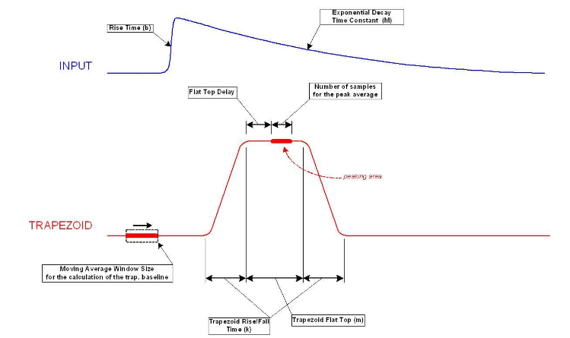Figure 4 . Type of trapezoidal signal and its parameters.
The task of the trigger-time filter ( TTF - time & trigger filter ) in MCA HP is the input pulse timestamp and noise discrimination. TTF is a fast trapezoid filter, the zero crossing of the first derivative of the fast trapezoid corresponds to the time stamp of the signal[5]. The zero crossing does not depend on the pulse amplitude, the scheme of action is shown in Fig.5.
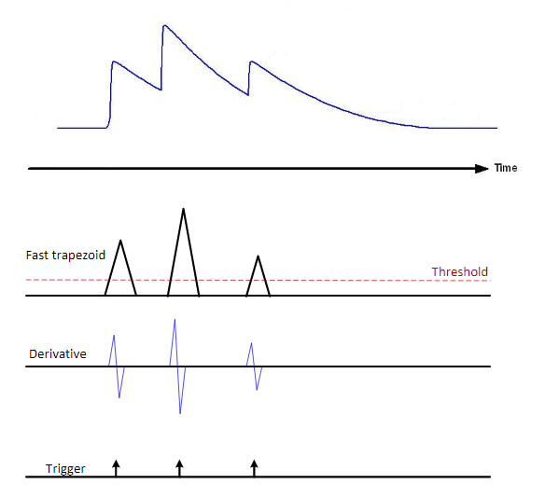
Figure 5 . Scheme of the action of a fast trapezoidal filter.
To adjust this filter, the TRIF _ K , TRIG _ M parameters are used , which have the same meaning as for the energy calculation trapezoid, but the fast trigger trapezoid parameters are chosen small for fast peak detection and elimination of overlaps.
The MCA HP block includes a baseline calculator that calculates the baseline by averaging the recorded number of points or samples before the start of the trapezoid, this is shown in fig. 4. The baseline is then fixed at the time of the trapezoid and used to calculate its height. At this time, the calculation of the baseline is prohibited. The height of the pulse (i.e. the amplitude of the trapezoid reflecting the energy of the signal) is given as the difference between the flat top and the baseline at the given position of base line. The following parameters are used to configure the restorer:
- BL _ LEN is the number of points on which the baseline is calculated.
- BL _INIB equals Risetime*2+ Flattop+100 . This is a blocking value to delay the calculation of the baseline beyond the end of the trapezoid, thereby achieving noise reduction in the calculation[5].
MCA block also uses the input data:
- OFS - signal time shift;
- POL - input signal polarity;
- THRS - threshold value for fast trapezoidal trigger;
- GAIN - amplification of the energy value for normalization in the histogram.
Operation of the MCA HP includes filtering, integration, timestamping, and baseline building of the input signal. The received data is fed to the ENERGY output, which is intended for the SPECTRUM block. The ENERGY_DV- enable signal is also sent to the SPECTRUM, which indicates the correctness of the data of this and two nearby channels. At the output of the MCA HP side there are signals for monitoring different stages of pulse processing: TRIGGER_DELTA_M (MONITOR) - a view of trapezoidal signal after differentiation, a trigger is launched on it, TRIGGER_TRAP (MONITOR) - a fast trapezoidal signal, TRAP_MON (MONITOR) - a view of energy trapezoid, TRAP- BL_MON (MONITOR) - energy trapezoid subtract the baseline, BASELINE (MONITOR) - view of baseline .
  - . Blocks for processing and presenting output data.
They are represented by the SPECTRUM and OSCILLOCOPE components. SPECTRUM is a block that calculates the amplitude distribution of input pulses and stores it in internal memory [2]. The number of spectrum channels can be selected in the configuration menu. OSCILLOCOPE - a block that allows you to visualize input signals. Has a both digital and digitized analog input. The user can set the number of oscilloscope channels when creating a block[2].
RecoursesExplorer firmware testing utility is used . The USB cable connects to the DT 5560 SE and authorizes the device in the SCI - Compiler .
- Results.
In this part, to test the circuit, the project was compiled and the FPGA was configured . The results of the test signal from the generator were received. Thus, with the configuration of the input registers shown in fig. 6 (temporal values are presented in readings), a spectrum was obtained from an ideal exponential signal representing one channel of energy and visualization of a trapezoid reflecting energy Fig.7.
Figure 6 . Table of register values.
Figure 7 . Trapezoidal output - channel 5. Baseline - channel 6. Blocking baseline calculation - digital channel 0.
Then the generator block was replaced with an analog input block in the circuit, to which an analog signal (emitting spectrum) was applied, emulated using the CAEN software Digital Detector Emulator control Software , for energy normalization in the register table, GAIN was increased to a value of 300000, the results are shown in fig. 9.

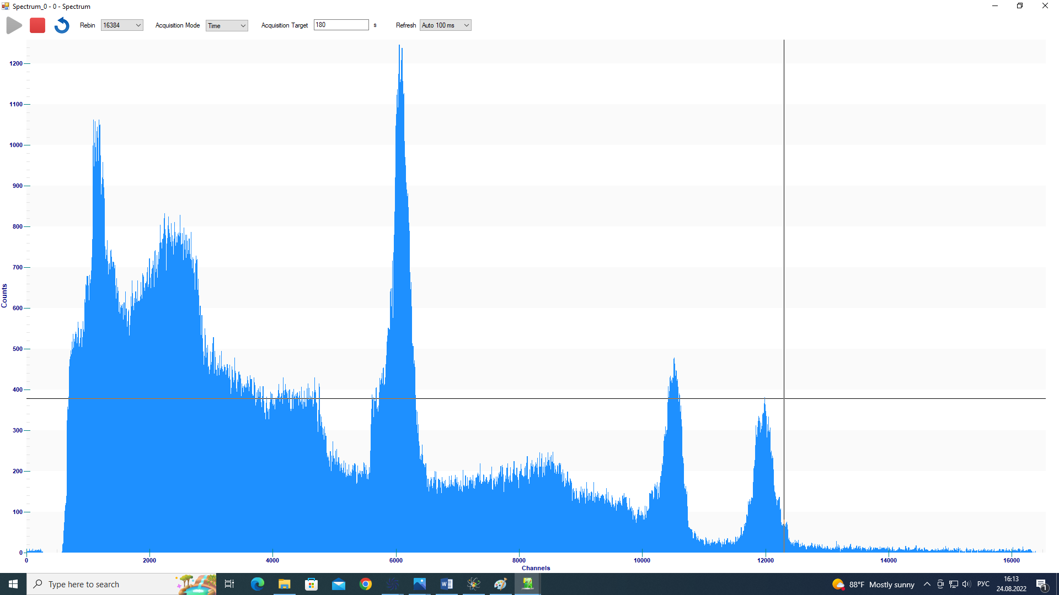
а
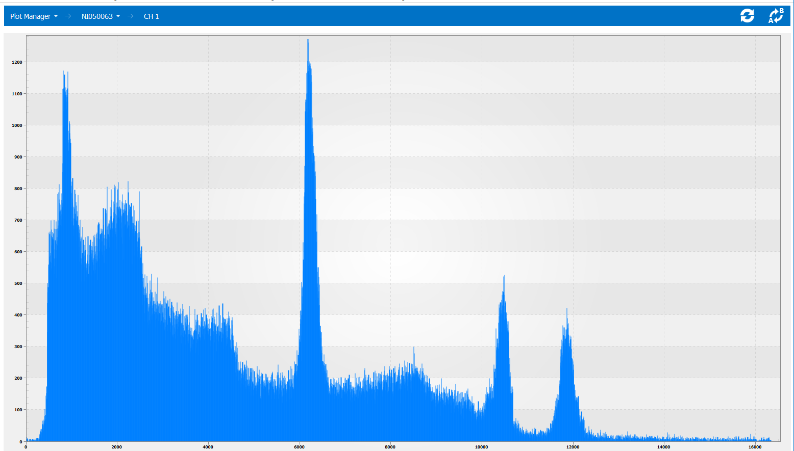
б
Figure 9. Energy spectra of the emulator a) and the Spectrum block b).
- Conclusion.
DT5560SE electronic device from CAEN, which is intended for amplitude processing of signals from the detector. The project is useful for educational purposes, as well as for testing the SCI - Compiler package and library blocks and working with the DT 5560 SE digitizer . Also, the scheme can be used in a physical experiment to create a multichannel detector system.
Thanks.
- Head of the Department of Detectors and Electronics, FLNP JINR Milkov Vasil Mikhailov.
- Elena I. Litvienko, Senior Researcher of the FLNP Sector, JINR.
- Senior Researcher of the FLNP Sector, JINR Bogdzel Andrey Alekseevich.

References.
- CAEN website [ SCI compiler new generator and compiler for custom firmware for CAEN programmable boards ]// ( https://www.caen.it/products/sci-compiler/ )
- Nuclear Instruments SciCompiler Help// Nuclear Instruments SRL - 2019
- User Manual WP2081 Digital Pulse Processing in Nuclear Physics//Overview of CAEN DPP algorithms// Rev. 4 - June 12 th , 2017.
- Digital synthesis of pulse shapes in real time for high resolution radiation spectroscopy//Valentin T. Jordanov, Glenn F. Knoll// Department of Nuclear Engineering, The University of Michigan, 2355 Bonisteel Blvd., Ann Arbor, MI 48109, USA// Received January 18, 1994.
- UM3182 – MC2Analyzer User Manual Software for digital Multi Channel Analyzer// Rev. 5-December 20th, 2017
- Radiation Detection and Measurement// Glenn F. Knoll.
- Application of Computers in Experiments Design, Building and Evaluation of a New Generation of Multichannel Analyzers Implemented in Xilinx ZYNQ-7020// V. Esmaeili Sani, M. Mohamadian, I. Alizadeh, and H. Afarideh.
- User Manual UM4150 DT5770 Digital MCA// Rev. 2-May 9th, 2017 .

