JOINT INSTITUTE FOR NUCLEAR RESEARCH
Frank Laboratory of Neutron Physics

FINAL REPORT ON THE
START PROGRAMME

Investigation of the properties of superconducting and ferromagnetic heterostructures by reflectometry of polarized neutrons

Supervisor:
Vladimir Dmitrievich Zhaketov

Student:
Anelya Kadikova, Russia, Kazan Federal University

Participation period:
July 17 – August 27, 2022

Dubna, 2022
Table of contents
Abstract 3
Coexistence of superconductivity and magnetism 4
Reflectometry of polarized neutrons 8
X-ray reflectometry 12
Experiment details 15
Results 17
Conclusion 39
Acknowledgments 41
References 42

Abstract
When a ferromagnet and a superconductor come into contact, proximity effects appear [1]. These effects show how ferromagnetism (F) affects superconducting (S) properties. There are also inverse proximity effects where superconductivity affects ferromagnetism. Such phenomena are observed in S/F thin-film systems, where the products of the effective energy and the thickness of the corresponding layer E_{F}d _{F} and E_{S}d_{S} are comparable, but such phenomena are less studied. In this work, rare-earth elements Gd, which has weak ferromagnetism at room temperature, and Dy, which has helicoidal magnetic ordering in the range from the Curie temperature T_{F} = 85 K to the Neel temperature T_{N} = 178 K in bulk materials, acted as ferromagnets [2, 3]. Studies of the influence of superconductivity on magnetism are of particular interest in connection with the expected wide application of the observed effects in superconducting spin valves and other applications of spintronics, therefore, the objectives of the work are to certify the periodic structure of Nb (5 nm)/[ Dy (2 nm)/ Nb (25 nm)]x12, as well as a study of the inverse proximity effect in the V (70 nm )/ Gd (3 nm )/ Nb (100 nm ) heterostructure. Using the methods of reflectometry of polarized neutrons and X-ray reflectometry, it was established that the periodicity of the superlattice Nb (5 nm)/[Dy (2 nm)/Nb (25 nm)]x12 varies over a fairly wide range, presumably due to interdiffuse processes at the layer boundaries, as evidenced by increased interaction potentials of Nb and Dy , as well as an increase in the model thickness Dy by 30% relative to the declared one. The inverse effect of proximity in the V (70)/Gd (3)/Nb (100) heterostructure manifested itself in an increase in the amplitude of spin asymmetry during the transition of vanadium and niobium to the superconducting state at a gadolinium magnetization M(Gd) = 780 Oe. The magnetization in superconducting layers decreases exponentially. Modeling of the structure showed that the interaction potentials of each of the layers are below the nominal ones. This indicates a decrease in density, which may be due to the diffusion of atoms in the boundary layers. This conclusion is supported by the fact that the model layer thickness V is 15% lower than the nominal one.

Coexistence of superconductivity and magnetism
In 1933, W. Meisner and R. Ochsenfeld first discovered the phenomenon of "ideal diamagnetism", which consists in the complete displacement of the magnetic field from the conductor during its transition to the superconducting state. This phenomenon is due to the fact that superconductivity carriers - Cooper pairs - exist in the singlet state. For ferromagnets, the collinear ordering of magnetic moments in an external magnetic field is characteristic. Considering that the ferromagnetic ordering temperature T _{F} much higher than the superconducting transition temperature T_{C}, and the exchange energy is proportional to T_{F}, it is expected that due to the dominance of the ferromagnetic order parameter, the superconducting state will be destroyed. It can be concluded that the magnetic properties of superconductors are opposite to those of ferromagnets, but it is known that the coexistence of superconductivity and ferromagnetism is possible in some uranium compounds and in rare earth elements.
When a ferromagnet and a superconductor come into contact, classical and inverse proximity effects appear. These effects show how ferromagnetism affects superconducting properties and how superconductivity affects ferromagnetism. The presence of such effects was observed in periodic thin-film heterostructures with alternating superconducting (S) and ferromagnetic (F) layers [4]. For the vast majority of S/F structures, the ferromagnetic ordering temperature T_{F} is much higher than the superconducting transition temperature T_{C}, which suggests that the observation of the effect of ferromagnetism on superconductivity is the most common for such structures due to the dominance of the influence of the exchange interaction. Inverse proximity effects can be observed in systems where the Curie and superconducting transition temperatures are comparable [5]. In this case, the existence of Cooper pairs in a ferromagnetic metal is possible near the contact boundary, which leads to the appearance of superconductivity in a thin layer of magnetic metal. In this case, the exchange interaction is a factor tending to destroy singlet pairs.
In S/F heterostructures consisting of elemental metals or alloys, where T_{F} significantly exceeds T_{C}, one can expect significant magnetic proximity effects if the effective energy E_{F} ∼ T_{F} d_{F} / d_{S} becomes comparable with E_{S} ∼ T_{С}, where d_{F} (d_{S}) are the thicknesses of the layers F(S) [4]. Comparability of two phases can be achieved due to the small thickness of the ferromagnetic layer (~1÷10 nm) and due to the rather large thickness of the superconducting layer (~10÷100 nm), at which the size effects become insignificant for the superconductor and the layer has the properties of a bulk substance, in in particular, the critical temperature, which depends on the layer thickness. It was previously observed that in systems consisting of S and F layers, there is a phenomenon of cryptoferromagnetism (CFM) - a homogeneous magnetic phase above T_{С} becomes inhomogeneous below T_{С}, that is, a nontrivial domain structure is formed [6]. This effect is possible if the thickness of the ferromagnetic layer is less than the correlation length of superconductivity in a ferromagnet. Such a transition reduces the effective exchange field of the ferromagnet, which allows superconductivity and magnetism to coexist. It is also predicted that in the case of uniform ferromagnetic ordering, superconductivity in the ferromagnetic layer can exist if at d_{F} < ξ_{F} and d_{S} _ < ξ_{S} , where d_{F} , ξ_{F} and d_{S} , ξ_{S} , are the superconductivity thickness and coherent length for the ferromagnetic and superconducting layers, respectively, and the effective exchange field in the superconductor h_{eff} ≈d_{F}h_{F}/d_{S} , where h_{F} is the exchange field in a ferromagnet, does not exceed the paramagnetic limit 1.24Т_{C} , where T_{C} is the superconducting transition temperature. However, in a ferromagnetic superconductor with a domain structure, the effective exchange field can exceed the paramagnetic limit. The formation of a domain structure in a thin superconducting ferromagnetic (S/F) bilayer can occur under the conditions d_{F} < ξ_{F} < d_{S} and D < ξ_{S}, where D is the period of the domain structure in the plane of the ferromagnetic layer [6]. In this case, the limiting thickness of the ferromagnetic layer is the condition d_{F} < ξ_{F} = (D_{F}/h_{F})^{1/2}, where D_{F} is the diffusion coefficient of a superconducting pair in a ferromagnet. It follows from this condition that in order to increase d_{F} , it is necessary to decrease the exchange field in the ferromagnet.
The inverse effects of proximity are less studied for natural reasons, therefore, active work is underway on the synthesis of artificial nanosized heterostructures, where the observation of these phenomena will be possible. The most obvious solution for implementing inverse proximity effects in S/F heterostructures is the synthesis of structures with high-temperature cuprates, however, the complex chemical composition and structure of such compounds complicates the possibility of fabricating homogeneous single-crystal heterostructures with continuous morphology. The preferred superconductors are elementary ones with the highest critical temperatures, such as Nb and V, for which T_{C} ~ 9 and 4 K, respectively, and these values are lower for thinner films. Another way is to use alternative ferromagnets and magnetic compounds. Traditionally, there are two groups of ferromagnets used: transition metals (Fe, Ni, Co) and rare earth elements (Gd, Dy, Ho). The magnetic layers can be made of collinear magnetic compounds Fe_{1- x} V_{x}, Ni_{1- x} Cu_{x}, in which the exchange field of the ferromagnet is reduced by adding non-magnetic metals. However, structural inhomogeneities also appear in such ferromagnetic systems due to interdiffuse processes, which leads to the formation of nonequilibrium states [7]. Rare earth metals are of particular interest because their magnetism is due to the indirect exchange RKKY interaction. The ferromagnetism of gadolinium and other rare earth metals is associated with 4f electrons. Direct interaction between these electrons of neighboring ions is unlikely, since the distance between them is almost an order of magnitude greater than the radius of the 4f shell. Therefore, it is assumed that the exchange interaction of 4f electrons of different ions of rare earth elements occurs indirectly through the polarization of conduction electrons. This leads to the fact that despite the high value of the magnetic moment per atom, Gd has a Curie temperature close to room temperature, which suggests the possibility of the coexistence of magnetism and superconductivity. Another advantage of gadolinium is its low solubility in classical superconductors such as Nb and V. The existing literature demonstrates the synthesis of three-layer structures Nb (25 nm)/Gd(d_{F})/Nb(25 nm) with a high transparency of the S/F interface and a high coherence length ξ_{F} = 4 nm [8]. Gadolinium, which has a weak ferromagnet, as previously reported, has a Curie temperature T_{F} = 293 K. And the combination of Gd with Nb, which is the strongest elemental superconductor with T_{C} = 9.3 K, allows you to prepare S/F systems with E_{F} ∼ E_{S}.
Dy and Ho exhibit complex non-collinear types of magnetic ordering and also have fairly low Néel temperatures, making them more preferable for studying the effect of superconductivity on magnetic properties. In the case of bulk Dy a long- period spiral magnetic structure (helicoid) is formed in the range from the Curie temperature (T_{F} = 85 K) to the Neel temperature (T_{N} = 178 K). The magnetic moments of dysprosium are within the base plane, and the helicoidal period is incommensurable with the crystal lattice parameter. In an external magnetic field, the helicoidal magnetic order can be transformed [9]. In bulk Ho, a long-period helicoidal magnetic order incommensurate with the lattice parameter is observed between T_{N} = 132 K and T_{F} = 18 K. In this case, the magnetic moments are also within the basal plane. Below T = 19 K, the helicoidal period in Ho becomes commensurate with the crystal lattice parameter and does not depend on temperature, and the magnetic moments partly deviate from the base plane, forming a conical magnetic structure.
The existence of superconductivity in a medium with a noncollinear magnetic moment, such as a helicoidal magnet, is realized in the form of spin-triplet superconductivity [10]. An excellent interaction with the magnetism of this type of superconductivity is expected compared to singlet superconductivity, which may also manifest itself as an adjustment of the helicoid period to the parameters of spin-triplet superconductivity. Compared to bulk material [11], in thin layers of helicoidal magnets, it is possible to suppress the ferromagnetic transition observed at temperatures below the Néel temperature, therefore, in thin films, these magnets retain helicoidal ordering down to low temperatures, including at temperatures below T_{c}(Nb). Also, in the case of preparing heterostructures with layers of helical magnets, the correlation of structural and magnetic properties becomes significant, since the axis of the helicoid is tied to the crystal lattice, the growth of which is determined by the crystallographic orientation of the substrate and other layers. However, the question of studying the effect of superconductivity on the period of helicoidally ordered magnetic phases of rare-earth metals is currently on the agenda.
At the moment, most research efforts are focused on two-layer and three-layer S/F structures [12-13]. However, both the superconducting and magnetic properties of more complex S/F systems such as [S/F]_{N} superlattices can qualitatively differ from the properties of their S/F unit cells, which opens up prospects for new functionalities. A significant difference in behavior is expected when the thickness of the S and/or F layer becomes comparable to the coherence length, which determines the strength of superconducting correlations in the S(ξ_{S}) or F(ξ_{F}) layers [14]. The production of such superlattices requires the correct choice of materials with thin F and S layers and the uniformity of the characteristics of the layers throughout the entire structure. Moreover, the materials S and F should be chosen in such a way as to increase the transparency of the S/F interface, i.e. the rate of leakage of superconducting correlations into the F layers.
The existence of inverse proximity effects implies the possibility of controlling the magnetic state with the help of superconductivity. It was found that in superconducting Nb/Dy (Ho) heterostructures, the superconducting state of Nb can be effectively controlled by changing the magnetic ordering of adjacent rare-earth layers [15]. Such a prospect attracts attention in applied research in various fields of technology, including such new approaches as quantum computing and superconducting computing [16, 17]. It is proposed to use such systems in superconducting spintronics based on the effects of injection of spin-polarized electrons into a superconducting material. Of particular interest are systems with the ability to control magnetic ordering with the help of a superconducting order parameter as candidates for the basis for superconducting spin valves. Therefore, the goals of this work are to certify the [Dy(2)/Nb(25)]x12 periodic structure , as well as to study the inverse proximity effect in the V(70)/Gd(3)/Nb(100) heterostructure.

Reflectometry of polarized neutrons
Neutrons are actively used to study condensed media due to their lack of electric charge. This makes it possible to use various types of interaction of neutrons with matter to study the properties of crystalline structures. The presence of a spin in a neutron makes it possible to study the magnetic properties of matter. Thermal neutrons have an energy of ∼ meV, which corresponds to wavelengths of 1-15 Å . The periods of crystal lattices of solids have the same order. The combination of these properties makes it possible to study the magnetic properties of crystalline substances with spatial periodicity by the method reflectometry of polarized neutron (RPN), which is based on the measurement of nuclear-magnetic interaction. For spatially sensitive measurements of the magnetization profile of S/F structures, the method of neutron reflectometry in the modes of standing and enhanced standing neutron waves is used [18, 19]. Operation in these modes makes it possible to simultaneously record secondary radiation from the structure. The method also makes it possible to study the magnetic inhomogeneities of the structure, including the magnetic lattice. This requires registration of small- angle scattering (GISANS) and diffraction patterns in grazing geometry (GIND).
Interaction of an incident neutron beam n (Figure 1) with the sample under study occurs at a sliding angle θ_{i} . The neutrons reflected and scattered from the sample are recorded by a two-dimensional position-sensitive detector. Mirrored at an angle θ_{f} = θ_{i} neutrons with wave vector k_{m} and neutrons that have passed through the structure provide information about the average nuclear U_{n} (z) and magnetic U_{m} (z) complex potentials of neutron interaction with the structure in the plane of the sample,
𝑈 _{𝑛} ( 𝑧 ) = 𝑉 _{𝑛} ( 𝑧 ) − 𝑖𝑊 _{𝑛} ( 𝑧 ), 𝑈 _{𝑚} ( 𝑧 ) = 𝜇 ( 𝑩 ( 𝑧 ) − 𝑖 ∆ 𝑩 ( 𝑧 ) ), (1)
where Vn (z) and W _{n} (z) are the real and imaginary parts of the nuclear interaction potential, respectively, μ is the magnetic moment of the neutron, B (z) and ΔB ( z ) are the vectors of induction and changes in the magnetic field induction in the xy plane .
Scattered neutron beams carry information about interface roughness and inhomogeneities with correlation lengths along certain axes depending on the transmitted projection of the wave vector on this axis in the range of 1÷100 nm .
The wave function of a free neutron can be represented as a plane wave:
𝜓 ₀ ( 𝒓 , 𝒌 , 𝑡 ) = exp ( 𝑖𝒌𝒓 − 𝑖𝜔𝑡 ), (2)
where k is the wave vector, ω is the frequency. The process of mirror reflection of neutrons is described by a wave function (1) that satisfies the Schrödinger equation :
$iℏ\frac{∂}{∂t}ψ\left(r, t\right)=[-\frac{ℏ^{2}}{2m}∆+U\left(r, t\right)]ψ\left(r, t\right)$, (3)
where m is the neutron mass, U ( 𝒓 , 𝑡 ) is the potential energy of neutron interaction with matter.

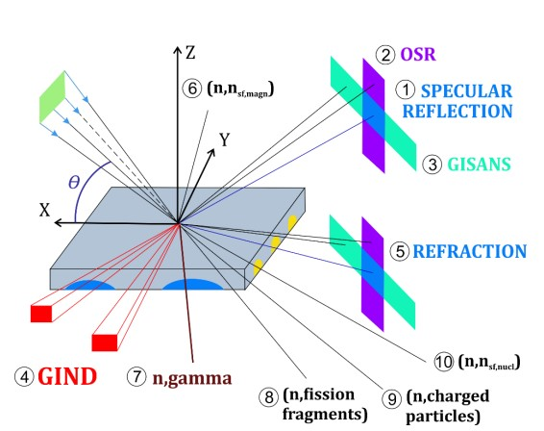
Figure 1. Scheme of the reflectometric experiment and possible channels for neutron scattering and secondary radiation: 1 – neutron specular reflection, 2 – non- specular neutron scattering, 3 – small- angle neutron scattering in grazing geometry, 4 – neutron diffraction in grazing geometry, 5 – neutron refraction, 6 - spin-flip neutrons, 7 - gamma-quanta, 8 - nuclear fission fragments, 9 - charged particles, 10 - incoherently scattered neutrons.
Most real problems can be represented as a one-dimensional semi- infinite potential barrier problem. Reflection from a potential step of a plane wave incident on the left is described by the solution of the Schrödinger equation :
$\left[\frac{d^{2}}{{dx}^{2}}-u_{0}θ\left(x>0\right)+k^{2}\right]ψ\left(x\right)=0$, (4)
where 𝑢 ₀ = 2 𝑚𝑈 ₀ / ℏ ² , 𝜃 is a step function equal to one if the inequality in its argument is satisfied and zero if not.
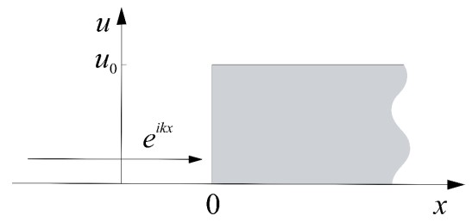
Figure 2. Potential height step u0 at the point x=0.
Solution for x < 0 we will search in the form 𝑒 ^{𝑖𝑘𝑥} + 𝑟 ₀ 𝑒 ^{− 𝑖𝑘 x} , which contains a freely incident and reflected wave with reflection amplitude 𝑟 ₀ . For x < 0 in the form 𝑡₀𝑒^{−𝑖𝑘′ x} , where 𝑡 ₀ is the refraction amplitude, k ' is the wavenumber inside the potential. The solution of equation (4) leads to the values of the reflection and transmission amplitudes:
$r_{0}=\frac{k-k'}{k+k'}, t_{0}=\frac{2k}{k+k'}$ (5)
The wave vector in the medium is defined as: $k^{'}=\sqrt{k^{2}-u_{0}}$. The reflection and transmission coefficients from the values of the amplitudes can be determined as: 𝑅 = |𝑟|², 𝑇 = | 𝑡 | ² respectively.
For neutrons, the main thing is the strong interaction with the nuclei of matter. The potential used in solving the problems of reflection and refraction of neutrons is the optical potential, which, in order of magnitude, is the average value of the nuclear potential over the volume [20]:
$U=\frac{ℏ^{2}}{2m}4πN_{0}b$, (6)
where 𝑁 ₀ is the number of atoms per unit volume of the substance, 𝑏 is the coherent length of neutron scattering on one substance nucleus. This expression was obtained by E. Fermi , who drew an analogy between the refraction of neutrons in a medium with the refraction of electromagnetic waves.
To simplify calculations in the problem for a layer of finite thickness d you can use the self-consistent equation:
𝑋 = exp ( 𝑖𝑘 ′ 𝑑 ) 𝑡 ₀ + exp ( 𝑖𝑘 ′ 𝑑 ) (− 𝑟 0) exp ( 𝑖𝑘, ′ 𝑑 ) (− 𝑟 0 ) 𝑋 , (7)
where 𝑋 is the amplitude of the wave incident on the right potential jump (Figure 3).
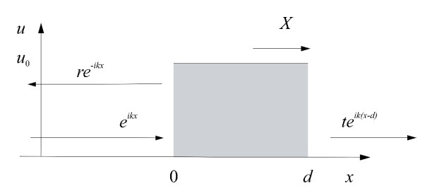
Figure 3. Rectangular potential barrier of height u0 and width d
Considering that d can be anything, for d = 0 , we get the reflection and transmission coefficients:
$R_{12}=r_{1}+t_{1}^{2}\frac{r_{2}}{1-r_{1}r_{2}}, T_{12}=\frac{t_{1}t_{2}}{1-r_{1}r_{2}}$. (8)
In the case of a multilayer structure, this approach makes it possible to recursively calculate the reflection and transmission coefficients for the entire structure.
The neutron is a particle with a magnetic moment, which means it can interact with the magnetic field of the medium B. This interaction is described by the interaction magnetic potential operator – $μB=\left|μ_{N}\right|σB$, where$σ$ - Pauli matrix. The sign of the eigenvalue of the operator depends on the projection of the neutron spin onto the direction of the magnetic field. For positive and negative projections:
$U_{mag}^{+}=-μB, U_{mag}^{-}=μB$ (9)
Taking into account the spinor properties of the neutron, the general Schrödinger equation takes the following form:
$iℏ\frac{∂}{∂t}\left|ψ\left(r, t\right)⟩\right.=\left(\frac{1}{2}\left[-∆+u\left(r, t\right)\right]+σB\left(r, t\right)\right)\left|ψ\left(r, t\right)⟩\right.,$ (10)
where $B\left(r, t\right)$is the magnetic induction in the substance. Then obtaining the reflection and transmission coefficients for a multilayer structure is similar to the non-magnetic case, but with the corresponding operations with the Pauli matrices. As a result, the reflection and refraction amplitudes are represented by matrices. The reflection coefficient of neutrons from the magnetic structure can be represented as a matrix: $R=(\begin{matrix}R_{++} & R_{+-} \\ R_{-+} & R_{--}\end{matrix})$. The matrix elements differ in the input and output neutron polarizations. Based on this, three cases are practically distinguished: 1) in the case of a non-magnetic structure 𝑴 = 0 there are no spin-flip neutrons (spin-flip neutrons), therefore 𝑅 ₊₋ = 𝑅 ₋₊ = 0 , and the components without spin flip are 𝑅 ₊₊ = 𝑅 ₋₋ ; 2) if the structure has only a magnetization collinear to the external magnetic field 𝑴 ≠ 0 , 𝑩 ǁ 𝑴 , then there are no spin-flip components 𝑅 ₊₋ = 𝑅 ₋₊ = 0 , and non-spin-flip components are different 𝑅 ₊₊ ≠ 𝑅 ₋₋ ; 3) in the case of a complex magnetic system with a magnetization that is non-collinear with respect to an external magnetic field 𝑴 ≠ 0 , 𝑩 ∦ 𝑴 , there is a spin flip and all reflection coefficients are different: 𝑅 ₊₊ ≠ 𝑅 ₋₋ ≠ 𝑅 ₊₋ ≠ 𝑅 ₋₊ ≠ 0 .
To study the magnetic properties, a complete analysis of the polarization is required, which is implemented by a circuit of a polarizer, an analyzer, and 4 spin flippers. The neutron beam is polarized using a polarizer and then passes through a spin flipper. This is a neutron spin flip device. The sample is then positioned, followed by the spin flipper, polarization analyzer, and detector. By changing the states of the flippers, it is possible to measure all 4 spin components for the noncollinear case. In the study of collinear systems, one can limit oneself to the operation of one flipper, since there are no components with spin flip.
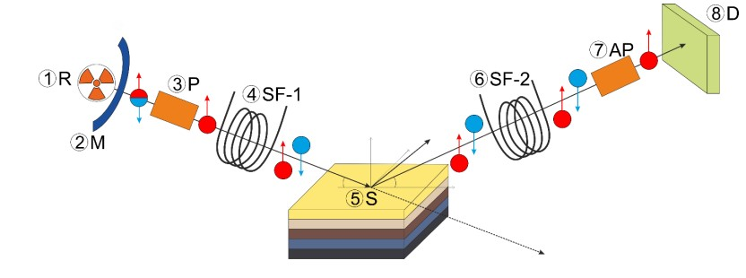
Figure 4. Scheme of a reflectometric experiment with polarized neutrons: 1 – reactor core; 2 - moderator; 3 – neutron polarizer; 4, 6 – spin flippers, 5 – sample, 7 – polarization analyzer, 8 – detector.

X-ray reflectometry
The intensity of synchrotron radiation in the X-ray range is many orders of magnitude higher than in laboratory sources. In connection with the development of both the sources themselves and the accompanying components of X-ray optics and detectors, new experimental methods for studying the structure and dynamics of matter have recently become available to users. To study thin films, surfaces, interfaces, ensembles of nanoparticles, interfaces between liquid and solid bodies, a small-angle X-ray scattering method in grazing geometry has recently been developed .
The scheme of experiments (Figure 5) is set by small angles of incidence α_{i} of synchrotron radiation on the sample surface and two scattering angles α_{f} and ϕ. In this case, by measuring the component of the transferred momentum Q_{z} perpendicular to the plane of the film sample, one can obtain information on the electron density distribution in the transverse film in the direction z, while by measuring the component Q ‖ in the plane of the sample (x, y), one can study the lateral structure of the film, its surface and interface with the substrate. The magnitude of the transferred momentum components is expressed in terms of the angles of incidence and scattering as follows:
$Q_{z}\left(φ, α_{f}\right)=\frac{2π}{λ}(\sin{α_{f}+\sin{α_{i})}}$, (11.1)
$Q_{║}\left(φ, α_{f}\right)=\sqrt{Q_{x}^{2}\left(φ, α_{f}\right)+Q_{y}^{2}\left(φ, α_{f}\right)}$, (11.2)
$Q_{x}\left(φ, α_{f}\right)=\frac{2π}{λ}(\cos{α_{f}}\cos{φ}{+\cos{α_{i}}{)}}$, (11.3)
$Q_{x}\left(φ, α_{f}\right)=\frac{2π}{λ}\cos{α_{f}}\sin{φ}.{ }{ }$ (11.4)
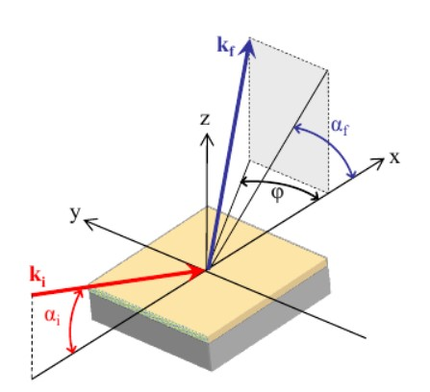
Figure 5. Geometry of experiments on surface scattering of synchrotron radiation. k _{i} and k _{f} are the wave vectors of the incident and scattered beams, respectively . The values of the angles α _{i} , α _{f} and ϕ determine the magnitude of the components of the transferred momentum Q _{x} , Q _{y} and Q _{z} in the coordinate system, where the x and y directions are in the film plane, respectively, along and perpendicular to the incident beam, the z direction is perpendicular to the film plane [285] .
The intensity distribution pattern of the scattered radiation is recorded by a two-dimensional position-sensitive detector (PSD). To study systems with characteristic lateral sizes of scatterers from several to several hundred nanometers, the size of the region of interest on the detector is, as a rule, a few degrees and depends on the distance between the sample and the PBH. The distance between the sample and the detector is typically between 1 and 4 m for GISAXS experiments, depending on the size of the detector and the characteristic size of the inhomogeneities under study. Gas-discharge chambers or CCD matrices are used as detectors. To avoid detector exposure, as a rule, the direct beam and the specular reflection beam are closed with a special shutter - a beam stop .
The standard GISAXS experiments use wavelengths characteristic of the “hard” X-ray region with energy E = 5 - 30 keV, and the scattering is assumed to be elastic, that is, without energy transfer from photons to the sample, but with momentum transfer.
In a reflectometric experiment, while scanning the angle of incidence α _{i} , the scattering intensity is measured in the direction α _{f} = α _{i} , ϕ = 0 . The thus obtained specular reflection curve R(Q_{z}) is related to the one-dimensional distribution of the electron density in the depth of the sample ρ(z) by modeling according to the Parratt method [21]. This method implies a model division of the entire thickness of the sample into a certain number of laterally homogeneous layers, each of which is characterized by thickness h _{i} , constant value of electron density ρ _{i} and roughness σ_{i} [22]. The best model is determined by selecting the required number of model layers and fitting the values of their parameters in order to ensure the correspondence between the experimental data and the calculated curve R(Q_{z}) by the method of least squares.
In experiments on small- angle scattering of synchrotron radiation in grazing geometry, the radiation flux penetrates the film to a finite depth L_{p}, where it is scattered by inhomogeneities in the internal structure of the film [22]. The depth L_{p} depends on the value of α _{i} and the value of the refractive index of the substance n = 1−δ− iβ , the real part of which δ is related to the electron density ρ as 2πδ = λ² r_{e} ρ , where r _{e} is the classical electron radius. In the general case, the dependence of L_{p} on α_{i} is expressed as follows [285]:
$L_{p}\left(α_{i}\right)=\frac{λ}{2\sqrt{2π(\sqrt{\left(α_{i}^{2}-α_{c}^{2}\right)+4β^{2}}-\sqrt{\left(α_{i}^{2}-α_{c}^{2}\right)})}}$, (12)
where $α_{с}=\sqrt{2δ}$ is the angle of total external reflection from the sample surface (critical angle). As can be seen from this formula, by changing the value of the angle of incidence α, it is possible to change the penetration depth in a controlled way, thereby gaining access to the near-surface layers of the sample located at different depths from the surface. This technique is based on the amplification of the small- angle signal scattering from the near-surface layers of the sample in the reflection geometry compared to traditional small- angle scattering in the transmission geometry.
The intensity of radiation scattering depending on the transferred momentum I (q) for lateral electron density fluctuations (sample inhomogeneities) on the surface can be represented as a product:
$I\left(q\right)=〈{\left|F\right|}^{2}〉S(q_{║})$, (13)
where F is the scattering form factor and S(q) is the total interference function. The interference function describes the spatial ordering of objects and their correlations in longitudinal directions, that is, it is the Fourier transform of the autocorrelation function of the location of inhomogeneities in real space. In the standard Born approximation, the form factor is the Fourier transform of the shape function of an object, which is defined as follows:
$F\left(q\right)=\int_{V}^{ }{exp⁡(iqr)d^{3}r}$. (14)
The Born approximation works in describing the interaction of plane de Broglie waves with individual point potentials in an infinite medium. To take into account the effects of reflection and refraction of rays on the surface, and their interference, it is necessary to calculate the form factor in the Born approximation of refracted waves), where it will have a more complex expression.
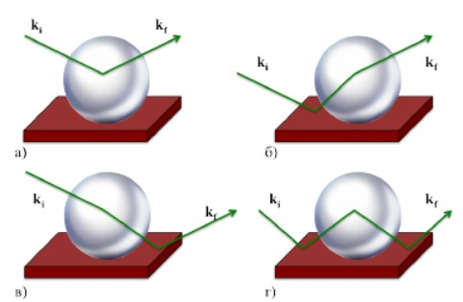
Figure 6. Various scenarios of the SR scattering process: a) q _{z} = k _{fz} − k _{iz} b ₎ qz = k _{iz} + k _{fz} c) q _{z} = − k _{iz} − k _{fz} d) q _{z} = k _{iz} – k _{fz} .
Figure 6 shows the physical picture corresponding to taking into account all the refraction processes that are calculated in DBWA.
The four contributions shown in Figure 6 represent four different scattering processes, including or not including the reflection of the direct or transmitted beam that hits the detector. These beams interfere in a coherent manner, which leads to an increase in the effective form factor (FDBWA), which includes the classical form factor with the corresponding values of the scattering wave vector. Each term enters with the corresponding Fresnel reflection coefficient R decreasing with a power law as q⁻⁴. The reduction in reflection intensity due to roughness can be calculated classically using standard deviations. The scattering cross section is proportional to the square of the modulus of the Fourier transform of the electron density distribution function. For small angles, the effects associated with the SR polarization may not be taken into account. The position of the diffraction peaks in the momentum space can be used to determine the characteristic structural periodicity d in the film in real space.

Experiment details
The measurements presented in this work were carried out on a REMUR polarized neutron reflectometer. The spectrometer is located on channel No. 8 of the IBR-2 pulsed reactor in Dubna (Russia). The installation site of the structure under study at REMUR is located at a distance of 29 m from the IBR-2 neutron moderator. The position-sensitive neutron detector is located at a distance of 5.03 m from the sample installation site. The neutron wavelength is determined by the time of flight from the moderator surface to the detector. The standard deviation of the wavelength of neutrons recorded by the detector is 0.02 Å at a distance of 34 m from the moderator. The reflectometer makes it possible to carry out a polarization analysis of nonspecular reflection of neutrons from layered magnetic structures in the range of wavelengths 1÷10 Å and scattering angles 1÷30 mrad. The polarized neutron channel includes a polarizer, input and output neutron spin flippers, a polarization analyzer, and a neutron detector; the structure under study is located between the spin flippers. The beam intensity on the sample is determined by its divergence, which is set by a cadmium diaphragm located at the output of the polarizer. The reflectometer can be operated in various moderator modes: warm water moderator / cryogenic moderator.
In an experiment to study the inverse effects of proximity in the Al₂O₃/Nb(100 nm)/ Gd (3 nm)/V (70 nm)/Nb (15 nm) heterostructure , the angle of incidence of the neutron beam was θ = 7 mrad. Measurements were carried out at temperatures above the superconducting transition V and Nb T = 12 K and below at T = 1.5 K. Since the magnetic ordering in Gd is collinear, only one of the two spin flippers worked to determine the components of the reflection coefficient without spin flip. Gd was preliminarily magnetized in an external magnetic field H = 500 Oe.
superlattice certification Al₂O₃/[Nb(25 nm)/Dy(2 nm)]x12/Nb(5), an experiment was carried out with the angle of incidence of the neutron beam θ = 9.42 mrad. The ferromagnet layer Dy was preliminarily magnetized in the field H = 250 Oe.
In this work, for the certification of structures by the XRR method, we used the FAZA facility located in the Kurchatov specialized synchrotron radiation source. All major diffraction techniques, such as high-resolution diffraction, multiwave diffraction, reciprocal space mapping, resonant diffraction, and reflectometry , are implemented at the station . An important role in experiments at the station is played by phase-sensitive techniques, such as standing X-ray waves and holographic methods. The station is equipped with one-dimensional and two-dimensional detectors. The main objects of research: surface layers, thin films and interfaces, multilayer structures, semiconductor superlattices and nanostructures, structures with quantum wells, filaments and dots, nanostructures on porous layers, real crystal structures and crystal defects. The monochromator allows you to work in the range of 3.5÷40 keV, the energy resolution is 1·10⁻³ ÷5·10⁻ ⁴. Beam size on the sample: 2x80 mm². The angular divergence is 0.04 mrad in the vertical plane (the diffuse scattering plane for this setup) and 3.3 mrad in the horizontal plane. The unit is equipped with a cryothermostat for the temperature range 6÷273 K and a furnace with a working temperature up to 1300°C.
The certification was carried out by irradiating the structures with synchrotron radiation corresponding to the wavelength of the emission line Cu k_{α} and equal to λ = 1.5406 Å.

Results
To master the methods used in the work, several methodological tasks were proposed to identify the dependences of the type of scattering spectra on the parameters included in the solution.
Task 1. Comparing reflectivity at different grazing angles (calculation only neutron reflectivity).
The dependence of the reflection coefficient on the angle of incidence of the neutron beam was studied on the Al₂O₃ Nb(100 nm)/Gd (3 nm)/V (70 nm)/Nb (15 nm) system. It has been established that with an increase in the angle of incidence, the spectrum shifts towards longer wavelengths (Figure 7).
Figure 7. Dependence of reflection coefficient on the angle of incidence of the neutron beam: black line - θ = 3 mrad, red line - θ = 6 mrad, blue line - θ = 12 mrad
The obtained dependence coincides with theoretical regularities. The reflection coefficient is a function of the scattering vector, or rather, the perpendicular projection of the scattering vector Q_{z} :
$Q_{z}=\frac{4π}{λ}θ$, (15)
where $λ$ is the neutron wavelength. In order for Q_{z} to remain constant, as the angle of incidence increases, the wavelength must also increase, which is observed in Figure 7.
As the wavelength increases, the oscillation amplitude changes in this system. This is due to the fact that Gd has a complex dependence of the interaction potential on the wavelength of the incident neutron, which can lead to a change in the shape of the scattering spectrum with increasing angle. Therefore, a more convenient type of dependence in this case is R (λ_{per}), where λ_{per} = λ/θ is the perpendicular component of the neutron wavelength.
Figure 8. Dependence of the type of reflection coefficient on the angle of incidence of the neutron beam in the coordinates of the perpendicular component of the wavelength: black line - θ = 3 mrad, red line - θ = 6 mrad, blue line - θ = 12 mrad.
Task 2. Comparing reflectivity at different magnetization (calculation only neutron reflectivity).
The reflection coefficient depends on the magnitude of the magnetic field in the ferromagnet, which is included in the magnetic potential of neutron interaction. According to the direction of the magnetic moments in the system, in the general case, collinear and noncollinear magnets are distinguished. To study the dependence of the reflection coefficient on the magnetic field, it was proposed to simulate the Al₂O₃/Nb(100 nm)/Gd(3 nm )/V(70 nm)/Nb(15 nm) system with different projections of the magnetic moment Gd onto the direction of the external magnetic field, as well as observe the behavior of the system if it is non-collinear. The beam incidence angle is fixed and equal to θ = 6 mrad.
Figure 9. Dependence of the reflection coefficient R ₊₊ on the magnetic field (collinear case): black line - field 100 Oe, red line - 1 kOe, blue line - 10 kOe.
A change in the magnetic field leads to a change in the amplitudes of the oscillations of the components of the reflection coefficient. As the field increases, the difference between the R ₊₊ and R ₋ components increases. The spin-flip component is not observed in the model, as predicted in the theoretical materials.

Figure 10. Dependence of the reflection coefficient R _{on} the magnetic field (collinear case): black line - field 100 Oe, red line - 1 kOe, blue line - 10 kOe.
Figure 11. The dependence of the reflection coefficient R ₊₊ on the magnetic field (non-collinear case). Modeling at M _{z} =1 kOe and different M _{x} : black line - field 100 Oe, red - 1 kOe, blue - 10 kOe. To increase the effect, the model was calculated for M _{z} =10 kOe and M _{x} =10 kOe.
Figure 12. The dependence of the reflection coefficient R ₋ on the magnetic field (non-collinear case). Modeling at M _{z} =1 kOe and different M _{x} : black line - field 100 Oe, red - 1 kOe, blue - 10 kOe. To increase the effect, the model was calculated for M _{z} =10 kOe and M _{x} =10 kOe.
For small projections of the magnetic moment M_{x} onto the x axis there is no visible difference in the reflection coefficient components. The possibility of observing the effect appears in sufficiently high fields (10 kOe) and at large deviation angles (≈ 45°) of the direction of the intrinsic magnetic field Gd from the direction of the external magnetic field, which is directed along the z axis . When modeling a non-collinear system, spin-flip components of the reflection coefficient R ₊₋ and R ₋₊ appeared (Figure 12). The graph shows that the spin-flip components are equal to each other.
Figure 13. Components of the reflection coefficient R ₋₊ and R ₊₋ with spin flip: M _{z} =10 kOe and M _{x} =10 kOe.
Task 3. Comparing structures with different thickness (calculation of neutron and X-ray reflectivity).
The layer thickness is one of the important characteristics of the structure. It determines the nature of the dominant type of interaction of neutrons with matter. In the system Al₂O₃ /Nb(100 nm)/Gd(3 nm)/V(70 nm)/Nb(15 nm) there is a layer of gadolinium, the 157th isotope of which has a large neutron absorption cross section σ(Gd) = 254 000 barn. In such systems, the realization of standing and amplified standing waves is possible, which measures the spatial profile of the imaginary part of the interaction potential. This mode involves the registration of secondary radiation to study the spatial distribution of the isotope density. The source of secondary radiation are charged particles, gamma quanta and fragments of nuclear fission. In a broader interpretation, secondary radiation should include fluxes of neutrons incoherently scattered on the nuclei of atoms, inelastically scattered by atoms and the medium, and also diffusely scattered at interfaces and inhomogeneities in the layers of the structure. Special secondary radiation includes neutrons that have experienced a coherent spin flip in a noncollinear magnetic structure. In practice, the regime of amplified standing neutron waves is realized in resonator structures, when a neutron wave propagating in the opposite direction is reflected from the amplifying medium, which is a potential barrier [23]. In this case, the amplitude of the neutron wave in the phase-shifting layer increases. The density of neutrons in the layer also increases.
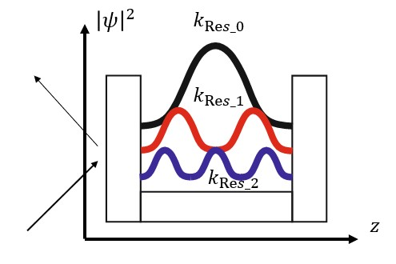
Figure 14. Scheme of the implementation of the mode of enhanced standing neutron waves.
However, these modes may not be realized at large thicknesses of absorbing layers [24].
The dependence of the absorption coefficient on the thickness of the Gd layer was studied . Due to the magnetic collinearity of the system and the absence of Gd magnetization , it makes no sense to consider the R ₋₋ and R ₊₊ components, since they coincide.
Figure 15. Dependence of the reflection coefficient on the thickness of the Gd layer .
The dependence on the layer thickness is nontrivial due to two factors: gadolinium has a large absorption cross section, and, accordingly, with an increase in the thickness of the absorbing layer, the contribution of the imaginary part of the potential increases, but the structure of Nb/Gd/V is resonant. With an increase in the thickness of the absorbing layer in such systems, the resonator properties may decrease. For a more detailed study of the dependence of the contribution of absorption to the interaction of neutrons, a more thorough study of this issue is required.
A similar dependence for synchrotron radiation was also studied (Figure 16). The X-ray SR wavelength corresponds to the Cu k_{α} emission line and is equal to λ = 1.5406 Å. It can be seen that with an increase in the thickness of the Gd layer , the amplitude decreases and the position of the peaks changes.
Figure 16. Models of the XRR spectra for different thicknesses of the Gd layer: black line - d(Gd) = 3 nm, red - d(Gd) = 6 nm, blue - d(Gd) = 12 nm.
Task 4. Comparing structures with different ferromagnets (calculation of neutron and X-ray reflectivity).
As mentioned earlier, the interaction potential of a neutron with matter includes nuclear and magnetic potentials. If the latter depends on the magnetic field in the substance, then the nuclear potential, according to formula (6), is determined by the coherent scattering length 𝑏 or the scattering length density N₀𝑏. This value is a characteristic of the interaction of a neutron with the nuclei of a particular substance, therefore it is constant for each compound or element. The same approach is applicable to X-ray synchrotron radiation.
To reveal the dependence of the reflection coefficient on the interaction potential, or, in other words, on the type of nuclei, the RPN and MRSI spectra were modeled for Al₂O₃/Nb(100 nm)/Х(3 nm)/V(70 nm)/Nb(15 nm), where X = Gd, Fe, Co, Ni, Dy (Figure 17). It should be noted that models are used where ferromagnets are not magnetized. The scattering length densities for each element, except for Gd, are given in Table 1. The angle of incidence of the neutron beam is fixed and equal to θ = 6 mrad. The X-ray SR wavelength corresponds to the Cu k_{α} emission line and is equal to λ = 1.5406 Å.
Table 1 . The real parts of SLD neutrons and X-rays.
Element | Fe | co | Ni | Dy
SLD (neutrons)  (10 ⁻⁶ / Å ) | 8.024 | 2.265 | 9.408 | 5.356
SLD  (X Ray)  (10 ⁻⁶ / Å ) | 59.454 | 63.020 | 64.405 | 50.152
Figure 17 shows the dependence of the neutron reflection coefficient on the layer material. The positions of the oscillations, due to the invariance of the thickness of the layer of variable material, do not change, the amplitudes vary.
Figure 17. Dependence of the neutron reflection coefficient R ₊₊ on the ferromagnet used.

Figure 18. Dependence of the XRR spectra on the ferromagnet used.
A similar situation is observed for SR. The positions of the peaks remain unchanged, however, the peak intensities are different for each ferromagnet.
Task 5. Superlattice (calculation of neutron and X-ray reflectivity)
Periodic structures consisting of alternating superconducting and ferromagnetic layers are new objects of study in which proximity effects can be nontrivial. To study the dependence of the reflection coefficient on the number of repetitions of bilayers, it was proposed to model the structures:
- Al₂O₃ /[Nb(25nm) / Gd(3nm)]x10 / Nb(15nm)
- Al₂O₃ / [Nb(25nm) / Gd(3nm)] x20 / Nb(15nm)
- Al₂O₃ / [Nb(25nm) / Gd(3nm)] x30 / Nb(15nm)
It should be noted that the structures in the calculated models are not magnetized.
Figure 19 shows that the Bragg peaks do not shift, since the periodicity of the structure does not change, but the amplitude of the oscillations decreases with increasing number of bilayer repetitions. This phenomenon is natural and is associated with an increase in the accumulated signal from the superlattice.
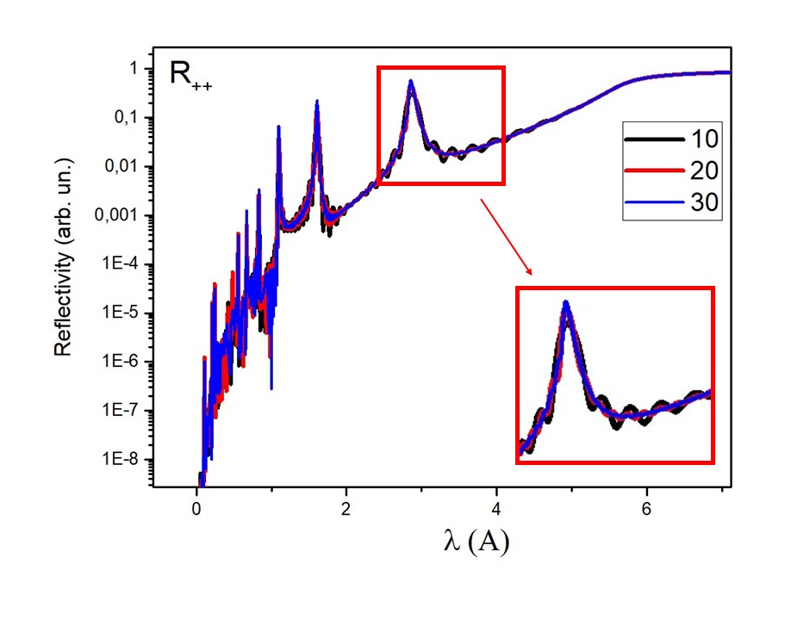
Figure 19. Dependence of the reflection coefficient on the number of biloy repetitions: black line - 10 repetitions, red - 20, blue - 30.
Based on the position of the Bragg peaks, the superlattice period can be calculated based on the Bragg-Wulf formula:
$2d\sin{θ=nλ}$, (16)
$d{=\frac{nλ}{2\sin{θ}}}$, (17)
For the sliding geometry of the experiment, the following is true:
$d{=\frac{nλ}{2θ}}$, (18)

Thus, at $θ$= 6 mrad: n = 1d _ ≈ 23.8 nm, n = 2d _ ≈ 26.8 nm, n = 3d _ ≈ 27.1 nm. Discrepancies between the periodicity values of the superlattice and the nominal value (d = 28 nm) may be due to the high neutron absorption of the Gd layer.
Figure 20. XRR spectra for superlattices with different numbers of repetitions of bilayers: black line - 10 repetitions, red - 20, blue - 30.
For the XRR spectra, an increase in the intensity of diffraction peaks with an increase in the number of repetitions is observed, similarly to neutron spectra. The oscillation frequency also increases. The position of the reflexes does not change.
Task 6. Influence of roughness ( calculation only X - ray reflectivity ).
Ideally smooth structures are a model abstraction that cannot be obtained in real experiments. Therefore, it is important to take into account the effect of interface and surface roughness on research results. To study the dependence of the SR scattering intensity on the roughness of the interface between the layers, models were constructed with roughness values of 1, 2, and 3 nm.
Figure 21. XRR spectra for different values of layer roughness: red line - 1 nm, blue - 2 nm, pink - 3 nm.
With an increase in the roughness of the layers, the intensity of the peaks decreases due to the appearance of scattering on the inhomogeneities of the interfaces.
Task 7. Structure with helicoidal magnetic (calculation only of neutron reflectivity).
The effect of superconductivity on complex types of magnetic ordering is an important area of scientific research with prospects for application in superconducting spintronics. The helicoidal ordering characteristic of the rare earth elements Dy and Ho is magnetically non-collinear (Figure 22).
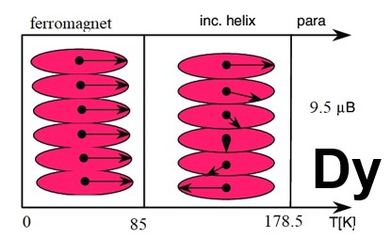
Figure 22. Types of magnetic ordering in Dy as a function of temperature.
In the study of noncollinear magnetic systems by the RPN method, the reflection coefficient should have spin-flip components.
To study the structure of Al₂O₃/Nb(100nm)/Dy(3nm)/V(70nm)/Nb(15nm), a model was calculated where the helicoidal ordering axis in dysprosium is oriented perpendicular to the heterostructure plane, and the helicoid period d_{He} = 3 nm. The dysprosium layer was divided into 10 layers, the magnetic moment in each of which is oriented in the plane of the structure, but rotated by 36° relative to the magnetic moment of the previous layer. Dysprosium layer magnetization M(Dy) = 100 kOe.
Figure 23. R ₊₊ and R₋₋ components of the reflection coefficient of the structure with helicoidal ordering of the ferromagnet Dy.

Figure 24. R ₊ ₋ and R ₋ ₊ components of the reflection coefficient of the structure with helicoidal ordering of the ferromagnet Dy .
Fit of experimental data
- Plot reflectivity for plus and minus states:$R_{+}=\frac{I_{+}}{I_{dir}};$ $R_{-}=\frac{I_{-}}{I_{dir}}$;
- Calculate spin asymmetry for experimental data: $SA=\frac{R_{+}-R_{-}}{R_{+}+R_{-}}$;
- Modeling of reflectivity for nominal structure: Al₂O₃ / Nb(100nm) / Gd(3nm) / V(70nm) / Nb(15nm) ;
- Try to fit experimental data (make better correspondence between experiment and modeling) ;
- Below T<T _{c} (Nb, V) superconducting layers close to ferromagnet layer must be magnetized (see 'inverse proximity effect').
For the simultaneous construction of models of the spectra of polarized neutrons and XRR in sliding geometry, an algorithm was written in the Matlab program , leading to the solution of equation (10). The SR spectra are modeled on the basis of the X-ray scattering length density value, which is individual for each compound and is a tabular value. The X-ray SR wavelength corresponds to the Cu k_{α} emission line and is equal to λ = 1.5406 Å. To calculate the models using the written program, the Al₂O₃ / Nb (100 nm)/ Gd (3 nm)/ V (70 nm)/ Nb (15 nm) system was chosen. Traditionally, the Parratt method is used to model the electron density and SR reflection from it, but in this work, drawing an analogy between X-ray and neutron scattering, it was decided to use solution (10) to construct SR scattering spectra. To confirm the correctness of the SR models, the obtained spectra were compared with the model built in the X’Pert Reflectivity program, as well as with experimental data (Figure 25). The models correspond to a system with ideally smooth interfaces between layers (roughness is zero), beam divergence and background are also not taken into account.
Figure 25. Small-angle scattering spectra of the SR structure Al₂O₃ / Nb (100 nm)/ Gd (3 nm)/ V (70 nm )/ Nb (15 nm ) : black line - model in the program X'Pert Reflectivity , red - model in the experimental program, blue - experimental data.
Figure 25 shows that the model calculated by the new program is the same as the model in the X'Pert Reflectivity program. Asymptotically, models of an ideal system are similar to experimental data. This program will be improved. It is planned to add the ability to vary the system parameters: thickness, roughness, density, as well as averaging the curve over a given number of points.
A fit of experimental data was made in the program X'Pert Reflectivity and the parameters of the model most suitable for the experimental spectrum were calculated (Figure 26).
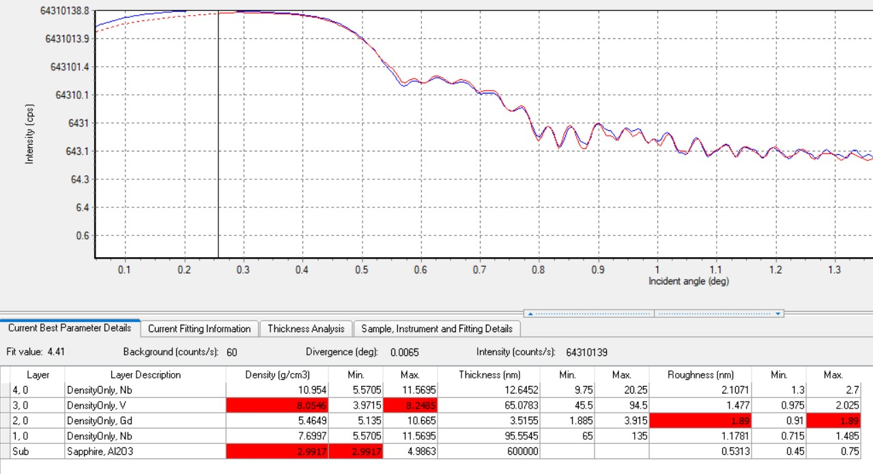
Figure 26. Fitting the model spectrum of the structure Al₂O₃ / Nb (100 nm)/ Gd (3 nm)/ V (70 nm)/ Nb (15 nm) to the experimental data with the obtained system parameters: blue line - experimental data, red line - model.
Based on the high agreement between the model spectrum and the experimental spectrum, it can be argued that the roughness of the heterostructure layers varies from 2 to 1 nm, with the surface layer having the highest roughness. This fact takes place, since the surface layer is subject to corrosion and other types of degradation.
Simulation of the system at T = 12 K. The model of the RPN spectrum at nominal values of interaction potentials and thicknesses, as well as at an angle corresponding to the experimental angle of incidence of the neutron beam θ = 7 mrad, is shown in Figure 27. To determine the properties of the system under study, it is necessary to bring the model curve as close as possible to the experimental one by varying the parameters listed above.
Figure 27. RPN spectrum model of Al ₂ O ₃ / Nb (100 nm )/ Gd (3 nm )/ V (70 nm )/ Nb (15 nm) structure at nominal parameters.
The model curve after the fit, shown in Figure 28, corresponds to the parameters given in Table 2. Model dip angle θ = 8.5 mrad. Magnetization M(Gd) = 1 kOe.
Table 2 . Model values of system parameters.
Nb (5 nm) | V (70 nm) | Gd ( 3 nm) | Nb (100 nm) | Al2O3 _ _ _
Interaction potential SLD (10 ⁻⁶ /A)
0.55*3.919 | -0.9*0.320 | 0.6*f(λ) | 0.65*3.919 | 0.9*1.436
Thickness (nm)
0.97 *15 | 0.85*700 | 1*30 | 1*1000 | -
The table shows the nominal parameters with the corresponding coefficients used when fitting the model to the experimental spectrum.
Figure 28. RPN spectrum model of the structure Al ₂ O ₃ / Nb (100 nm )/ Gd (3 nm )/ V (70 nm)/ Nb (15 nm ) at optimal values of the system parameters.
The best approximation of the XRR spectrum model to the experimental curve is shown in Figure 26. The parameters of the simulated system are inconsistent with the results of the simulation of the RPN spectrum. The potential of layer V of the XRR model is 30% higher than the nominal one, while the potential of the same layer in the RPN spectrum model is 10% lower. For the best approximation of the model to the experimental data, as well as to bring the results of RPN and XRR into agreement, it is necessary to refine the program for simultaneous processing and refine the imaginary parts of the interaction potentials of each of the layers. However, a correspondence was found in the substrate potential: for both models, it was lowered by more than 20%.
Simulation of the system at T = 1.5 K. To detect the inverse proximity effect, it is necessary to simulate the system at a temperature below the temperatures of the Nb and V superconducting transitions. Ascertain the existence of this effect in the Nb (100 nm )/ Gd (3 nm )/ V (70 nm ) structure it is possible if the model, the distribution of magnetization in the layers of superconductors of which looks like it is shown in Figure 29, coincides with the experimental data. For this, we consider the spin asymmetry of the experimental structure and the model structure after fitting the values of the magnetization of the layers. It is known from the existing literature that in the Nb/Gd/Nb system 𝝃_{F} (Gd) = 4 nm [6], so the coherence length in the structure was varied near this value.
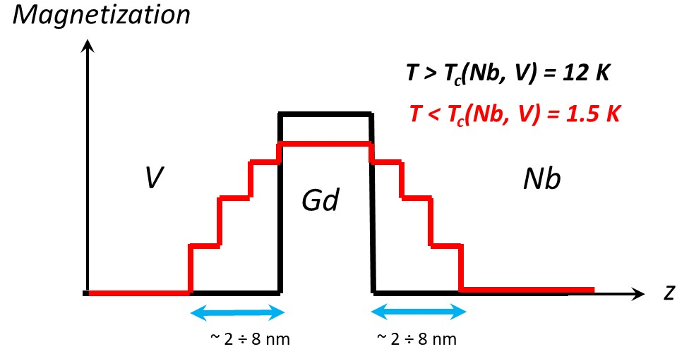
Figure 29. Magnetization distribution for modeling the inverse proximity effect in the Al₂O₃/Nb(100 nm )/ Gd (3 nm )/ V (70 nm )/ Nb (15 nm ) structure.
Figure 30. Spin asymmetry model of the Al₂O₃ /Nb(100 nm)/Gd (3 nm)/ V (70 nm)/ Nb (15nm ) structure at optimal values of the system parameters.
It can be argued from the simulation results that in the Al₂O₃/Nb(100 nm)/Gd(3 nm)/V(70 nm)/Nb (15 nm) heterostructure , an inverse proximity effect is observed, which manifests itself in the magnetization of small layers of superconductors: length coherence in the Nb layer 𝝃_{F}(Gd) ≈ 4 nm, in layer V 𝝃_{F}(Gd) ≈ 5 nm, which is comparable with the results presented earlier [8]. The magnetization Gd is M(Gd) = 780 Oe and decreases exponentially in superconducting layers with distance from the interface with the ferromagnet.

Al₂O₃ /[Dy (2 nm)/ Nb (25 nm)] superlattice certification x 12/ Nb (5 nm) .
The periodicity of the structure, the correspondence of thicknesses, densities and roughnesses to the nominal ones can be determined by the RPN and XRR methods. To certify the Al₂O₃/[Dy (2 nm)/ Nb (25 nm)] x 12/ Nb (5 nm) system , an on-load tap-changer model was built with optimal coefficients for the structure parameters (Figure 31).
Figure 31. RPN spectrum model of the Al₂O₃ /[ Dy (2 nm)/ Nb (25 nm)] x 12/ Nb (5 nm) superlattice at optimal values of system parameters.
The model periodicity of the structure is 26.5 nm, with the thickness Nb d(Nb) = 24.5 nm. The interaction potentials of Nb and Dy are higher than the nominal ones by 19% and 7%, respectively. Such parameters of the system may indicate the interdiffusion of atoms in the boundary layers.
The simulation of the XRR spectrum is shown in Fig. 32. To achieve a better fit, the superlattice was divided into two identical parts with different initial values of the parameters. The model values of the interaction potentials of the substrate and six Nb layers are lower than the nominal ones by more than 25%, which does not correspond to the results of the RPN. The thicknesses of six Dy layers are 30% higher than the nominal ones. This may be due to the diffusion of atoms. Also, a thin surface layer of NbO₂ with high roughness was added to the model, which is often found in structures using complementary research methods. The structure periodicity averaged over all layers, obtained from the XRR model, is 27.9 nm.
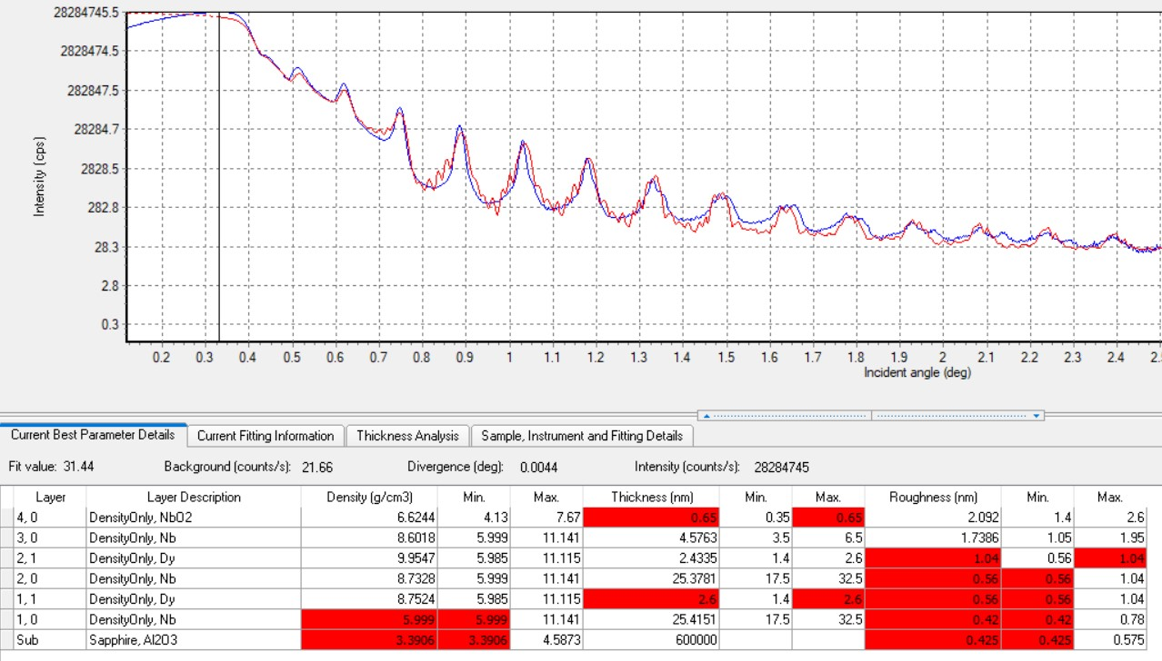
Figure 32. XRR spectrum model and experimental spectrum of Al₂O₃ /[Dy(2 nm)/ Nb(25 nm)]x12/ Nb (5 nm) superlattice at optimal values of the system parameters: blue line - experimental data, red line - model.

Conclusion
During the implementation of methodological tasks, the main patterns were found in the methods of RPN and XRR:
- The complex dependence of the interaction potential of gadolinium with neutrons affects the dependence of the reflection coefficient on the angle of incidence of the neutron beam. To exclude the influence of gadolinium, the construction of reflection spectra is carried out in the coordinates λ_{per} .
- The effect of magnetization on the reflection coefficient manifests itself at large values of the magnetic moment of the ferromagnet for both collinear and noncollinear magnetic systems. The R₊₋ and R₋₊ components appear in non-collinear magnets and increase with increasing magnetization.
- In the Al₂O₃ / Nb (100 nm)/ Gd (3 nm) / V (70 nm)/ Nb (15 nm) structure, the thickness dependence of the reflection coefficient is complex due to the high absorption cross section of Gd and the type of structure. With increasing thickness, absorption in classical structures increases, but in some structures, the phenomenon of enhanced standing waves is observed. In resonator structures, a nontrivial dependence of absorption on thickness is observed. Therefore, it is necessary to select the optimal layer thickness to achieve maximum neutron absorption and to study secondary radiation in the mode of enhanced standing waves.
- A dependence of the neutron reflection on the layer material is found, which is due to different potentials of interaction of neutrons with various substances.
- The study of the dependence of neutron reflection on the repetition number of bilayers in superlattices revealed a regular decrease in oscillations in the RPN spectra. An increase in the intensity of the Bragg peaks in the XRR spectra has also been demonstrated.
- An increase in roughness leads to a decrease in the intensity of the XRR spectra and a smoother form of the spectrum, presumably due to diffuse scattering of X-rays by inhomogeneities of the interfaces.
- As expected, spin-flip components appear in helicoidally ordered magnetic structures due to their noncollinearity, and the effect manifests itself at high values of magnetization.
- Experimental spectra of the structure Al₂O₃ / Nb (100 nm)/ Gd (3 nm)/ V(70 nm)/ Nb (15 nm ) were studied. The interaction potentials of neutrons in all layers are lower than the nominal ones, which may possibly indicate the interdiffusion of atoms. It was found that at T = 1.5 K , the inverse proximity effect manifests itself in the heterostructure. The simulation made it possible to determine the coherence lengths in the layer V and Gd, which are 𝝃_{F} (Gd) ≈ 5 nm and 𝝃_{F}(Gd) ≈ 4 nm, respectively. It is found that the magnetization decreases exponentially with increasing distance from the interface with the ferromagnet.
- Investigation of experimental data on the reflection of neutrons in the structure Al₂O₃ /[Dy (2 nm)/ Nb (25 nm)] x 12/ Nb (5 nm) made it possible to determine that an increased interaction potential indicates high bilayer densities. This circumstance may be due to the interdiffusion of atoms. This fact confirms the increased thicknesses of the Dy layers according to the XRR data.
- During the processing of experimental data, problems with the software were identified. When modeling the system Al₂O₃/[Dy(2 nm)/Nb(25 nm)]x12/Nb(5 nm) , inconsistencies were found in the periodicity values obtained by the RPN and XRR methods. Discrepancies were also observed in the values of the interaction potentials of neutrons with Al₂O₃, in the Al₂O₃/ Nb (100 nm)/ Gd (3 nm) / V (70 nm) / Nb (15 nm) heterostructure, as well as different layer potentials V , according to two methods. To solve this issue, it is necessary to refine the program for simultaneous processing of the RPN and XRR spectra.

Acknowledgments
The author is grateful to Zhaketov V.D. for help in mastering the current research method, valuable advice and continuous mentoring throughout the practice.

References
- Schmidt, V.V. Introduction to the physics of superconductors / V.V. Schmidt // Moscow. - 2000.
- J. Yu, PR LeClair, GJ Mankey, JL Robertson, ML Crow, and W. Tian, “Exploring the magnetic phase diagram of dysprosium with neutron diffraction,” Phys. Rev. B 91, 014404 (2015).
- AS Chernyshov, AO Tsokol, AM Tishin, KA Gschneidner, Jr., and VK Pecharsky, “Magnetic and magnetocaloric properties and the magnetic phase diagram of single-crystal dysprosium,” Phys. Rev. B 71, 184410 (2005).
- Buzdin, AI Proximity effects in superconductor-ferromagnet heterostructures / AI Buzdin // Reviews of Modern Physics. - 2005. - Vol. 77 - No. 3 - P. 935.
- J. Stahn, J. Chakhalian, C. Niedermayer, J. Hoppler, T. Gutberlet, J. Voigt, F. Treubel, H.-U. Habermeier, G. Cristiani, B. Keimer, and C. Bernhard, Phys. Rev. B 71, 140509(R) (2005).
- Buzdin, I. Ferromagnetic film on the surface of a superconductor: possible onset of inhomogeneous magnetic ordering / I. Buzdin, LN Bulaevskii // JETP. - 1998. - Vol. 94 - P. 256-261.
- Aksenov, VL Peculiarities of magnetic states in ferromagnet/superconductor heterostructures due to the proximity effects / VL Aksenov, Yu.N. Khaidukov and Yu.V. Nikitenko // Journal of Physics: Conference Series. - 2010. - Vol. 211 - P. 012022.
- Yu.N. Khaydukov, AS Vasenko, EA Kravtsov, VV Progliado, VD Zhaketov, A. Csik, Yu.V. Nikitenko, A.V. Petrenko, T. Keller, A.A. Golubov, 147 M.Yu. Kupriyanov, VV Ustinov, VL Aksenov, B. Keimer. Magnetic and superconducting phase diagram of Nb/Gd/Nb trilayers // Physical Review B. - 2018. - T. 97. - no. 14 - S. 144511.
- AS Chernyshov, AO Tsokol, AM Tishin, KA Gschneidner, Jr., and VK Pecharsky, “Magnetic and magnetocaloric properties and the magnetic phase diagram of single-crystal dysprosium,” Phys. Rev. B 71, 184410 (2005).
- Khaydukov, Yu.N. Evidence for spin-triplet superconducting correlations in metaloxide heterostructures with noncollinear magnetization / Yu.N. Khaydukov, GA Ovsyannikov, AE Sheyerman, KY Constantinian, L. Mustafa, T. Keller, MA Uribe-Laverde, Yu.V. Kislinskii, A. V. Shadrin, A. Kalabukhov, B. Keimer, D. Winkler // Physical Review B. - 2014. - Vol. 90 - No. 3 - P. 035130.
- Yu, J. Exploring the magnetic phase diagram of dysprosium with neutron diffraction / J. Yu, PR LeClair, GJ Mankey, JL Robertson, ML Crow, and W. Tian // Physical Review B. - 2015. - Vol. 91 - No. 1 - P. 014404.
- Ng, TK Spontaneous Vortex Phase Discovered? / TK Ng and CM Varma // Physical Review Letters. - 1997. - Vol. 78 - No. 2 - P. 330.
- Sonin, E. B. Spontaneous vortex phase in a superconducting weak ferromagnet / E. B. Sonin and I. Felner // Physical Review B. - 1998. - Vol. 57 - No. 22 - P. 14000.
- Zhu, Y. Superconducting exchange coupling between ferromagnets / Y. Zhu, A. Pal, MG Blamire and ZH Barber // Nature Materials. - 2017. - Vol. 16 - P. 195-199.
- Klenov, N. Periodic Co/Nb pseudo spin valve for cryogenic memory / N. Klenov, Yu. Khaydukov, S. Bakurskiy, R. Morari, I. Soloviev, V. Boian, T. Keller, M. Kupriyanov, A. Sidorenko and B. Keimer // Beilstein Journal of Nanotechnology. - 2019. - Vol. 10 - P. 833-839.
- Bakurskiy, SV Proximity effect in multilayer structures with alternating ferromagnetic and normal layers / SV Bakurskiy, MY Kupriyanov, AA Baranov, AA Golubov, NV Klenov and II Soloviev // JETP Letters. - 2015. - Vol. 102 - P. 586-593.
- Nevirkovets, I. Memory Cell for High-Density Arrays Based on a Multiterminal Superconducting-Ferromagnetic Device / I. Nevirkovets and OA Mukhanov // Physical Review Applied. - 2018. - Vol. 10 - No. 3 - P. 034013.
- Aksenov VL Neutron interference at grazing incidence reflection. Neutron standing waves in multilayered structures: applications, status, perspectives / VL Aksenov and Yu.V. Nikitenko // Physica B: Condensed Matter. - 2001. - Vol. 297 - No. 1-4 - P. 101-112.
- Nikitenko, Yu.V. Neutron standing waves in layered systems: formation, detection and application in neutron physics and nanostructure studies / Yu.V. Nikitenko // Physics of elementary particles and the atomic nucleus. - 2009. - Vol. 40 - No. 6 - P. 1682.
- Golub R., Richardson D., Lamoreaux SK Ultra-Cold Neutrons. Bristol, Philadelphia, New York: Adam Hilger, 1991.
- Zhou X.-L., Chen S.-H. Theoretical foundation of X-ray and neutron reflectometry // Physics Reports. 1995 Vol. 257.Pp. 223-348.
- Grigorieva N. A., Vorobyov A. A., Ukleev B. A., Dyadkina E. A., Lutsev L. V., Stogniy A. I., Novitsky N. N., Grigoriev C. B. The study SiO₂ (Co)/GaAs heterostructures by methods superficial scattering synchrotron radiation // Letters in ZhETF . 2010Vol. 92, no. 11. R. - Letters in ZhETF .
- Nikitenko Yu.V., Syromyatnikov V.G. Reflectometry of polarized neutrons. – M.: FIZMATLIT, 2013. – 224 p.
- Zhang, H. Grazing incidence prompt gamma emissions and resonance-enhanced neutron standing waves in a thin film / H. Zhang, PD Gallagher, SK Satija, RM Lindstrom, RL Paul, TP Russell, P. Lambooy, EJ Kramer // Physical Review letters. - 1994. - Vol. 72 - No. 19 - P. 3044-3047.

