JOINT INSTITUTE FOR NUCLEAR RESEARCH
Dzhelepov Laboratory of Nuclear Problems

FINAL REPORT ON THE
START PROGRAMME

Supervisor:
PhD Yakushev Evgeny

Student:
Khussainov Temirlan, Kazakhstan
Tomsk Polytechnic University

Participation period:
July 24 – September 03,
Summer Session 2022

Dubna 2022
Table of contents
1. Abstract 3
2. Introduction 3
3. Baikal underwater neutrino telescope 3
3.1 Structure of Baikal-GVD 3
4. High-purity germanium detectors 5
4.1 P-type coaxial detector 5
4.2 Segmented HPGe 7
5. ROOT 11
6. Conclusions 11
7. References 12

Abstract
During the practice I learned the structure, principals of work and purpose of Baikal-GVD, which is to detect neutrinos its study will open up new data on the formation of the world, our planet and dark matter and other poorly understood cosmic forces.
I became experienced working with different types of HPGe and learned its application in modern science, calibrated one of them and checked correctness of the work of the second one.
I found out what ROOT is and got basic skills to work with it and analyze data using this program.

Introduction
The purpose of participation in the START program was to familiarize with modern spectrographic techniques and modern experimental methods. During the practice, I got acquainted with the structure of the Baikal underwater neutrino telescope, gained skills in working with gamma-ray detectors made of high-purity germanium.

Baikal underwater neutrino telescope
The Baikal deep underwater neutrino telescope (Baikal-GVD – Gigaton Volume Detector) is an international project in the field of astrophysics and neutrino astronomy. The construction of Baikal-GVD is motivated by its discovery potential in astrophysics, cosmology and particle physics. Its primary goal is the detailed study of the flux of high-energy cosmic neutrinos and the search for their sources. Baikal-GVD will also search for dark matter candidates, for neutrinos from the decay of super heavy particles, for magnetic monopoles and other exotic particles [1].
Baikal-GVD is located at the southern part of Lake Baikal, almost 4 km away from the shore station which houses the control and data taking system. The place was chosen due to the depth of the lake (1366 meters) and its flat bottom, the transparency of water and the possibility to assemble all the telescope equipment right on the ice during late winter [1].

3.1 Structure of Baikal-GVD
The telescope is a set of clusters (figure 1). With respect to control, triggering and readout, each cluster can be considered as an independent detector of high-energy neutrinos. Such a structure allows adding new clusters without reconfiguring the whole telescope [2].
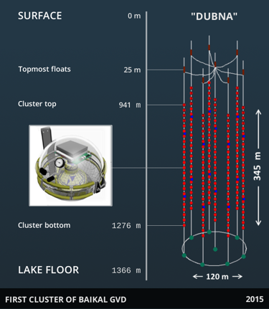
Figure 1 – Structure of the “Dubna” cluster
A cluster consists of eight strings which hold optical modules (OM) detecting the Cherenkov radiation. These modules are grouped in sections. Each section contains 12 OMs.
Baikal-GVD is studying the most violent processes in the Universe, which accelerate charged particles to highest energies, far beyond the reach of laboratory experiments on Earth. These processes must be accompanied by the emission of neutrinos. The large detection volume, combined with very good angular and energy resolution and the moderate light background in fresh water of Lake Baikal allows for an efficient study of the diffuse neutrino flux and of neutrinos from individual astrophysical objects, be they steady or transient [2].

High-purity germanium detectors
High Purity Germanium (HPGe) detector for gamma quantum is one of the best radiation detection devices that provides sufficient information to accurately and reliably identify radionuclides from their passive gamma ray emissions [3].
During the practice I got skills to work with the HPGe. I learned its main parameters such as voltage, energy resolution, formation time, voltage amplification and relative counting efficiency and found some of them for the two types of detectors.

4.1 P-type coaxial detector
First HPGe that I worked with was p-type coaxial detector in a portable cryostat manufactured by Canberra (figure 3). I had to calibrate it by finding its optimal parameters and then calculating detector’s efficiency.
Figure 2 – P-type coaxial detector with copper shielding from background radiation
A calibration isotope ¹⁵⁵Eu was used to determine the optimal parameters with two gamma-decay lines: 105.3 and 1274.5 keV. The first step was to determine the voltage amplification optimal for the particular ADC, that was done with the 1274.5 keV gamma ray and was found to be 100 times.
Then optimal voltage was found by measuring energy resolution (full width at half maximum energy) with 200 volt step starting from 0 to 3000 volt. The change is shown below (figures 3, 4). We can see that FWHM decreases as the voltage rise.

Figure 3 – FWHM dependency of voltage for 105.3 peak

Figure 4 – FWHM dependency of voltage for 105.3 peak
The 2800 V voltage was used to measure the radiation by calibration isotope ⁶⁰Co. Probe had radioactivity equal to 1050 Bq on December 17th of 2019. Measurements were made on August 5th of 2022, so time between 2 dates equals to 962 days. ⁶⁰Co has half-life equal to 1962 days, then radioactivity at the moment was 743 Bq. For a time equal to 238236 seconds, 46383 events were registered from which the absolute efficiency can be found as (1):
(1)
And relative efficiency (2):
(2)
Where 0.0012 is the AE of NaI crystal with the size of 3×3 inches (ORTEC standart [4]). The resulting value of ≈ 22 % is adequate and corresponds to average efficiency of HPGe detectors.

Segmented HPGe
Second HPGe that I worked with was segmented detector (figure 5) manufactured by Baltic Scientific Instruments.
Figure 5 – Segmented HPGe
I needed to compare segments with each other so it was decided to use ⁶⁰Co isotope again and rotate the source of radiation inside of detector by 3° each step (figure 6).
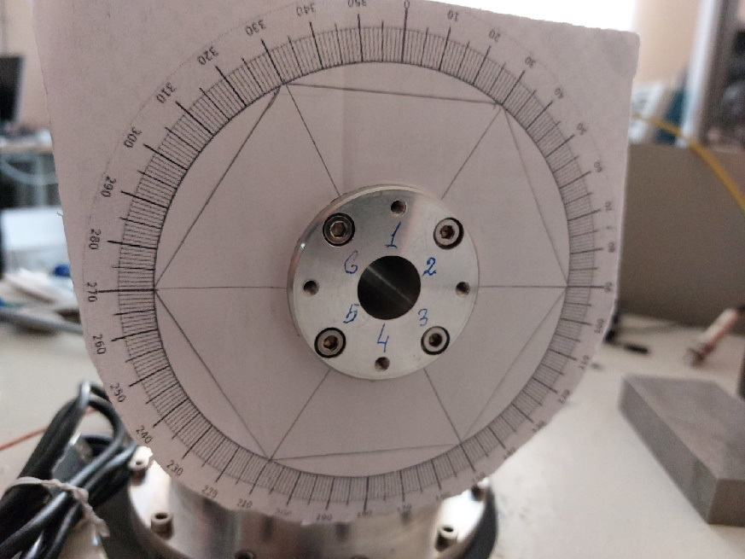
Figure 6 – Segment designations on the dial
The results of the measurements are presented below (figures 7-13).

Figure 7 – Number of events detected by 1st segment

Figure 8 – Number of events detected by 2nd segment

Figure 9 – Number of events detected by 3rd segment

Figure 10 – Number of events detected by 4th segment

Figure 11 – Number of events detected by 5th segment

Figure 12 – Number of events detected by 6th segment

Figure 13 – Summary of the measurements in all segments
By looking at the pictures we can conclude that the most of the segments have adequate results except for the fifth, which has the minimum point between peaks.
The best picture is presented y the fourth segment, it has plateau without any peaks and all other segments have almost same form with few maximum points.

ROOT
ROOT is an object-oriented program and library developed by CERN. It was originally designed for particle physics data analysis and contains several features specific to this field, but it is also used in other applications such as astronomy and data mining [5].
A key feature of ROOT is a data container called tree, with its substructures branches and leaves. A tree can be seen as a sliding window to the raw data, as stored in a file. Data from the next entry in the file can be retrieved by advancing the index in the tree. This avoids memory allocation problems associated with object creation, and allows the tree to act as a lightweight container while handling buffering invisibly [5].
ROOT is written in C++ but is integrated with other languages such as Python and R. The Python bindings are also commonly called PyROOT. PyROOT is indeed a Python extension module that allows the user to interact with any ROOT class from the Python interpreter. This is done generically using the ROOT dictionary, therefore there is no need to generate any Python wrapper code to include new ROOT classes. At the same time PyROOT offers the possibility to execute and evaluate any Python command or start a Python shell from the ROOT/Cling prompt.

Conclusions
During the practice I learned the structure, principals of work and purpose of Baikal-GVD, which is to detect neutrinos its study will open up new data on the formation of the world, our planet and dark matter and other poorly understood cosmic forces.
I became experienced working with different types of HPGe and learned its application in modern science, calibrated one of them and checked correctness of the work of the second one.
I found out what ROOT is and got basic skills to work with it and analyze data using this program.

References
- BAIKAL-GVD. Neutrino Hunters. Dzhelepov Laboratory of Nuclear Problems. URL: https://dlnp.jinr.ru/ru/baikal-gvd/okhotniki-za-nejtrino
- BAIKAL-GVD. URL: https://baikalgvd.jinr.ru/
- ORTEC WHITE PAPER – Why High-Purity Germanium (HPGe) Radiation Detection Technology is Superior to Other Detector Technologies for Isotope Identification.
- GEM Series Coaxial HPGe Detector Product Configuration Guide. URL: https://www.ortec-online.com/-/media/ametekortec/brochures/g/gem-a4.pdf?la=en&revision=127d8898-b91f-4052-b632-038e5247564d
- ROOT Data Analysis Framework. URL: https://root.cern/about/

